

**PROGRAMMING WITH PYTHON**

**GROUP ASSIGNMENT**

**Subject Code:** AAPP010-4-2-PWP

**Intake Code:** UCDF2111

**Lecturer Name:** Usman Hashmi

**Hand Out Date:** 13th October 2022

**Hand In Date:** 2nd December 2022

**Weightage:** 100%

|  |  |
| --- | --- |
| **Team Member Name** | **TP Number** |
| Miyoko Pang Zi Xuan | TP 067553 |
| Tai Eason | TP 060486 |

Table of Contents

Introduction and Assumptions 3

Design of the Program 4

Programming Concepts 74

Additional Features 113

Demonstration and Explanation 122

Conclusion 134

References 135

Appendix 137

# Introduction and Assumptions

The APU Online Shopping Mall (AOSM) is an online service which was recently launched. Its primary customers are the students at Asia Pacific University (APU), Malaysia. The intended main purpose is to allow students to order different study materials, such as reference books, encyclopaedias, and so on. Their orders will then be delivered to them by delivery staff, and the system is maintained by the administrative users only.

This assignment displays the source code, pseudo code, and flowcharts for the Python code behind the AOSM. The system is catered to both customers and staff members.

In our program, there are four user interfaces: a customer user interface, a main user interface for unregistered customers, an administrator interface, and a staff interface.

The customer user interface allows the users to view the item categories, the items, place orders, and make orders, whereas the main user interface for unregistered users only allows the users to view the items in the system, and if they wish to place order, then they may register themselves as customers.

The administrator user interface allows the administrator(s) to view, add, modify, and delete items, delivery staff users, and item categories, as well as being able to view customer order and payment history. The staff user interface allows the staff members to view and select orders for delivery, as well as updating the delivery status and taking feedback on delivery.

When functions return 0, it means that the task has failed; any invalid entries will return the user to the main user interface that they entered from. When functions return 1, it means that the task has been completed successfully. When functions return 3, it means that the system is not ready to carry out the task. The only module imported was OS, and the datetime function was replaced with a similar personally created function.

An assumption was made that the only default payment method would be through the APU student card which every student has, using any Malaysian currency that the student has deposited into their card; therefore, it is like a debit card, and no credit payments are accepted to avoid confusion and uncertainty.

A second assumption was made that the line number would act as the ID; a hidden primary key, in all databases.

A third assumption was made that the product or category listed online cannot be withdrawn or deleted to prevent against human error; for example, if the user is new, or forgot, or is not aware of a product which is represented by the entry.

No other assumptions were made.

# Design of the Program

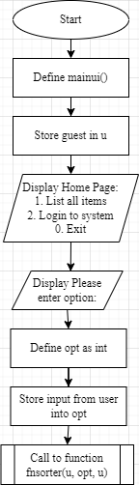 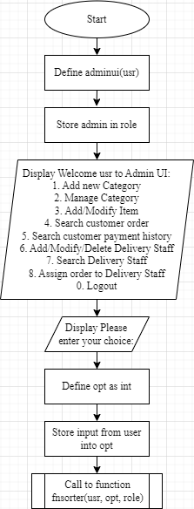 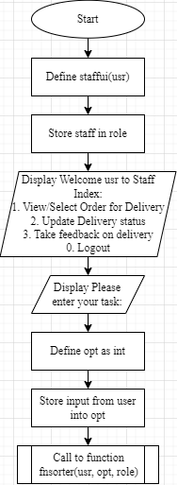  
Flowchart 1: Main UI Flowchart 2: Admin UI((usr) Flowchart 3: Staff UI(usr) 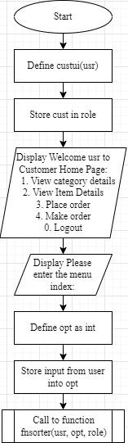 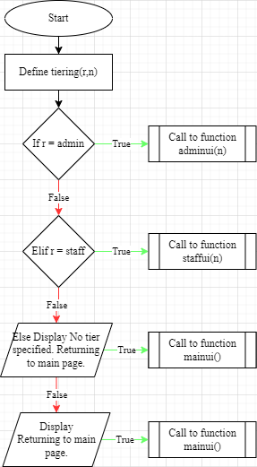  
Flowchart 4: Cust UI(usr) Flowchart 5: Tiering(r, n)

Flowchart 6: Login(opt)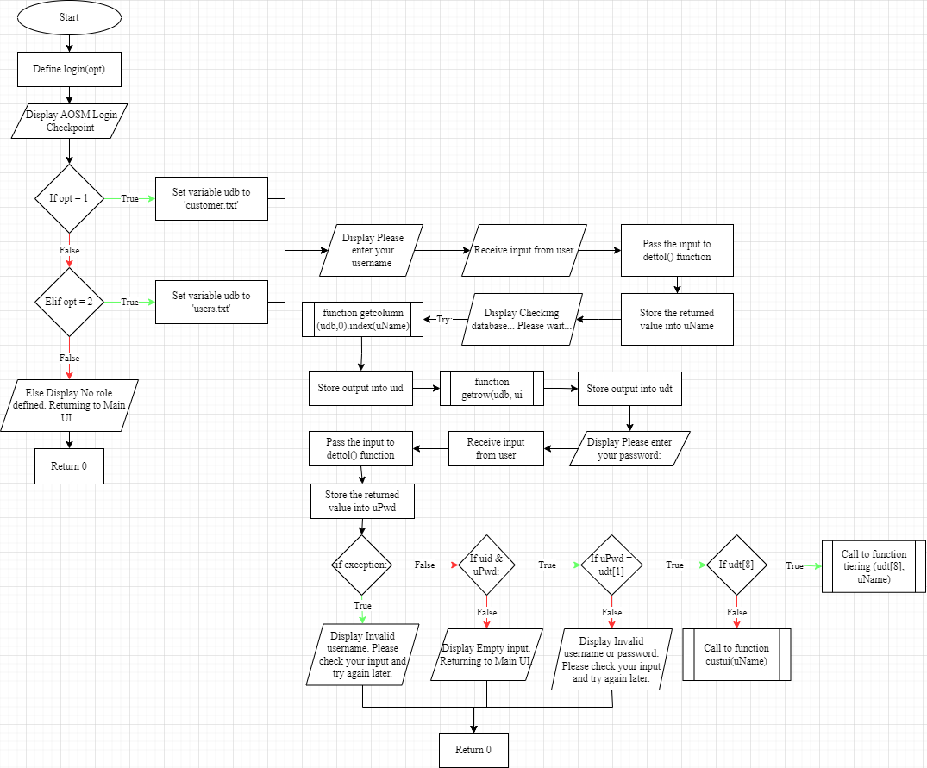

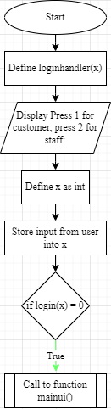  
Flowchart 7: Login Handler(x)

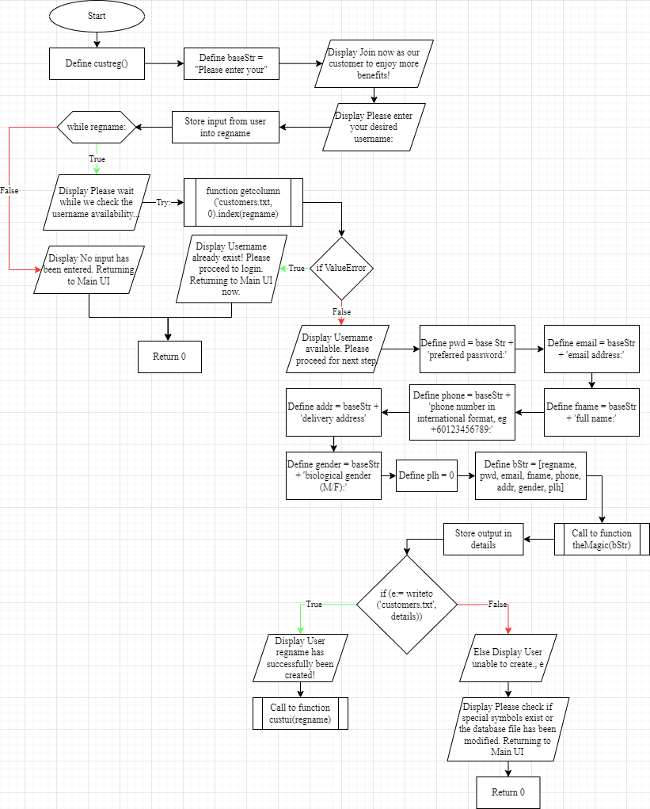  
Flowchart 8: Cust Reg

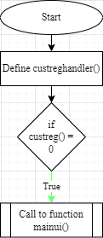  
Flowchart 9: Cust Reg Handler

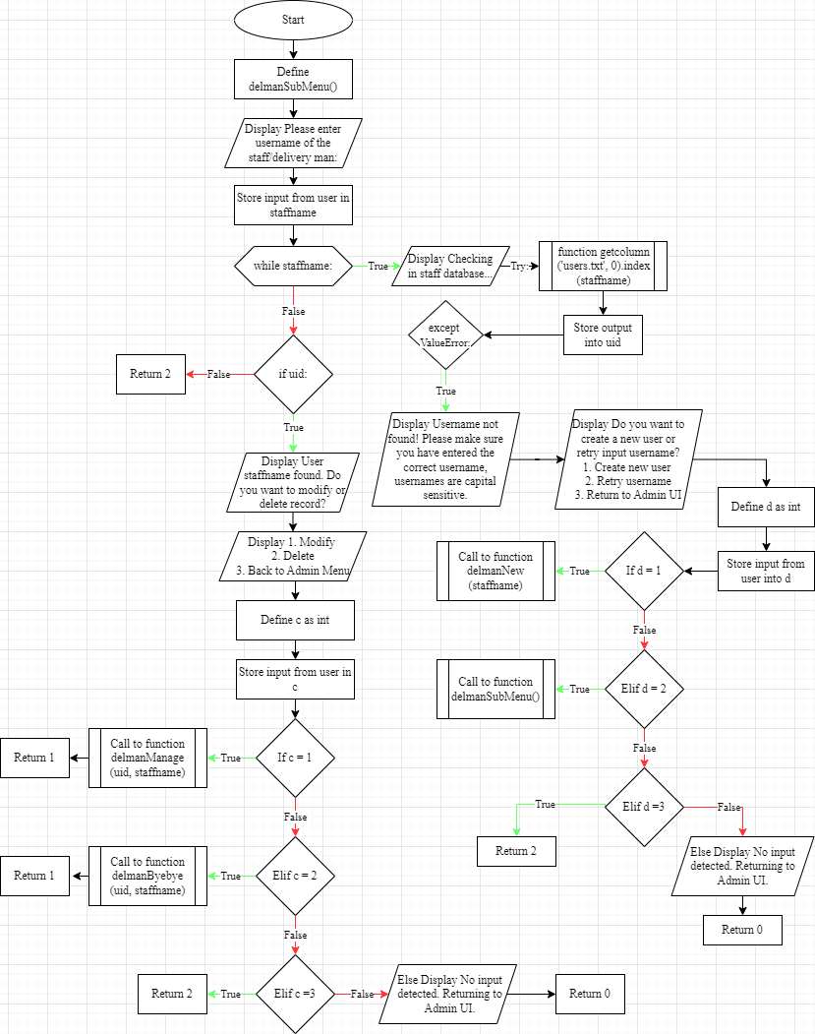  
Flowchart 10: Del Man Sub Menu

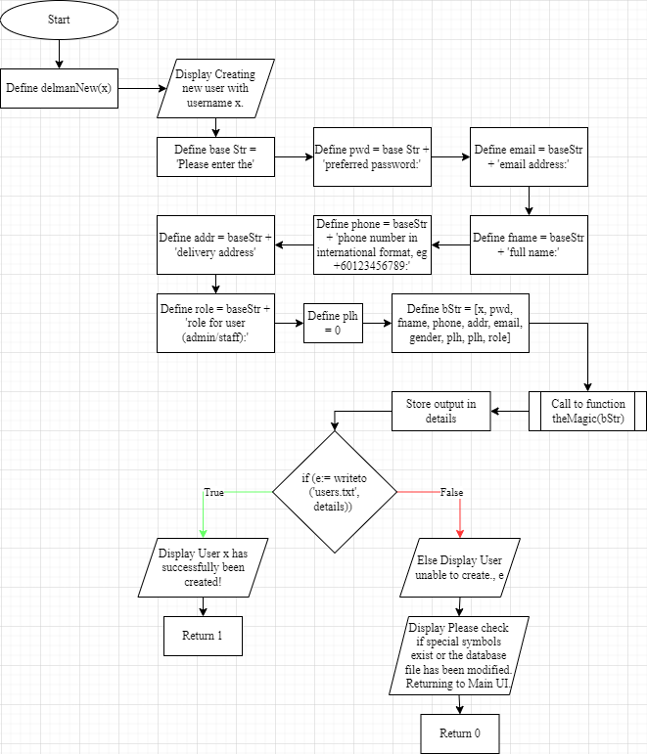  
Flowchart 11: Del Man New(x)

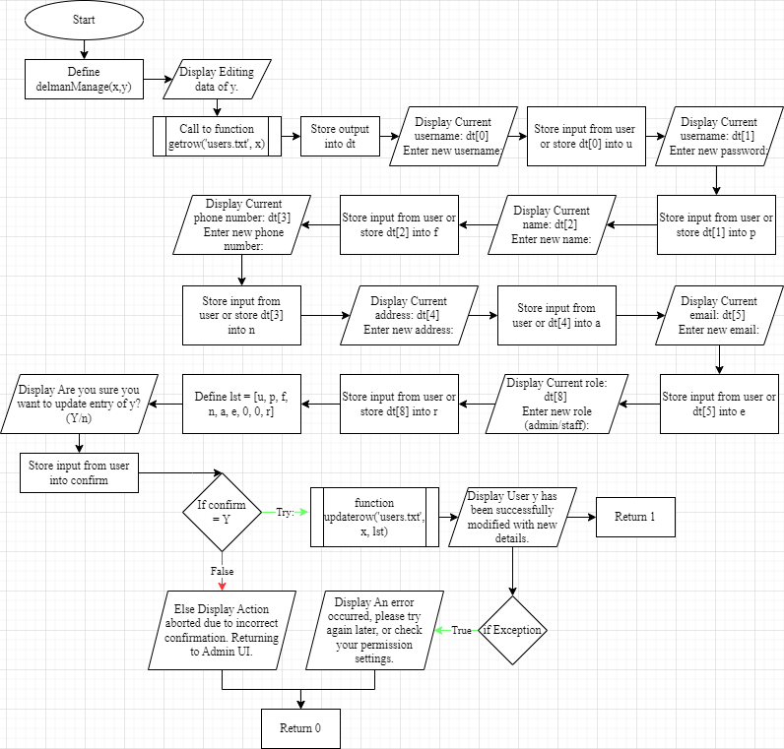  
Flowchart 12: Del Man Manage(x, y)

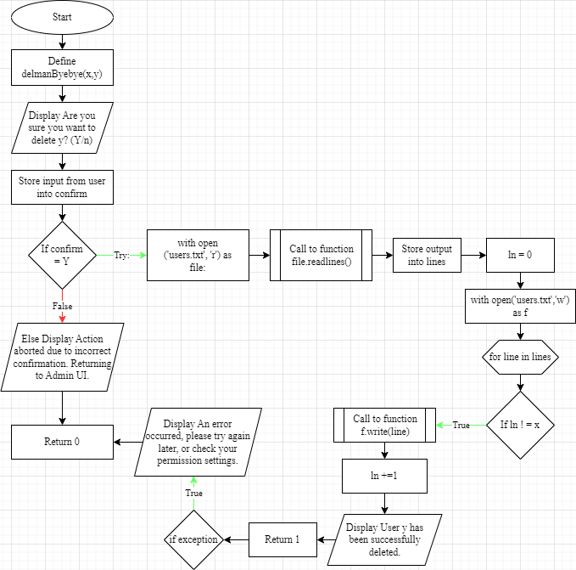  
Flowchart 13: Del Man Bye Bye(x, y)

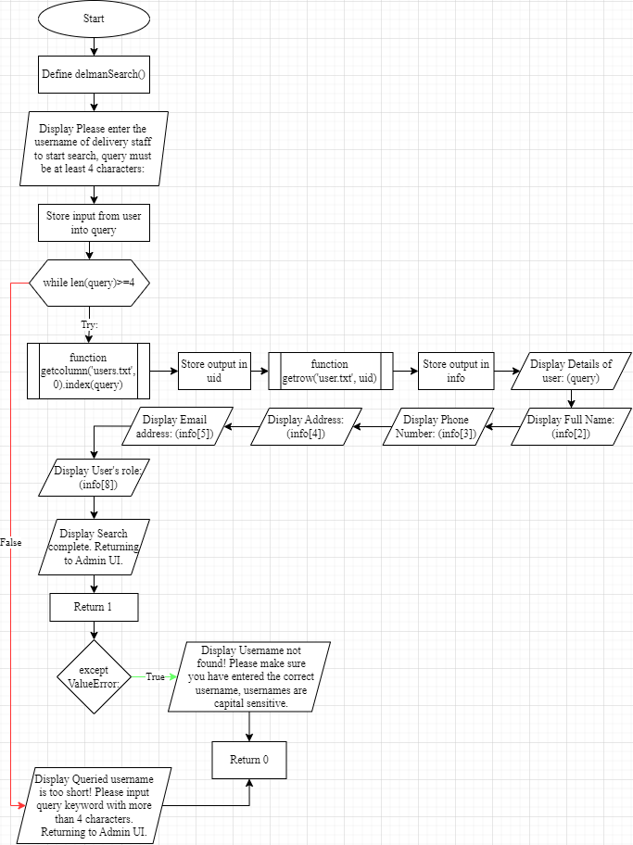  
Flowchart 14: Del Man Search

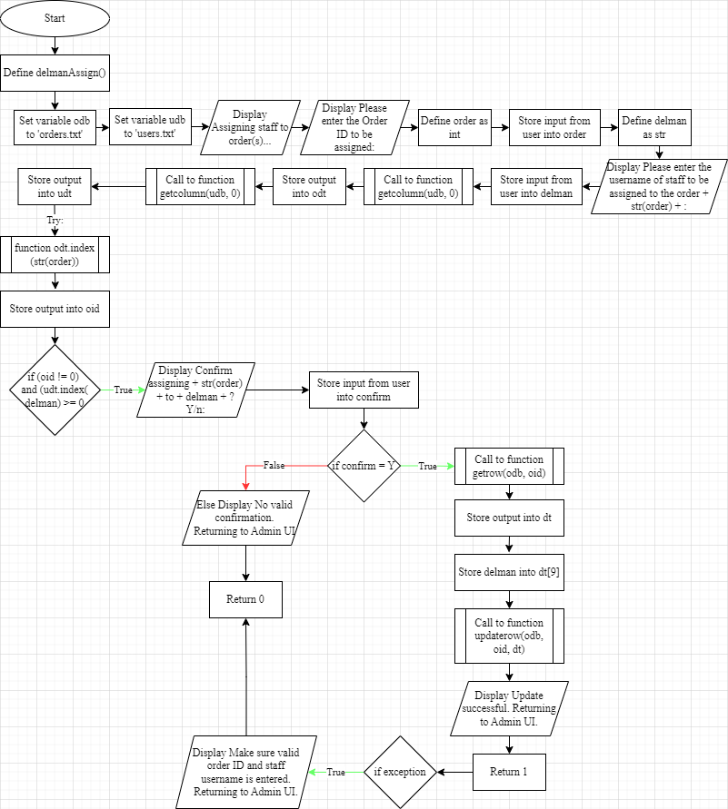  
Flowchart 15: Del Man Assign

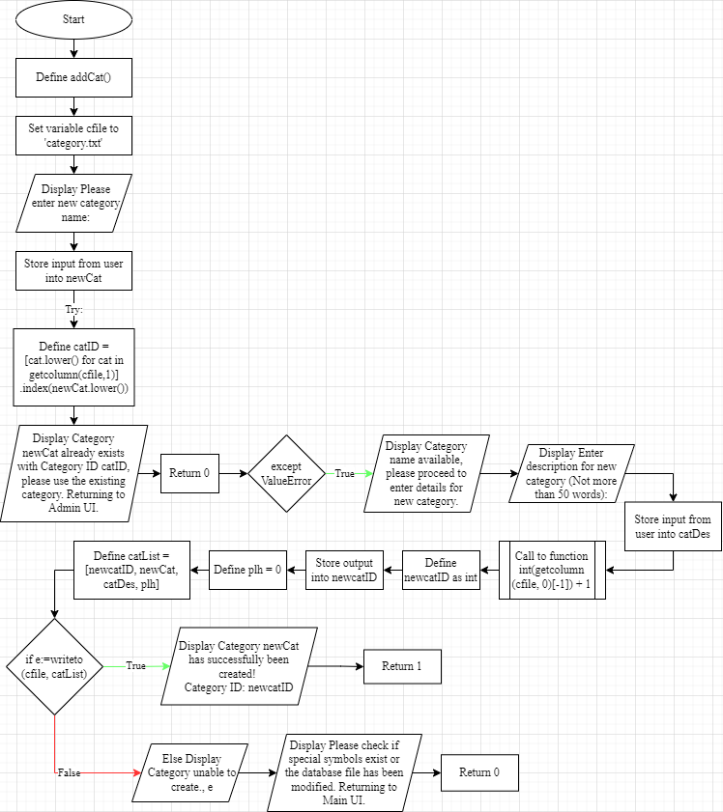  
Flowchart 16: Add Cat

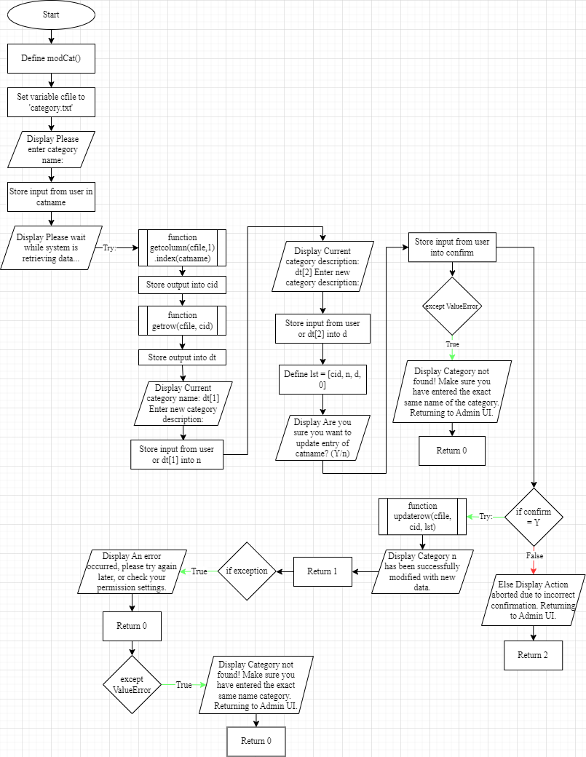  
Flowchart 17: Mod Cat

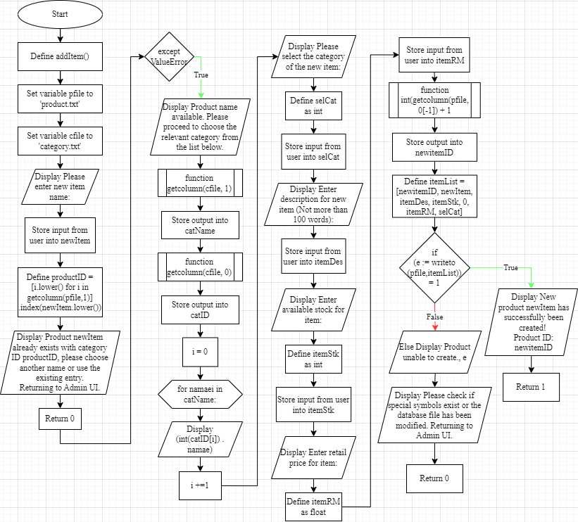  
Flowchart 18: Add Item

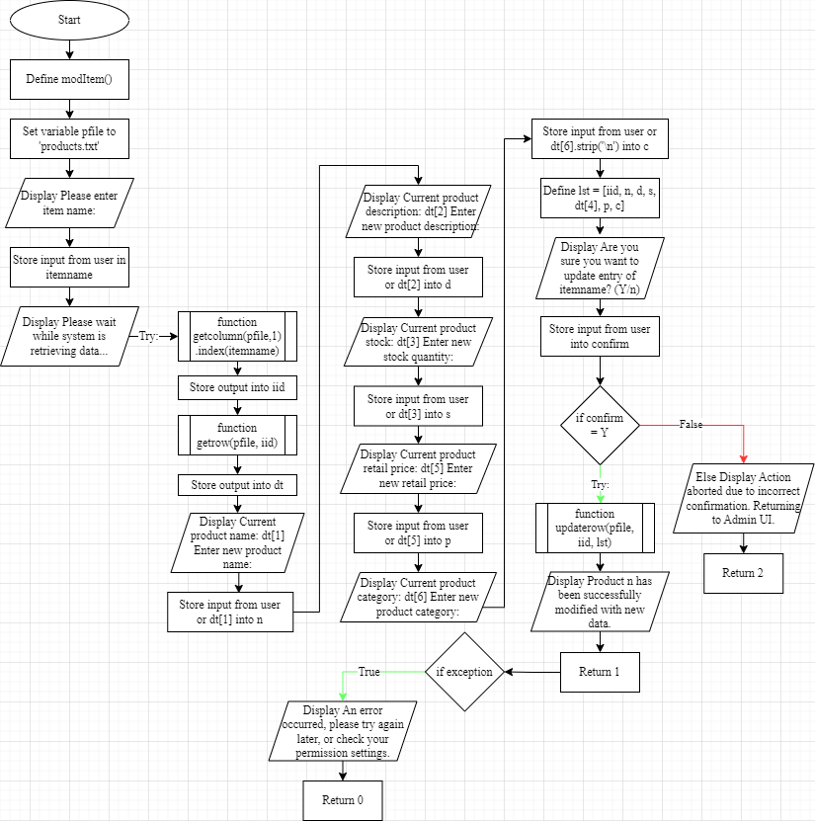  
Flowchart 19: Mod Item

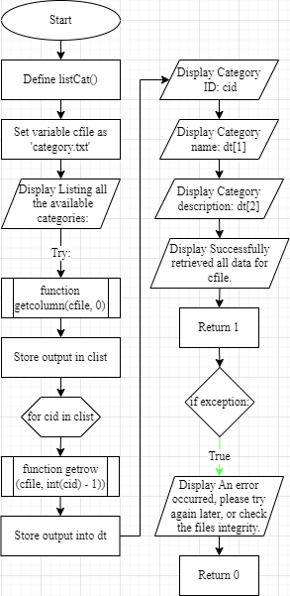   
Flowchart 20: List Cat

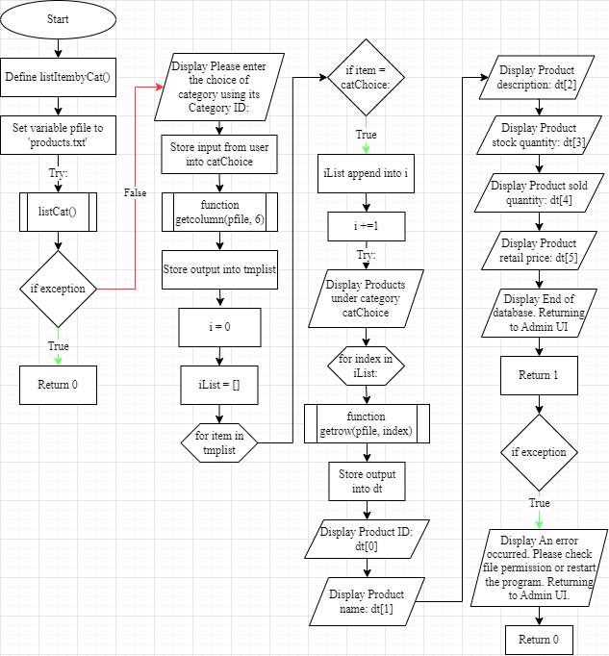  
Flowchart 21: List Item by Cat

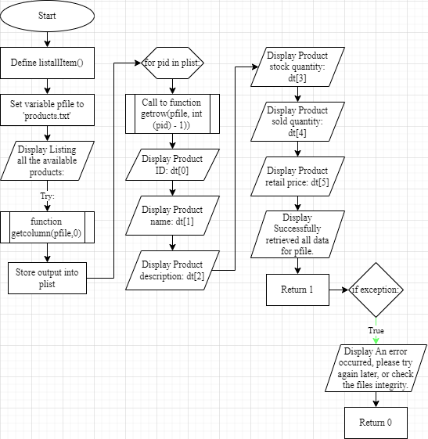  
Flowchart 22: List All Item

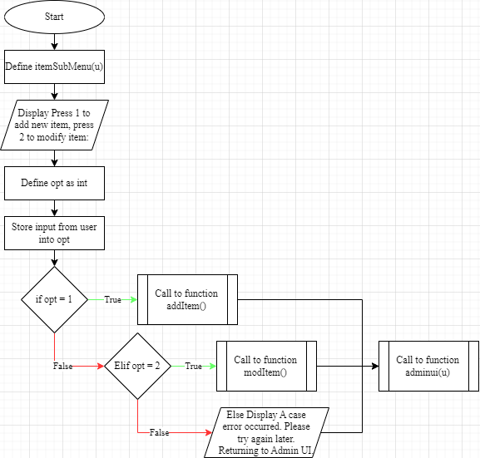  
Flowchart 23: Item Sub Menu(u)

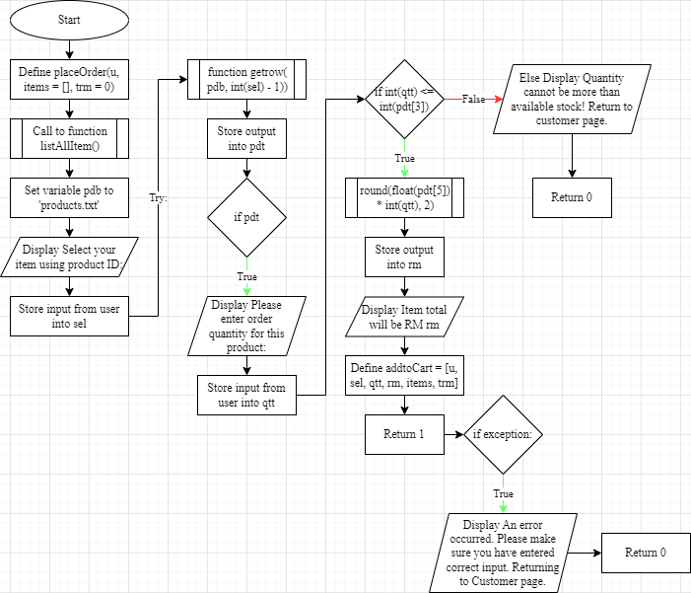  
Flowchart 24: Place Order (u, items = [], trm = 0)

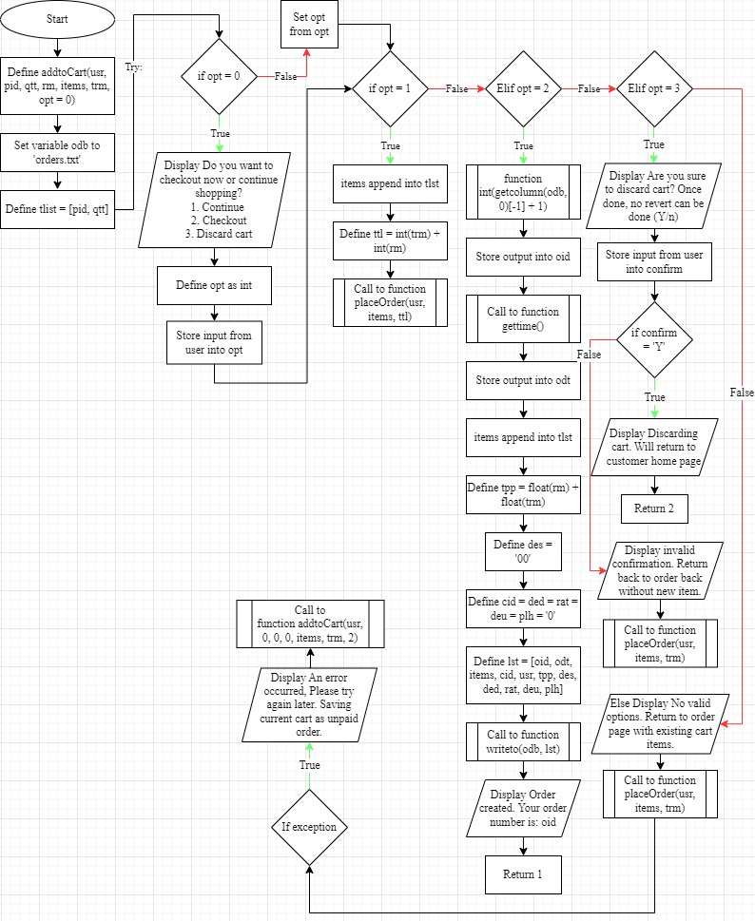  
Flowchart 25: Add to Cart(usr, pid, qtt, rm, items, trm, opt = 0)

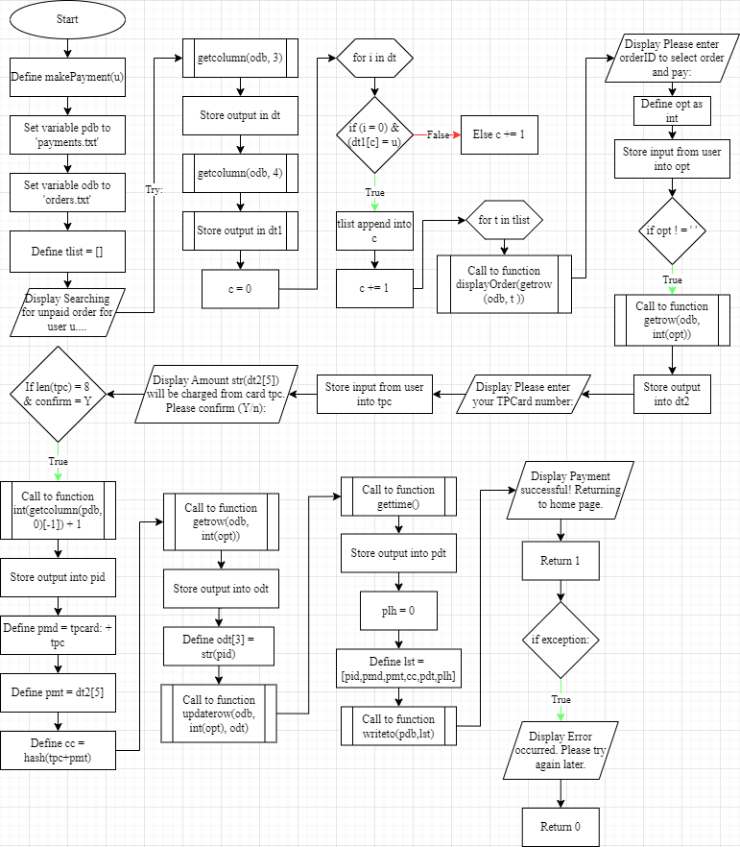  
Flowchart 26: Make Payment(u)

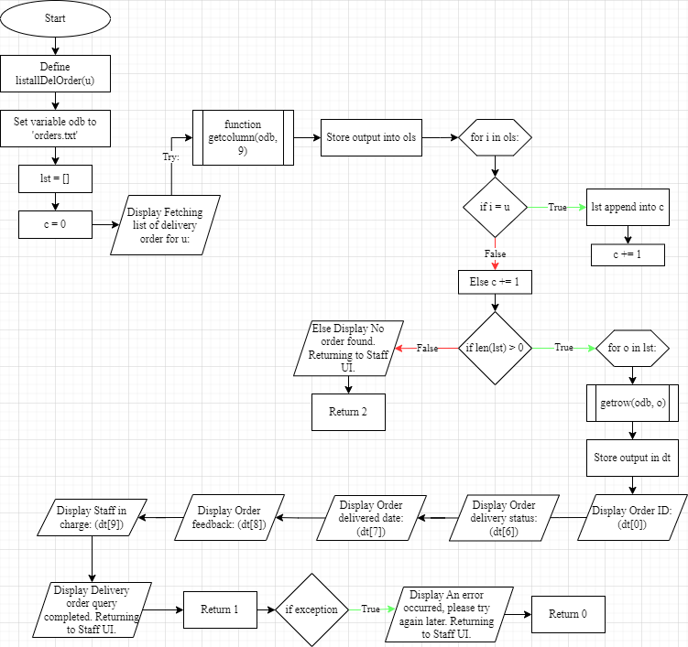Flowchart 27: List All Del Order(u)

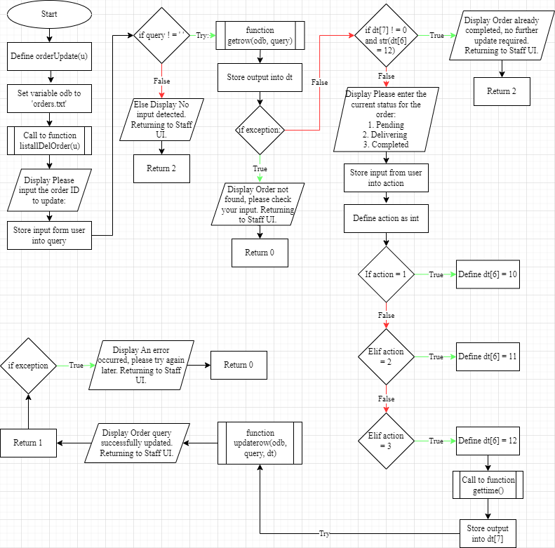Flowchart 28: Order Update(u)

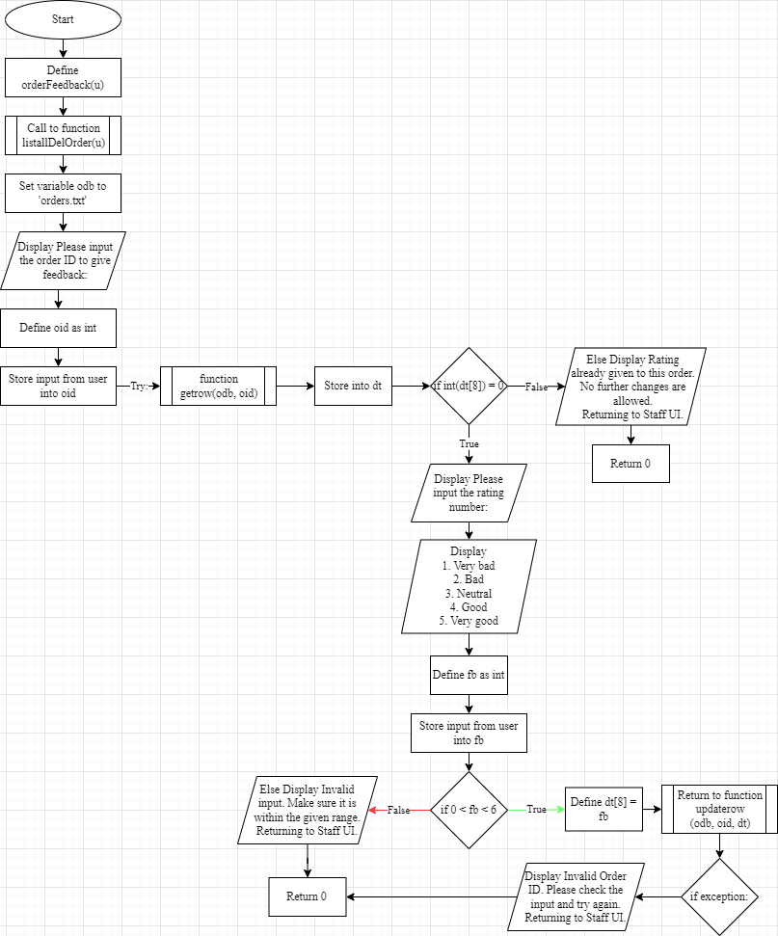Flowchart 29: Order Feedback(u)

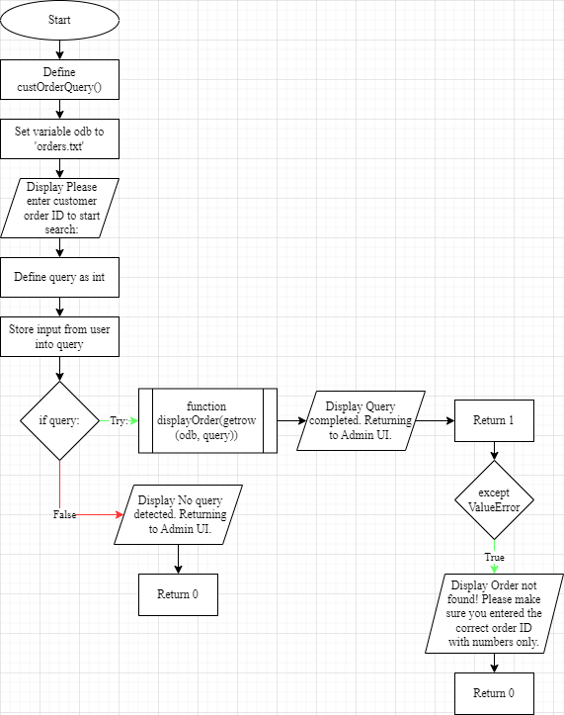Flowchart 30: Cust Order Query

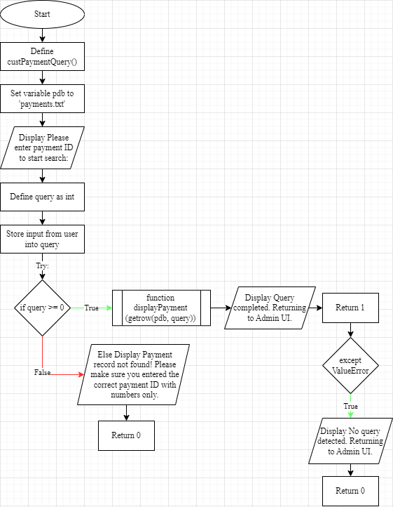  
Flowchart 31: Cust Payment Query

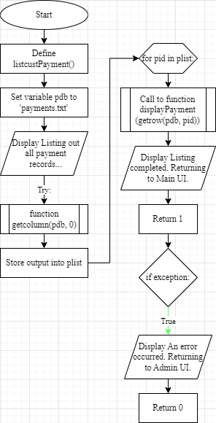 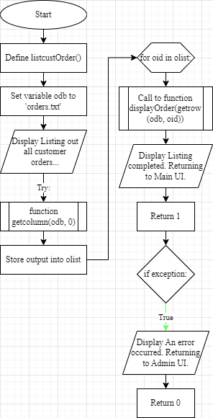  
Flowchart 32: List Cust Order Flowchart 33: List Cust Payment

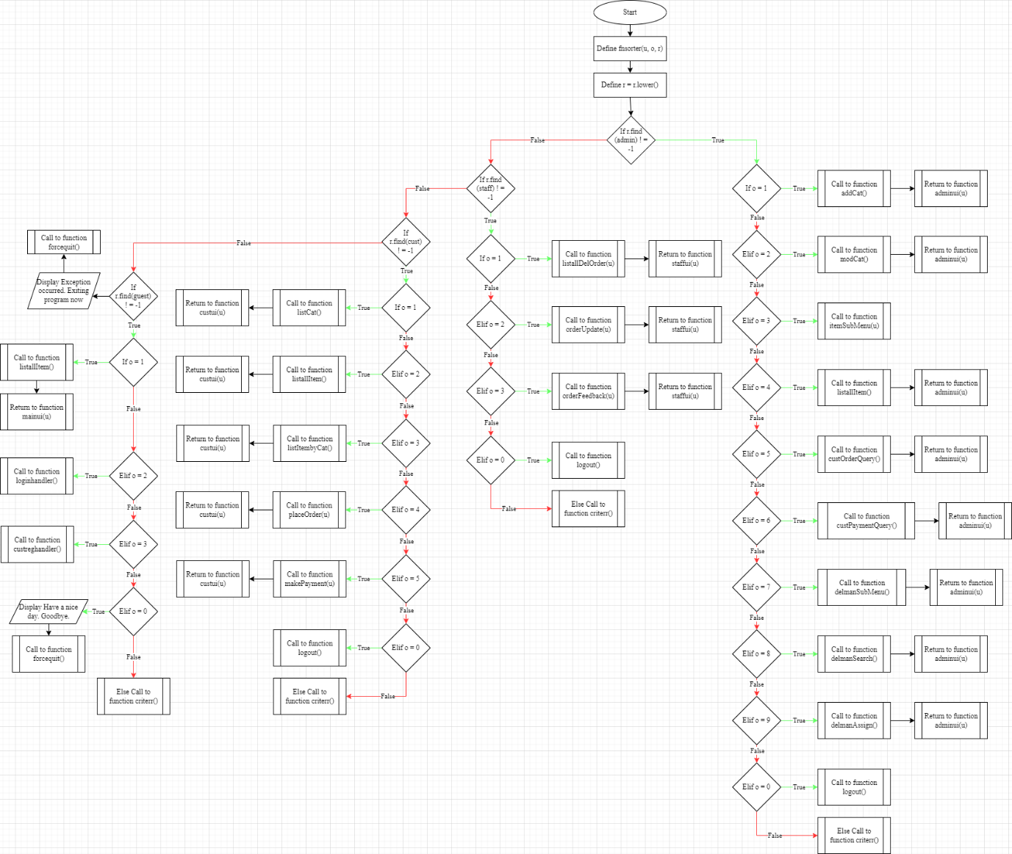  
Flowchart 34: Fnsorter(u, o, r)

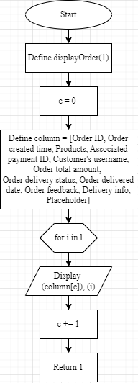 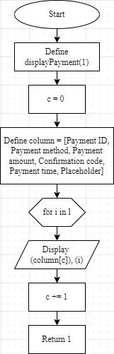 Flowchart 35: Display Order(l) Flowchart 36: Display Payment(l)

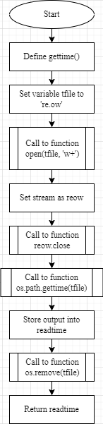 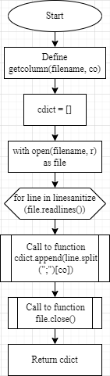 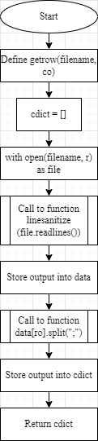  
Flowchart 37: Get Time Flowchart 38: Get Column(filename, co) Flowchart 39: Get Row(filename, co)

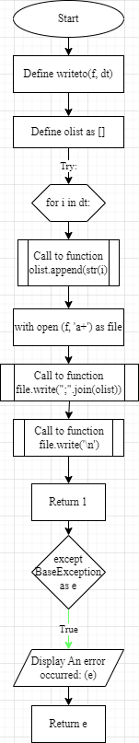 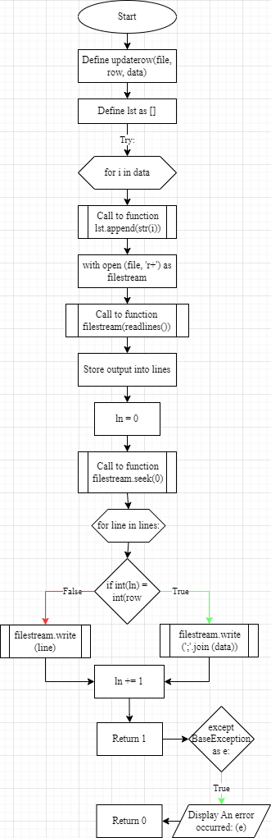  
Flowchart 40: Write To(f, dt) Flowchart 41: Update Row(file, row, data)

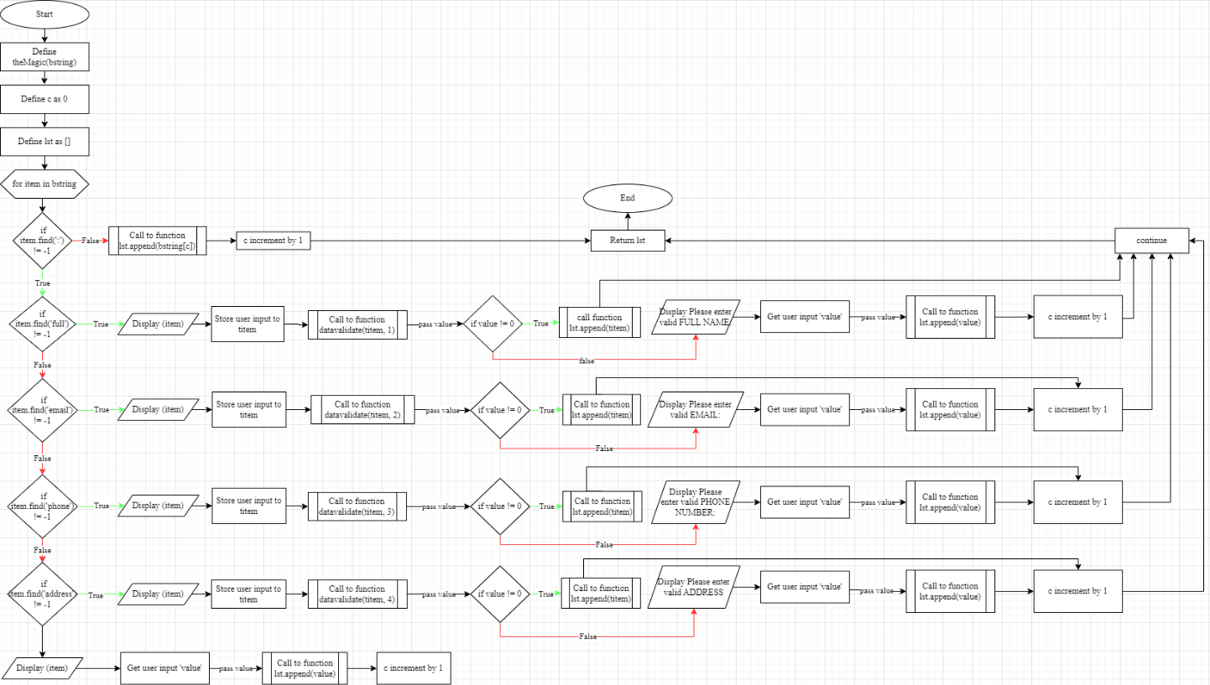Flowchart 42: The Magic(bstring)

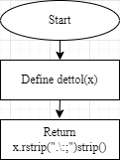 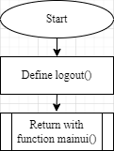 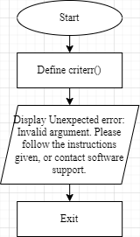 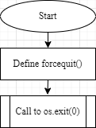  
Flowchart 43: Dettol(x) Flowchart 44: Log Out Flowchart 45: Criterr Flowchart 46: Force Quit

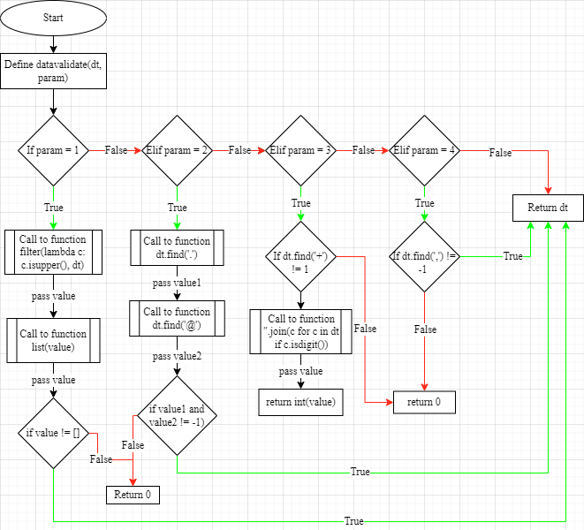  
Flowchart 47: Data Validate(dt, param)

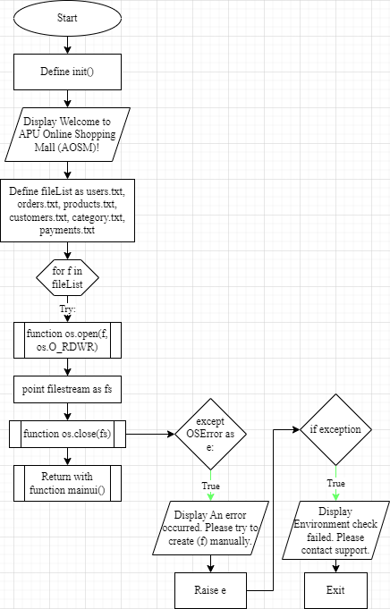  
Flowchart 48: Init

# Main UI Initial Page

DEFINE FUNCTION mainui ():  
 SET u TO 'guest'  
 OUTPUT ('Home Page:')  
 OUTPUT ('1. View all items\n')  
 OUTPUT ('2. Login to system\n')  
 OUTPUT ('3. Register as customer\n')  
 OUTPUT ('0. Exit\n')  
 SET opt TO int (READ ('Please enter option:'))

CALL fnsorter (u, opt, u)

# Admin UI Initial Page

DEFINE FUNCTION adminui(usr):  
 SET role TO 'admin'  
 OUTPUT ('Welcome ', usr, ' to Admin UI:')  
 OUTPUT ('1. Add new Category\n')  
 OUTPUT ('2. Manage Category\n')  
 OUTPUT ('3. Add/Modify Item\n')  
 OUTPUT ('4. Display all item details\n'  
 OUTPUT ('5. Search customer order\n')  
 OUTPUT ('6. Search customer payment history\n')  
 OUTPUT ('7. Add/Modify/Delete Delivery Staffs\n')  
 OUTPUT ('8. Search Delivery Staff\n')  
 OUTPUT ('9. Assign order to Delivery Staff\n')  
 OUTPUT ('0. Logout\n')  
 SET opt TO int (READ ('Please enter your choice:'))  
 CALL fnsorter (usr, opt, role)

# Delivery Staff Initial Page

DEFINE FUNCTION staffui(usr):  
 SET role TO 'staff'  
 OUTPUT ('Welcome ', usr, ' to Staff Index:')  
 OUTPUT ('1. View/Select Order FOR Delivery\n')  
 OUTPUT ('2. Update Delivery status\n')  
 OUTPUT ('3. Take feedback on delivery\n')  
 OUTPUT ('0. Logout\n')  
 SET opt TO int (READ ('Please enter your task:'))  
 CALL fnsorter (usr, opt, role)

# Customer UI Initial Page

DEFINE FUNCTION custui(usr):  
 SET role TO 'cust'  
 OUTPUT ('Welcome ', usr, ' to Customer Home Page:')  
 OUTPUT ('1. View category details\n')  
 OUTPUT ('2. View all items\n')  
 OUTPUT ('3. View items by category\n')  
 OUTPUT ('4. Place order\n')  
 OUTPUT ('5. Make order\n')  
 OUTPUT ('0. Logout\n')  
 SET opt TO int (READ ('Please enter the menu index:'))  
 CALL fnsorter (usr, opt, role)

# User role identifying function

DEFINE FUNCTION tiering (r, n):  
 IF r EQUALS 'admin':  
 CALL adminui(n)  
 IF r EQUALS 'staff':  
 CALL staffui(n)  
 OUTPUT ('No tier specified. Returning to main page.\n')  
 CALL mainui ()

# Main login logic function

DEFINE FUNCTION login(opt):  
 OUTPUT ('AOSM Login Checkpoint\n')  
 IF opt EQUALS 1:  
 SET udb TO 'customers.txt'  
 ELSEIF opt EQUALS 2:  
 SET udb TO 'users.txt'  
 ELSE:  
 OUTPUT ('No role defined. Returning to Main UI')  
 RETURN 0  
 SET uName TO dettol (READ ('Please enter your username:\n'))  
 OUTPUT ('Checking database... Please Wait...\n')  
 TRY:  
 SET uid TO getcolumn (udb, 0).index(uName)  
 SET udt TO getrow (udb, uid)  
 SET uPwd TO dettol (READ ('Please enter your password:\n'))  
 EXCEPT:  
 OUTPUT ('Invalid username. Please check your READ AND try again later.\n')  
 RETURN 0  
 IF (uid NOT EQUAL TO '') AND (uPwd NOT EQUAL TO ''):  
 IF uPwd EQUALS udt [1]:  
 TRY:   
 RETURN CALL tiering(udt [8], uName)  
 EXCEPT:  
 RETURN CALL custui(uName)  
 ELSE:  
 OUTPUT ('Invalid username OR password. Please check your READ AND try again later.\n Returning to Main UI\n')  
 RETURN 0  
 ELSE:  
 OUTPUT ('Empty READ. Returning to Main UI.\n')  
 RETURN 0

# Login function handler

DEFINE FUNCTION loginhandler():  
 SET x TO READ ('Press 1 FOR customer, press 2 FOR staff:\n')  
 TRY:  
 SET x TO int(x)  
 EXCEPT:  
 OUTPUT ('Invalid READ. Please try again')  
 CALL loginhandler()  
 IF login(x) EQUALS 0:  
 CALL mainui()

# Customer Register main logic function

DEFINE FUNCTION custreg():  
 SET baseStr TO 'Please enter your '  
 OUTPUT ('Join now AS our customer to enjoy more benefits! \n')  
 SET regname TO READ ('Please enter your desired username:\n')  
 WHILE regname:  
 OUTPUT ('Please wait WHILE we check the username availability...\n')  
 TRY:  
 CALL getcolumn ('customers.txt', 0).index(regname)  
 OUTPUT ('Username already exist! Please proceed to login. Returning to Main UI now.')  
 RETURN 0  
 EXCEPT ValueError:  
 OUTPUT ('Username available. Please proceed FOR next step.')   
 SET pwd TO baseStr + 'preferred password:'  
 SET email TO baseStr + 'email address:'  
 SET fname TO baseStr + 'full name:'  
 SET phone TO baseStr + 'phone number IN international format, e.g., +60123456789:'  
 SET addr TO baseStr + 'delivery address:'  
 SET gender TO baseStr + 'biological gender (M/F):'  
 SET plh TO '0'  
 SET bStr TO [regname, pwd, email, fname, phone, addr, gender, plh]   
 SET details TO theMagic(bStr)  
 IF (e ASSIGN FROM writeto('customers.txt', details)) EQUALS 1:  
 OUTPUT ('User "', regname, '" has successfully created! \n')  
 CALL custui(regname)  
 ELSE:  
 OUTPUT ('User unable to create.', e)  
 OUTPUT ("Please check IF special symbols exists OR the database file has been modified. Returning to Main UI. \n")  
 RETURN 0  
 OUTPUT ("No READ has been entered. Returning to Main UI \n")  
 RETURN 0

# Customer Register function handler

DEFINE FUNCTION custreghandler():  
 IF custreg() EQUALS 0:  
 CALL mainui()

# Delivery Man Sub Menu for Add/Manage/Delete delivery man

DEFINE FUNCTION delmanSubMenu():  
 SET staffname TO READ ('Please enter username of the staff/delivery man:\n')  
 OUTPUT ('Checking IN staff database...\n')  
 IF staffname NOT EQUAL TO '':  
 TRY:  
 SET uid TO getcolumn ('users.txt', 0).index(staffname)  
 OUTPUT ('User ', staffname, ' found. Do you want to modify OR delete record? \n')  
 SET c TO int (READ ("1. Modify\n2. Delete\n3. Back to Admin UI\n"))  
 IF c EQUALS 1:  
 CALL delmanManage(uid, staffname)  
 RETURN 1  
 ELSEIF c EQUALS 2:  
 CALL delmanByebye(uid, staffname)  
 RETURN 1  
 ELSEIF c EQUALS 3:  
 RETURN 2  
 ELSE:  
 OUTPUT ('No READ detected. Returning to Admin UI')  
 RETURN 0  
 EXCEPT:  
 OUTPUT ('Username not found! Please make sure you entered the correct username; username are capital sensitive.\n')  
 SET d TO int (READ ('Do you want to create a new user OR retry READ username? \n1. Create new user\n2. Retry username\3. Return to Admin UI\n'))  
 IF d EQUALS 1:  
 CALL delmanNew(staffname)  
 ELSEIF d EQUALS 2:  
 CALL delmanSubMenu()  
 ELSEIF d EQUALS 3:  
 RETURN 2  
 ELSE:  
 OUTPUT ('No READ detected. Returning to Admin UI')  
 RETURN 0  
 RETURN 2

# Create new delivery man profile

DEFINE FUNCTION delmanNew(x):  
 OUTPUT ('Creating new user WITH username "', x, '".')  
 SET baseStr TO 'Please enter the '  
 SET pwd TO baseStr + 'preferred password:'  
 SET email TO baseStr + 'email address:'  
 SET fname TO baseStr + 'full name:'  
 SET phone TO baseStr + 'phone number IN international format, e.g., +60123456789:'  
 SET addr TO baseStr + 'delivery address:'  
 SET role TO baseStr + 'role FOR user(admin/staff):'  
 SET plh TO '0'  
 SET bStr TO [x, pwd, fname, phone, addr, email, plh, plh, role] #username; password; fullname; phone number; address; email; placeholder; placeholder; role.  
 SET details TO theMagic(bStr)  
 IF (e ASSIGN FROM CALL writeto('users.txt', details)) EQUALS 1:  
 OUTPUT ('User "', x, '"has successfully created! \n')  
 RETURN 1  
 ELSE:  
 OUTPUT ('User unable to create.', e)  
 OUTPUT ("\n Please check IF special symbols exists OR the database file has been modified. Returning to Admin UI.\n")  
 RETURN 0

# Edit exist delivery man's profile

DEFINE FUNCTION delmanManage(x, y):  
 OUTPUT ('Editing data of "', y,'".')  
 SET dt TO getrow ('users.txt', x)  
 SET u TO READ (str ('Current username: ' + dt [0] + ', Enter new username:')) OR dt [0]  
 SET p TO READ (str ('Current password: ' + dt [1] + ', Enter new password:')) OR dt [1]  
 SET f TO READ (str ('Current name: ' + dt [2] + ', Enter new name:')) OR dt [2]  
 SET n TO READ (str ('Current phone number: ' + dt [3] + ', Enter new phone number:'))  
OR dt [3]  
 SET a TO READ (str ('Current address: ' + dt [4] + ', Enter new address:')) OR dt [4]  
 SET e TO READ (str ('Current email: ' + dt [5] + ', Enter new email:')) OR dt [5]   
 SET r TO READ (str ('Current role: ' + dt [8] + ' Enter new role(admin/staff):')) OR dt [8].strip('\n')  
 SET lst TO [u, p, f, n, a, e, '0', '0', r]  
 SET confirm TO READ (str ('Are you sure you want to update entry of "' + y + '"? (Y/n) \n'))  
 IF confirm EQUALS 'Y':  
 TRY:  
 CALL updaterow('users.txt', x, lst)  
 OUTPUT ('User "', y,'" has been successfully modified WITH new details.')  
 RETURN 1  
 EXCEPT:  
 OUTPUT ("An error occurred, please try again later, OR check your permission settings.")  
 RETURN 0  
 ELSE:  
 OUTPUT ('Action aborted due to incorrect confirmation. Returning to Admin UI.')  
 RETURN 0

# Delete existing delivery man's profile

DEFINE FUNCTION delmanByebye(x, y):  
 SET confirm TO READ (str ('Are you sure you want to delete "' + y + '"? (Y/n) \n'))  
 IF confirm EQUALS 'Y':  
 TRY:  
 WITH open ('users.txt', 'r') AS file:  
 SET lines TO file.readlines()  
 SET ln TO 0  
 WITH open ('users.txt', 'w') AS f:  
 FOR line IN lines:  
 IF ln NOT EQUAL TO x:  
 f.write(line)  
 ln INCREMENT 1  
 OUTPUT ('User "', y,'" has been successfully deleted.')  
 RETURN 1  
 EXCEPT:  
 OUTPUT ("An error occurred, please try again later, OR check your permission settings.")  
 RETURN 0  
 ELSE:   
 OUTPUT ('Action aborted due to incorrect confirmation. Returning to Admin UI.')  
 RETURN 0

# Search for delivery man using full username

DEFINE FUNCTION delmanSearch():  
 SET query TO READ ('Please enter the full username of delivery staff to start search:')  
 WHILE len (query)>=4:  
 TRY:  
 SET uid TO CALL getcolumn ('users.txt', 0).index(query)  
 SET info TO CALL getrow ('users.txt', uid)  
 OUTPUT ('Details of user:', query)  
 OUTPUT ('Full Name:', info [2])  
 OUTPUT ('Phone Number:', info [3])  
 OUTPUT ('Address:', info [4])  
 OUTPUT ('Email address:', info [5])  
 OUTPUT ("User's: role:", info [8])  
 OUTPUT ('Search complete. Returning to Admin UI.')  
 RETURN 1  
 EXCEPT ValueError:  
 OUTPUT ('Username not found! Please make sure you entered the correct username; username are capital sensitive.\n')  
 RETURN 0  
 OUTPUT ('Queried username is too short! Please READ query keyword WITH more than 4 characters. Returning to Admin UI.')  
 RETURN 0

# Assign delivery man to order

DEFINE FUNCTION delmanAssign():  
 SET odb TO 'orders.txt'  
 SET udb TO 'users.txt'  
 OUTPUT ('Assigning staff to order(s)...')  
 SET order TO int (READ ('Please enter the Order ID to be assigned:'))  
 SET delman TO READ (str ('Please enter the username of staff to be assigned to the order ' + str(order) + ':'))  
 SET odt TO CALL getcolumn (odb, 0)  
 SET udt TO CALL getcolumn (udb, 0)  
 TRY:  
 SET oid TO odt.index(str(order))  
 IF (oid NOT EQUAL TO 0) AND (udt.index(delman) LARGER EQUAL 0):  
 SET confirm TO READ (str ('Confirm assigning ' + str(order) + ' to ' + delman +'? (Y/n): \n'))  
 IF confirm EQUALS 'Y':  
 SET dt TO getrow (odb, oid)  
 SET dt [9] TO delman  
 CALL updaterow(odb, oid, dt)  
 OUTPUT ('Update successful. Returning to Admin UI.\n')  
 RETURN 1  
 ELSE:  
 OUTPUT ('No valid confirmation. Returning to Admin UI\n')  
 RETURN 0  
 EXCEPT:  
 OUTPUT ('Make sure valid order ID AND staff username is entered.\n Returning to Admin UI\n')  
 RETURN 0

# Add new category

DEFINE FUNCTION addCat():  
 SET cfile TO 'category.txt'  
 SET newCat TO READ ('Please enter new category name:')  
 TRY:  
 SET catID TO [cat.lower() FOR cat IN getcolumn (cfile, 1)].index(newCat.lower())  
 OUTPUT ('Category "', newCat, '" already exist WITH Category ID "', catID, '", please use the existing category.\n Returning to Admin UI.\n')  
 RETURN 0  
 EXCEPT ValueError:  
 OUTPUT ('Category name available, please proceed to enter details FOR new category.')  
 SET catDes TO READ ('Enter description FOR new category (Not more than 50 words):')  
 SET newcatID TO int(getcolumn (cfile, 0) [-1]) + 1  
 SET plh TO 0  
 SET catList TO [newcatID, newCat, catDes, plh]  
 IF (e ASSIGN FROM CALL writeto(cfile, catList)) EQUALS 1:  
 OUTPUT ('Category "', newCat, '" has successfully created! \n Category ID:', newcatID)  
 RETURN 1  
 ELSE:  
 OUTPUT ('Category unable to create.', e)  
 OUTPUT ("Please check IF special symbols exists OR the database file has been modified. Returning to Main UI.")  
 RETURN 0

# Modify existing category

DEFINE FUNCTION modCat():  
 SET cfile TO 'category.txt'  
 SET catname TO READ ('Please enter category name:')  
 OUTPUT ('Please wait WHILE system is retrieving data...')  
 TRY:  
 SET cid TO getcolumn (cfile, 1).index(catname)  
 SET dt TO getrow (cfile, cid)  
 SET n TO READ (str ('Current category name: ' + dt [1] + ', Enter new category name:')) OR dt [1]  
 SET d TO READ (str ('Current category description: ' + dt [2] + ', Enter new category description:')) OR dt [2]  
 SET lst TO [cid, n, d, 0]  
 SET confirm TO READ (str ('Are you sure you want to update entry of "' + catname + '"? (Y/n): \n'))  
 IF confirm EQUALS 'Y':  
 TRY:  
 CALL updaterow(cfile, cid, lst)  
 OUTPUT ('Category "', n,'" has been successfully modified WITH new data.')  
 RETURN 1  
 EXCEPT:  
 OUTPUT ("An error occurred, please try again later, OR check your permission settings.")  
 RETURN 0  
 ELSE:  
 OUTPUT ('Action aborted due to incorrect confirmation. Returning to Admin UI.')  
 RETURN 2  
 EXCEPT ValueError:  
 OUTPUT ('Category not found! Make sure you have entered the exact same name of the category.\n Returning to Admin UI.')  
 RETURN 0

# Add new item

DEFINE FUNCTION addItem():  
 SET pfile TO 'products.txt'  
 SET cfile TO 'category.txt'  
 SET newItem TO READ ('Please enter new item name:')  
 TRY:  
 SET productID TO [i.lower() FOR i IN getcolumn (pfile, 1)].index(newItem.lower())  
 OUTPUT ('Product "', newItem, '" already exist WITH Category ID "', productID, '", please choose other name OR use the existing entry.\n Returning to Admin UI.')  
 RETURN 0  
 EXCEPT ValueError:  
 OUTPUT ('Product name available. Please proceed to choose the relevant category from list below.')  
 SET catName TO CALL getcolumn (cfile, 1)  
 SET catID TO CALL getcolumn (cfile, 0)  
 SET i TO 0  
 FOR namae IN catName:  
 OUTPUT (int(catID[i]), '.', namae)  
 i INCREMENT 1  
 SET selCat TO int (READ ('Please select the category of the new item:'))  
 SET itemDes TO READ ('Enter description FOR new item (Not more than 100 words):')  
 SET itemStk TO int (READ ('Enter available stock FOR item:'))  
 SET itemRM TO float (READ ('Enter retail price FOR item:'))  
 SET newitemID TO int(getcolumn (pfile, 0) [-1]) + 1  
 SET itemList TO [newitemID, newItem, itemDes, itemStk, 0, itemRM, selCat]  
 IF (e ASSIGN FROM writeto(pfile, itemList)) EQUALS 1:  
 OUTPUT ('New product "', newItem, '"has successfully created! \n Product ID:', newitemID)  
 RETURN 1  
 ELSE:  
 OUTPUT ('Product unable to create.', e)  
 OUTPUT ("Please check IF special symbols exists OR the database file has been modified. Returning to Admin UI.")  
 RETURN 0

# Modify existing item

DEFINE FUNCTION modItem():  
 SET pfile TO 'products.txt'  
 SET itemname TO READ ('Please enter item name:')  
 OUTPUT ('Please wait WHILE system is retrieving data...')  
 TRY:  
 SET iid TO str(getcolumn (pfile, 1).index(itemname))  
 SET dt TO getrow (pfile, iid)  
 SET n TO READ (str ('Current product name: ' + dt [1] + ', Enter new product name:')) OR dt [1]  
 SET d TO READ (str ('Current product description: ' + dt [2] + ', Enter new product description:')) OR dt [2]  
 SET s TO READ (str ('Current product stock: ' + dt [3] + ', Enter new stock quantity:')) OR dt [3]  
 SET p TO READ (str ('Current product retail price: ' + dt [5] + ', Enter new retail price:')) OR dt [5]  
 SET c TO READ (str ('Current product category: ' + dt [6] + ', Enter new product category:')) OR dt [6].strip('\n')  
 SET lst TO [iid, n, d, s, dt [4], p, c]  
 SET confirm TO READ (str ('Are you sure you want to update entry of "' + itemname + '"? (Y/n) \n'))  
 IF confirm EQUALS 'Y':  
 TRY:  
 CALL updaterow(pfile, iid, lst)  
 OUTPUT ('Product "', n,'" has been successfully modified WITH new data.')  
 RETURN 1  
 EXCEPT:  
 OUTPUT ("An error occurred, please try again later, OR check your permission settings.")  
 RETURN 0  
 ELSE:  
 OUTPUT ('Action aborted due to incorrect confirmation. Returning to Admin UI.')  
 RETURN 2  
 EXCEPT:  
 OUTPUT ('Item not found! Make sure you have entered the exact same name of the product.\n Returning to Admin UI.')  
 RETURN 0

# List all available category

DEFINE FUNCTION listCat():  
 SET cfile TO 'category.txt'  
 OUTPUT ('Listing all the available categories:')  
 TRY:  
 SET clist TO getcolumn (cfile, 0)  
 FOR cid IN clist:  
 SET dt TO CALL getrow (cfile, (int(cid)-1))  
 OUTPUT ('Category ID: ', cid)  
 OUTPUT ('Category name: ', dt [1])  
 OUTPUT ('Category description: ', dt [2])  
 OUTPUT ('Successfully retrieved all data FOR ', cfile, '.\n')  
 RETURN 1   
 EXCEPT:  
 OUTPUT ("An error occurred, please try again later, OR check the files integrity.")  
 RETURN 0

# List items by relevant category

DEFINE FUNCTION listItembyCat():  
 SET pfile TO 'products.txt'  
 TRY:  
 CALL listCat()  
 EXCEPT:  
 RETURN 0  
 SET catChoice TO READ ('Please enter the choice of category using its Category ID:')  
 SET tmplist TO CALL getcolumn (pfile,6)  
 SET i TO 0  
 SET iList TO []  
 FOR item IN tmplist:  
 IF item EQUALS catChoice:  
 iList.append(i)  
 i INCREMENT 1   
 TRY:   
 OUTPUT ('Products under category ', catChoice)  
 FOR index IN iList:  
 SET dt TO getrow (pfile, index)  
 OUTPUT ('Product ID: ', dt [0])   
 OUTPUT ('Product name: ', dt [1])  
 OUTPUT ('Product description: ', dt [2])  
 OUTPUT ('Product stock quantity: ', dt [3])  
 OUTPUT ('Product sold quantity: ', dt [4])  
 OUTPUT ('Product retail price: ', dt [5])  
 OUTPUT ('End of database. Returning to Admin UI')  
 RETURN 1  
 EXCEPT:  
 OUTPUT ('An error occurred. Please check file permission OR restart the program. Returning to Admin UI')  
 RETURN 0

# List all available item

DEFINE FUNCTION listallItem():  
 SET pfile TO 'products.txt'  
 OUTPUT ('Listing all the available products:')  
 TRY:  
 SET plist TO CALL getcolumn (pfile, 0)  
 FOR pid IN plist:  
 SET dt TO CALL getrow (pfile, (int(pid)-1))  
 OUTPUT ('Product ID: ', dt [0])   
 OUTPUT ('Product name: ', dt [1])  
 OUTPUT ('Product description: ', dt [2])  
 OUTPUT ('Product stock quantity: ', dt [3])  
 OUTPUT ('Product sold quantity: ', dt [4])  
 OUTPUT ('Product retail price: ', dt [5])  
 OUTPUT ('Successfully retrieved all data for', pfile, '.\n')  
 RETURN 1   
 EXCEPT:  
 OUTPUT ("An error occurred, please try again later, OR check the files integrity.")  
 RETURN 0

# Item Sub menu for add/modify item

DEFINE FUNCTION itemSubMenu(u):  
 SET opt TO int (READ ('Press 1 to add new item, press 2 to modify item:'))  
 IF opt EQUALS 1:  
 CALL addItem()  
 CALL adminui(u)  
 ELSEIF opt EQUALS 2:  
 CALL modItem()  
 CALL adminui(u)  
 ELSE:  
 OUTPUT ('A case error occurred. Please try again later. Returning to Admin UI')  
 CALL adminui(u)  
 CALL adminui(u)

# Main logic for select item before adding into cart

DEFINE FUNCTION placeOrder(u, items TO [], trm TO 0):  
 CALL listallItem()  
 SET pdb TO 'products.txt'  
 SET sel TO READ ('Select your item using product ID:')  
 TRY:  
 SET pdt TO CALL getrow (pdb, (int(sel) -1))  
 IF pdt:  
 SET qtt TO READ ('Please enter order quantity FOR this product:')  
 IF int(qtt) SMALLER EQUAL int(pdt [3]):  
 SET rm TO round (float(pdt [5]) * int(qtt), 2)  
 OUTPUT ('Item total will be RM', rm)  
 CALL addtoCart(u, sel, qtt, rm, items, trm)  
 RETURN 1  
 ELSE:  
 OUTPUT ('Quantity cannot be more than available stock! Return to customer page.')  
 RETURN 0  
 EXCEPT:  
 OUTPUT ('An error occurred. Please make you have entered correct READ. Returning to Customer page.')  
 RETURN 0

# Add to cart helper for checkout

DEFINE FUNCTION addtoCart(usr, pid, qtt, rm, items, trm, opt TO 0):  
 SET odb TO 'orders.txt'  
 SET tlst TO [pid, qtt]  
 TRY:  
 SET opt TO int (READ ('Do you want to check out now OR continue shopping? \n 1. Continue\n 2. Checkout\n 3. Discard cart \n')) IF opt EQUALS 0 else opt  
 IF opt EQUALS 1:  
 items.append(tlst)  
 SET ttl TO int(trm) + int(rm)  
 CALL placeOrder(usr, items, ttl)  
 ELSEIF opt EQUALS 2:  
 SET oid TO int(getcolumn (odb, 0) [-1]) + 1  
 SET odt TO CALL gettime()  
 items.append(tlst)  
 SET tpp TO float(rm) + float(trm)  
 SET des TO '00'  
 SET cid TO ded TO rat TO deu TO plh TO '0'  
 SET lst TO [oid, odt, items, cid, usr, tpp, des, ded, rat, deu, plh]   
 CALL writeto(odb, lst)  
 OUTPUT ('Order created. Your order number is:', oid)  
 RETURN 1  
 ELSEIF opt EQUALS 3:  
 SET confirm TO READ ('Are you sure to discard cart? Once done no revert can be done(Y/n)):')  
 IF confirm EQUALS "Y":  
 OUTPUT ('Discarding cart. Will RETURN to customer home page')  
 RETURN 2  
 ELSE:  
 OUTPUT ('Invalid confirmation, will RETURN back to order page without new item added.')  
 CALL placeOrder(usr, items, trm)  
 ELSE:  
 OUTPUT ('No valid options. Returning to order page WITH existing cart items.')  
 CALL placeOrder(usr, items, trm)  
 EXCEPT:  
 OUTPUT ('An error occurred, please try again later. Saving current cart AS unpaid order.')  
 CALL addtoCart(usr, 0, 0, 0, items, trm, 2)

# Get order from order file and add new entry in payment file

DEFINE FUNCTION makePayment(u):  
 SET pdb TO 'payments.txt'  
 SET odb TO 'orders.txt'  
 SET tlist TO []  
 OUTPUT ('Searching FOR unpaid order FOR user ', u, '...')  
 TRY:  
 SET dt TO CALL getcolumn (odb, 3)  
 SET dt1 TO CALL getcolumn (odb, 4)  
 SET c TO 0  
 FOR i IN dt:  
 IF (i EQUALS '0') & (dt1[c] EQUALS u):  
 tlist.append(c)  
 c INCREMENT 1  
 ELSE:  
 c INCREMENT 1  
 FOR t IN tlist:  
 CALL displayOrder(getrow (odb, t))  
 SET opt TO READ ('Please enter orderID to select order AND pay:')  
 IF opt NOT EQUAL TO '':  
 SET dt2 TO CALL getrow (odb, int(opt))  
 SET tpc TO READ ('Please enter your TPCard number:')  
 SET confirm TO READ (str ('Amount '+ str(dt2[5]) + ' will be charged from card '+ tpc + '.\n Please confirm (Y/n):'))  
 IF (len(tpc) EQUALS 8) & (confirm EQUALS 'Y'):  
 SET pid TO int(getcolumn (pdb, 0) [-1]) + 1  
 SET pmd TO 'tpcard:' + tpc   
 SET pmt TO dt2[5]  
 SET cc TO CALL hash(tpc+pmt)  
 SET pdt TO CALL gettime()  
 SET plh TO 0  
 SET lst TO [pid, pmd, pmt, cc, pdt, plh]  
 CALL writeto(pdb, lst)  
 SET odt TO getrow (odb, int(opt))  
 SET odt [3] TO str(pid)  
 CALL updaterow(odb, int(opt), odt)  
 OUTPUT ('Payment successful! Returning to home page.')  
 RETURN 1  
 EXCEPT:  
 OUTPUT ('Error occurred. Please try again later.')  
 RETURN 0

# List all order assigned to specific delivery man

DEFINE FUNCTION listallDelOrder(u):  
 SET odb TO 'orders.txt'  
 SET lst TO []  
 SET c TO 0  
 OUTPUT ('Fetching list of delivery order FOR ', u, ': \n')  
 TRY:  
 SET ols TO CALL getcolumn (odb, 9)  
 FOR i IN ols:  
 IF i EQUALS u:  
 lst.append(c)  
 c INCREMENT 1  
 ELSE:  
 c INCREMENT 1  
 IF len(lst) LARGER THAN 0:  
 FOR o IN lst:  
 SET dt TO CALL getrow (odb, o)  
 OUTPUT ('Order ID: ', dt [0])  
 OUTPUT ('Order delivery status: ', dt [6])  
 OUTPUT ('Order delivered date: ', dt [7])  
 OUTPUT ('Order feedback: ', dt [8])  
 OUTPUT ('Staff IN charge: ', dt [9])  
 OUTPUT ('\n')  
 ELSE:  
 OUTPUT ('No order found. Returning to Staff UI.')  
 RETURN 2  
 OUTPUT ('Delivery order query completed.\n')  
 RETURN 1  
 EXCEPT:  
 OUTPUT ('An error occurred, please try again later. Returning to Staff UI.')  
 RETURN 0

# Update order delivery statuses

DEFINE FUNCTION orderUpdate(u):  
 SET odb TO 'orders.txt'  
 CALL listallDelOrder(u)  
 SET query TO READ ('Please READ the order ID to update:')  
 IF query NOT EQUAL TO '':  
 TRY:  
 SET dt TO CALL getrow (odb, query)  
 EXCEPT:  
 OUTPUT ('Order not found, please check your READ. Returning to Staff UI.')  
 RETURN 0  
 ELSE:  
 OUTPUT ('No READ detected. Returning to Staff UI')  
 RETURN 2  
 IF (dt [7] NOT EQUAL TO '0') AND (str (dt [6] EQUALS '12')):  
 OUTPUT ('Order already completed, no further update required. Returning to Staff UI')  
 RETURN 2  
 SET action TO int (READ ('Please enter the current status FOR the order:\n1. pending\n2. delivering\n3. completed\n'))  
 IF action EQUALS 1:  
 SET dt [6] TO '10'  
 ELSEIF action EQUALS 2:  
 SET dt [6] TO '11'  
 ELSEIF action EQUALS 3:  
 SET dt [6] TO '12'  
 SET dt [7] TO gettime()  
 TRY:  
 CALL updaterow(odb, query, dt)  
 OUTPUT ('Order ', query, 'successfully updated. Returning to Staff UI')  
 RETURN 1  
 EXCEPT:  
 OUTPUT ('An error occurred, please try again later. Returning to Staff UI.')  
 RETURN 0

# Update order feedback

DEFINE FUNCTION orderFeedback(u):  
 CALL listallDelOrder(u)  
 SET odb TO 'orders.txt'  
 SET oid TO int (READ ('Please READ the order ID to give feedback:'))  
 TRY:  
 SET dt TO CALL getrow (odb, oid)  
 IF int (dt [8]) EQUALS 0:  
 OUTPUT ('Please READ the rating number:\n')  
 SET fb TO int (READ ('1. Very bad\n2. Bad\n3. Neutral\n4. Good\n5. Very good\n'))  
 IF 0 SMALLER THAN fb SMALLER THAN 6:  
 SET dt [8] TO fb  
 RETURN CALL updaterow(odb, oid, dt)  
 ELSE:  
 OUTPUT ('Invalid READ. Make sure it's within the given range. Returning to Staff UI')  
 RETURN 0  
 ELSE:  
 OUTPUT ('Rating has been given to this order. No further amendment allowed.\n Returning to Staff UI.\n')  
 RETURN 0  
 EXCEPT:  
 OUTPUT ('Invalid Order ID. Please check the READ AND try again. Returning to Staff UI.')  
 RETURN 0

# Search for customer order and display

DEFINE FUNCTION custOrderQuery():  
 SET odb TO 'orders.txt'  
 SET query TO int (READ ('Please enter customer order ID to start search:'))  
 IF query:  
 TRY:  
 CALL displayOrder(getrow (odb, query))  
 OUTPUT ('Query completed. Returning to Admin UI.')  
 RETURN 1  
 EXCEPT ValueError:  
 OUTPUT ('Order not found! Please make sure you entered the correct order ID WITH numbers only.\n')  
 RETURN 0  
 OUTPUT ('No query detected. Returning to Admin UI.')  
 RETURN 0

# Search for customer payment and display

DEFINE FUNCTION custPaymentQuery():  
 SET pdb TO 'payments.txt'  
 SET query TO int (READ ('Please enter payment ID to start search:'))  
 TRY:  
 IF query LARGER EQUAL 0:  
 CALL displayPayment(getrow (pdb, query))  
 OUTPUT ('Query completed. Returning to Admin UI.')  
 RETURN 1  
 ELSE:  
 OUTPUT ('Payment record not found! Please make sure you entered the correct payment ID WITH numbers only.\n')  
 RETURN 0  
 EXCEPT ValueError:  
 OUTPUT ('No query detected. Returning to Admin UI.\n')  
 RETURN 0

# List out all customers' order

DEFINE FUNCTION listcustOrder():  
 SET odb TO 'orders.txt'  
 OUTPUT ('Listing out all customer orders...')  
 TRY:  
 SET olist TO CALL getcolumn (odb, 0)  
 FOR oid IN olist:  
 displayOrder(getrow (odb, oid))  
 OUTPUT ('Listing completed. Returning to Main UI.')  
 RETURN 1  
 EXCEPT:  
 OUTPUT ('An error occurred. Returning to Admin UI.')   
 RETURN 0

# List out all customers' payment

DEFINE FUNCTION listcustPayment():  
 SET pdb TO 'payments.txt'  
 OUTPUT ('Listing out all payment records...')  
 TRY:  
 SET plist TO CALL getcolumn (pdb, 0)  
 FOR pid IN plist:  
 displayPayment(getrow (pdb, pid))  
 OUTPUT ('Listing completed. Returning to Main UI.')  
 RETURN 1  
 EXCEPT:  
 OUTPUT ('An error occurred. Returning to Admin UI.')   
 RETURN 0

# Main logic for redirecting program users to destinated functions

DEFINE FUNCTION fnsorter(u, o, r):  
 SET r TO r.lower()  
 IF r.find('admin') NOT EQUAL TO -1:  
 IF o EQUALS 1:  
 CALL addCat()  
 RETURN CALL adminui(u)  
 ELSEIF o EQUALS 2:  
 CALL modCat()  
 RETURN CALL adminui(u)  
 ELSEIF o EQUALS 3:  
 CALL itemSubMenu(u)  
 ELSEIF o EQUALS 4:  
 CALL listallItem()  
 RETURN CALL adminui(u)  
 ELSEIF o EQUALS 5:  
 CALL custOrderQuery()  
 RETURN CALL adminui(u)  
 ELSEIF o EQUALS 6:  
 CALL custPaymentQuery()  
 RETURN CALL adminui(u)  
 ELSEIF o EQUALS 7:  
 CALL delmanSubMenu()  
 RETURN CALL adminui(u)  
 ELSEIF o EQUALS 8:  
 CALL delmanSearch()  
 RETURN CALL adminui(u)  
 ELSEIF o EQUALS 9:  
 CALL delmanAssign()  
 RETURN CALL adminui(u)  
 ELSEIF o EQUALS 0:  
 CALL logout ()  
 ELSE:  
 CALL criterr()   
 IF r.find('staff') NOT EQUAL TO -1:  
 IF o EQUALS 1:  
 CALL listallDelOrder(u)  
 RETURN CALL staffui(u)  
 ELSEIF o EQUALS 2:  
 CALL orderUpdate(u)  
 RETURN CALL staffui(u)  
 ELSEIF o EQUALS 3:  
 CALL orderFeedback(u)  
 RETURN CALL staffui(u)  
 ELSEIF o EQUALS 0:  
 CALL logout ()  
 ELSE:  
 CALL criterr()   
 IF r.find('cust') NOT EQUAL TO -1:  
 IF o EQUALS 1:  
 CALL listCat()  
 RETURN CALL custui(u)  
 ELSEIF o EQUALS 2:  
 CALL listallItem()  
 RETURN CALL custui(u)  
 ELSEIF o EQUALS 3:  
 CALL listItembyCat()  
 RETURN CALL custui(u)  
 ELSEIF o EQUALS 4:  
 CALL placeOrder(u)  
 RETURN CALL custui(u)  
 ELSEIF o EQUALS 5:  
 CALL makePayment(u)  
 RETURN CALL custui(u)  
 ELSEIF o EQUALS 0:  
 CALL logout ()  
 ELSE:  
 CALL criterr()  
 IF r.find('guest') NOT EQUAL TO -1:  
 IF o EQUALS 1:  
 CALL listallItem()  
 RETURN CALL mainui()  
 ELSEIF o EQUALS 2:  
 CALL loginhandler()  
 ELSEIF o EQUALS 3:  
 CALL custreghandler()  
 ELSEIF o EQUALS 0:  
 OUTPUT ('Have a nice day. Goodbye.')  
 CALL forcequit()  
 ELSE:  
 CALL criterr()   
 OUTPUT ('Exception occurred. Exiting program now')  
 CALL forcequit()

# Helper function to display customer order

DEFINE FUNCTION displayOrder(l):  
 SET c TO 0  
 SET column TO ['Order ID: ', 'Order created time: ', 'Products: ','Associated payment ID: ', "Customer's username: ", 'Order total amount: ', "Order delivery status: ", "Order delivered date: ", "Order feedback: ", "Delivery info: ", "Placeholder: "]  
 FOR i IN l:  
 OUTPUT (column[c], i)  
 c INCREMENT 1  
 RETURN 1

# Helper function to display customer payment

DEFINE FUNCTION displayPayment(l):  
 SET c TO 0  
 SET column TO ['Payment ID: ', 'Payment method: ', 'Payment amount: ', 'Confirmation code: ', 'Payment time: ', 'Placeholder: ' ]  
 FOR i IN l:  
 OUTPUT (column[c], i)  
 c INCREMENT 1  
 RETURN 1

# Custom function to get unix time by creating file and read time created

DEFINE FUNCTION gettime():   
 SET tfile TO 're.ow'  
 SET #reow TO os.open(tfile, os.O_RDWR)  
 SET reow TO open(tfile, 'w+')  
 # os.write(reow, "testline")  
 reow.close()  
 SET readtime TO os.path.getmtime(tfile)  
 os.remove(tfile)  
 RETURN readtime

# Function to get entire column from specified file

DEFINE FUNCTION getcolumn (filename, co):  
 SET cdict TO []  
 TRY:  
 WITH open (filename, 'r') AS file:  
 FOR line IN file.readlines():  
 cdict.append(line.split(";") [int(co)])   
 file.close()  
 RETURN cdict  
 EXCEPT:  
 OUTPUT ('An error occurred. Please try again, OR check your READ')  
 RETURN 0

# Function to get only one row from specified file

DEFINE FUNCTION getrow (filename, ro):  
 TRY:  
 WITH open (filename, 'r') AS file:  
 SET data TO file.readlines()  
 SET cdict TO data[int(ro)].split(";")  
 RETURN cdict  
 EXCEPT:  
 OUTPUT ('An error occurred. Please try again, OR check your READ')  
 RETURN 0

# Function to write data at the end of file

DEFINE FUNCTION writeto(f, dt)  
 SET olist TO []  
 TRY:  
 FOR i IN dt:  
 olist.append(str(i))  
 WITH open (f, 'a+') AS file:  
 file.write(";". join(olist))  
 file.write('\n')  
 RETURN 1  
 EXCEPT BaseException AS e:  
 OUTPUT ('An error occurred:', e)  
 RETURN e

# Function to update specific row in the file

DEFINE FUNCTION updaterow(file, row, data):  
 SET lst TO []  
 TRY:  
 FOR i IN data:  
 lst.append(str(i))  
 WITH open (file, 'r+') AS filestream:  
 SET lines TO filestream.readlines()  
 SET ln TO 0  
 filestream.seek(0)  
 FOR line IN lines:  
 IF int(ln) EQUALS int(row):  
 filestream.write(';'.join(lst))  
 ln INCREMENT 1  
 ELSE:  
 filestream.write(line)  
 ln INCREMENT 1  
 RETURN 1  
 EXCEPT BaseException AS e:  
 OUTPUT ('An error occurred: ', e)  
 RETURN 0

# Function to iterate through lists and get input when required

DEFINE FUNCTION theMagic(bstring):  
 SET c TO 0  
 SET lst TO []  
 FOR item IN bstring:  
 IF item.find(':') NOT EQUAL TO -1:  
 IF item.find('full') NOT EQUAL TO -1:  
 SET titem TO READ (item)  
 lst.append(titem) IF datavalidate(titem, 1) NOT EQUAL TO 0 else lst.append(READ ('Please enter valid FULL NAME:'))  
 c INCREMENT 1  
 continue  
 IF item.find('email') NOT EQUAL TO -1:  
 SET titem TO READ (item)  
 lst.append(titem) IF datavalidate(titem, 2) NOT EQUAL TO 0 else lst.append(READ ('Please enter valid EMAIL:'))  
 c INCREMENT 1  
 continue  
 IF item.find('phone') NOT EQUAL TO -1:  
 SET titem TO READ (item)  
 lst.append(titem) IF datavalidate(titem, 3) NOT EQUAL TO 0 else lst.append(READ ('Please enter valid PHONE NUMBER:'))  
 c INCREMENT 1  
 continue  
 IF item.find('address') NOT EQUAL TO -1:  
 SET titem TO READ (item)  
 lst.append(titem) IF datavalidate(titem, 4) NOT EQUAL TO 0 else lst.append(READ ('Please enter valid ADDRESS:'))  
 c INCREMENT 1  
 continue  
 lst.append(READ (item))  
 c INCREMENT 1  
 ELSE:  
 lst.append(bstring[c])  
 c INCREMENT 1  
 RETURN lst

# Sanitizing users input to prevent bug

DEFINE FUNCTION dettol (x): RETURN x.rstrip("\ :;").strip()

# Remove username from argument to logout

DEFINE FUNCTION logout (): RETURN CALL mainui()

# To reduce repeated code in fnsorter, quit when error is hit

DEFINE FUNCTION criterr():  
 OUTPUT ('Unexpected error: Invalid argument. Please follow the instructions given, OR contact software support.')  
 CALL quit ()

# Terminates the entire program

DEFINE FUNCTION forcequit():  
 CALL os._exit (0)

# Data validation function for name, email, phone, address

DEFINE FUNCTION datavalidate(dt, param):  
 IF param EQUALS 1:  
 RETURN dt IF list (filter (lambda c: c.isupper(), dt)) NOT EQUAL TO [] else 0  
 ELSEIF param EQUALS 2:  
 RETURN dt IF (dt.find('.') NOT EQUAL TO -1) AND (dt.find('@') NOT EQUAL TO -1) else 0  
 ELSEIF param EQUALS 3:  
 RETURN int (''.join(c FOR c IN dt IF c.isdigit())) IF dt.find('+') NOT EQUAL TO -1 else 0  
 ELSEIF param EQUALS 4:  
 RETURN dt IF dt.find(',') NOT EQUAL TO -1 else 0  
 ELSE:  
 RETURN dt

# Initialization of the program

DEFINE FUNCTION init():  
 OUTPUT ('Welcome to APU Online Shopping Mall(AOSM)!\n\n')  
 SET fileList TO ['users.txt', 'orders.txt', 'products.txt', 'customers.txt', 'category.txt', 'payments.txt']  
 FOR f IN fileList:  
 TRY:   
 SET fs TO os.open(f, os.O_RDWR)  
 os.close(fs)  
 EXCEPT OSError AS e:  
 OUTPUT ('An error occurred. Please try to create "', f, '" manually\n')  
 RAISE EXCEPTION e  
 EXCEPT:  
 OUTPUT ('Environment check failed. Please contact support.')  
 quit ()  
 CALL mainui()

# Start executing this program

CALL init()

# Programming Concepts

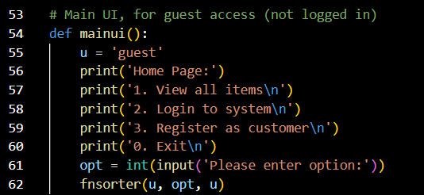  
Figure 1: Main UI Source Code

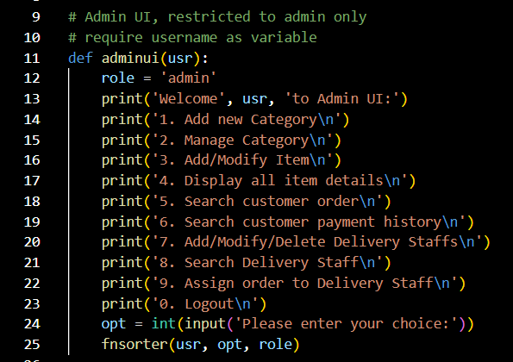  
Figure 2: Admin UI(usr) Source Code

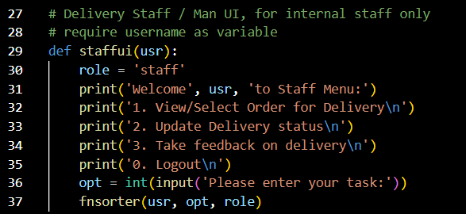  
Figure 3: Staff UI(usr) Source Code

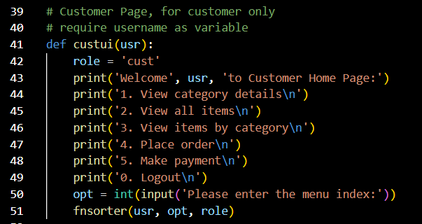  
Figure 4: Cust UI(usr) Source Code

|  |  |
| --- | --- |
| Variables | Explanation |
| usr | A string variable used to store the usernames of all users, derived from user input. |
| role | A string variable used to store the role of each user; the roles stored in this variable are ‘admin’, ‘cust’, and ‘staff’. It does not store the ‘guest’ role. The role parameter is defined according to each function. |
| opt | A variable used to store the option that the user has entered; it is defined as an integer, as users are often required to input integers to proceed to another function. |
| u | A string variable used to store the ‘guest’ name and role for unregistered customers, derived from user input. This maintains consistency throughout the fnsorter function. |

|  |  |
| --- | --- |
| Line(s) | Explanation |
| 9 ~ 10 | Comments: This is the Admin UI, restricted to administrators only. The username of the admin user is required as a variable. |
| 11 | The function adminui is defined. |
| 13 ~ 23 | A welcome message is printed, followed by options to pick the action that the user wishes to carry out. |
| 24 | A message requested the user to enter their choice is printed. The input from user is stored in variable opt. |
| 25 | The fnsorter function is called, which is responsible for calling the required functions according to the input entered, with the usr string variable, opt variable, and role string variable acting as variables in the called functions. |

This concept is used in Main UI, Cust UI, and Staff UI as well.

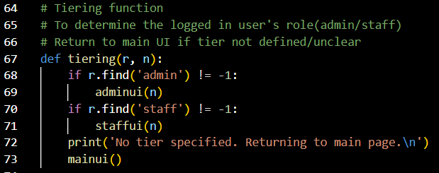  
Figure 5: Tiering(r, n) Source Code

|  |  |
| --- | --- |
| Variables | Explanation |
| r | A string variable used to store the role of administrator and staff users. |
| n | A string variable used to store the name of administrator and staff users. |

|  |  |
| --- | --- |
| Line(s) | Explanation |
| 64 ~ 66 | Comments: This is the tiering function. Its function is to determine whether the user who has logged in is a staff member or administrator. It will return the user to Main UI if the tier of the user is unclear. |
| 67 | The function tiering is defined. |
| 68 ~ 69 | If the r string is found to match with ‘admin’, then the result will be 1. As long as the result is not -1, then the function adminui will be called, with the n string acting as a variable in the called function. |
| 70 ~ 71 | If the r string is found to match with ‘staff’, then the result will be 1. As long as the result is not -1, then the function staffui will be called, with the n string acting as a variable in the called function. |
| 73 | If the results for both previous if statements, are -1, or invalid values, then the mainui function will be called, which is the user interface for guest users/unregistered customers. |

This function will only be called by the login function, to redirect the logged in staff members to Admin UI or the Staff UI, according to the database parameter ‘r’ which was passed from the login function.

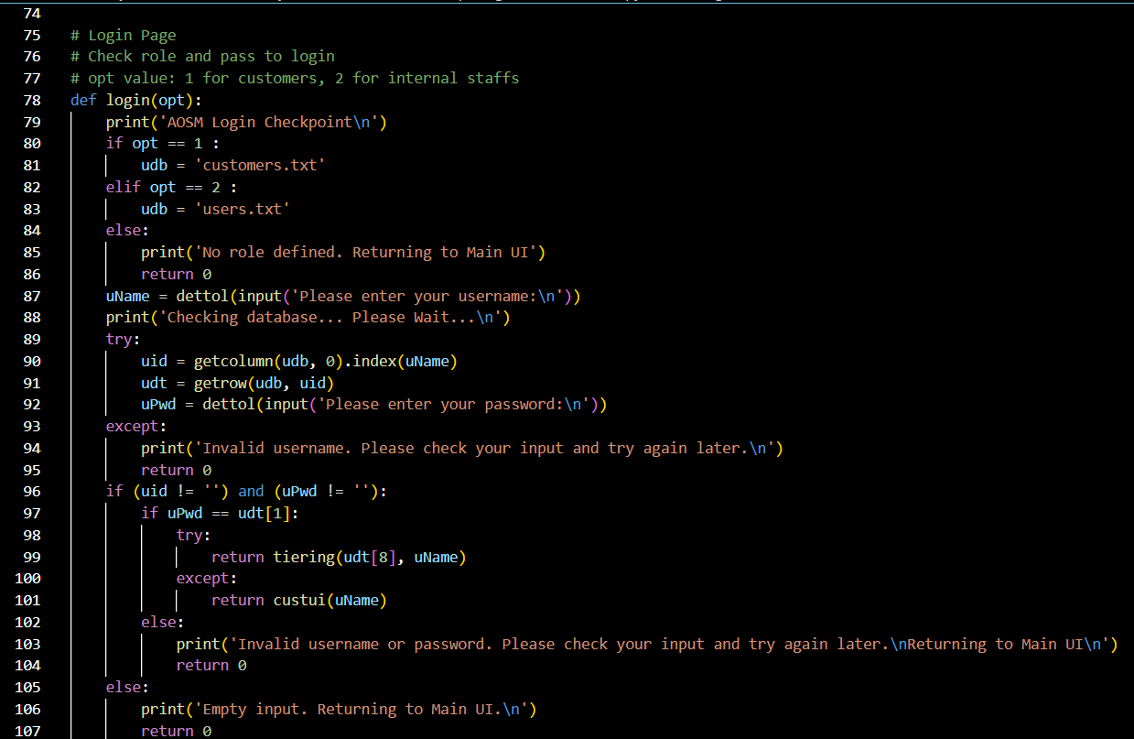  
Figure 6: Log In(opt) Source Code

|  |  |
| --- | --- |
| Variables | Explanation |
| opt | A variable used to store the option that the user has entered; it is defined as an integer, as users are often required to input integers to proceed to another function. |
| udb | A variable set to ‘users.txt’ or ‘customers.txt’, generated from the function itself. |
| uName | A string variable used to store the username of the users, derived from user input. |
| uid | A string variable used to store the user ID of the users, generated from the function itself. |
| udt | A string variable used to store the user details, generated from the function itself. |
| uPwd | A string variable used to store the user password of the users, derived from user input. |

|  |  |
| --- | --- |
| Line(s) | Explanation |
| 75 ~ 77 | Comments: This is the login page. It checks the role of the user and then passes on to the login process. In this function, the options that can be entered are 1 for customers, and 2 for internal staff. |
| 78 | The function login(opt) is defined. |
| 79 | A message informing the user that they are at the login checkpoint for AOSM is printed. |
| 80 ~ 86 | If the variable opt = 1, the variable udb is set to ‘customers.txt’. Else, if the variable opt = 2, the variable udb is set to ‘users.txt’. Else, if the variable opt is any other integer or invalid input, a message will be printed, saying that no role was defined, the user will be returned to Main UI. |
| 87 | A message requesting the user to enter their username is printed. The input will be sanitized by calling the dettol function, and then stored in the uName variable. |
| 88 | A message is printed, informing the user that the system is checking the database for the username, and to please wait. |
| 89 ~ 95 | Data is gotten from udb, column 0 by calling the getcolumn function, and the index value of uName is found in the list. The output from the functions is stored into the variable uid.  Next, data is gotten from udb, row uid, with the getrow function. The output from the function is stored into the variable udt.  Finally, a message is printed requesting the user to input their password. The input will be sanitized by calling the dettol function, and then stored into the uPwd variable.  However, if the username is not found in the database, a message is printed to inform the user that their username is invalid and to check it and try again later. |
| 96 ~ 107 | The function attempts to verify the user’s password if the username exists.  Next, the function tries to retrieve if role data exists for the user.  The tiering function is called, and the role data is passed to the function.  The custui function is called if there is no role data.  Relevant error messages will be thrown out depending on the stages. |

This is the main login function with the login logic implemented. The loginhandler function runs before the login function, and then passes the input from user into the opt argument. When it starts to run, the first action it does is to check for opt perimeter passed from the loginhandler function to determine which database to use.

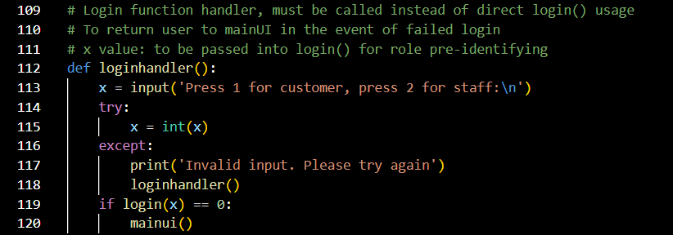  
Figure 7: Login Handler Source Code

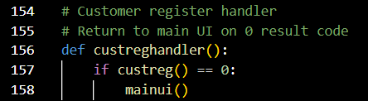  
Figure 8: Cust Reg Handler Source Code

|  |  |
| --- | --- |
| Variables | Explanation |
| x | A variable to store the input from user to be passed into another function. It is defined as an integer. |

|  |  |
| --- | --- |
| Line(s) | Explanation |
| 109 ~ 111 | Comments: This is the login function handler. It must be called instead of the direct login function usage in order to return the user to the Main UI in the event of a failed login. The x value is to be passed into the login function for role pre-identifying. |
| 112 | The function loginhandler is defined. |
| 113 | A message requesting the user to enter 1 or 2 to indicate that whether they wish to log in as a customer or staff member respectively is printed. The input from user is stored in the variable x. |
| 114 ~ 120 | The variable x is defined as an integer.  If there is invalid input, an error message is thrown out.  The mainui function is called if return code is 0. |

It handles return code from the login function. This concept is used in Cust Reg Handler as well. The purpose of custreghandler is to return the user to Main UI if the return code is 0.

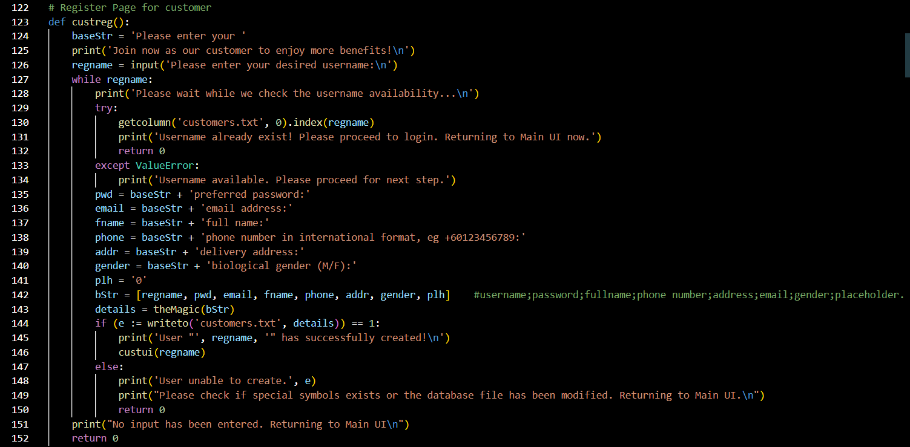  
Figure 9: Cust Reg Source Code

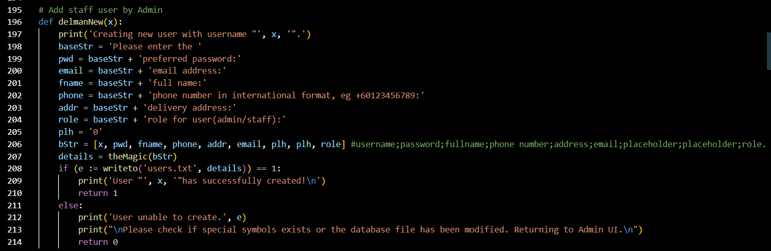  
Figure 10: Del Man New(x) Source Code

|  |  |
| --- | --- |
| Variables | Explanation |
| baseStr | A string variable used to store ‘Please enter the’. |
| regname | A string variable used to store user’s desired username, derived from user input. |
| pwd | baseStr + ‘preferred password:’ |
| email | baseStr + 'email address:' |
| fname | baseStr + 'full name:' |
| addr | baseStr + 'delivery address:' |
| gender | baseStr + 'biological gender (M/F):' |
| plh | '0' |
| bStr | A variable used to store [regname, pwd, email, fname, phone, addr, gender, plh] |
| details | A variable used to store the output from another function. |
| e | A variable standing for the word ‘error’. |

These string variables temporarily store default strings upon creation and will then be replaced by user inputs after being passed to theMagic function.

|  |  |
| --- | --- |
| Line(s) | Explanation |
| 122 | Comments: This is the registration page for customers. |
| 123 | The function custreg is defined. |
| 125 ~ 126 | A message inviting the customer to register as a user to gain more benefits is printed.  A message requesting the user to enter their desired username for registration is printed, the input is stored into variable regname. |
| 128 ~ 134 & 144 ~ 152 | The function first checks the regname variable, by taking the variable and checking towards the customer database.  An error message is printed if user data is found.  If there are no matching usernames, the function will proceed to get customer details using theMagic function and writeTo in order to save customer details.  When the username has successfully been registered, the user will be redirected to customer user interface with their username. This is done by calling the custui function, with the regname variable acting as a variable in the called function.  If an error occurred during writeto function, an error message will be printed, and the function will return 0. |
| 124 &  135 ~ 143 | Refer to variables table. |

It is the main customer register logic function. This concept is used in Del Man New(x) as well. The function delmanNew(x) is called only by delmanSubMenu function to ensure its intended operation, it gather user details using theMagic function and writeTo function to update user database; it is runs on the same logic as the custreg function.

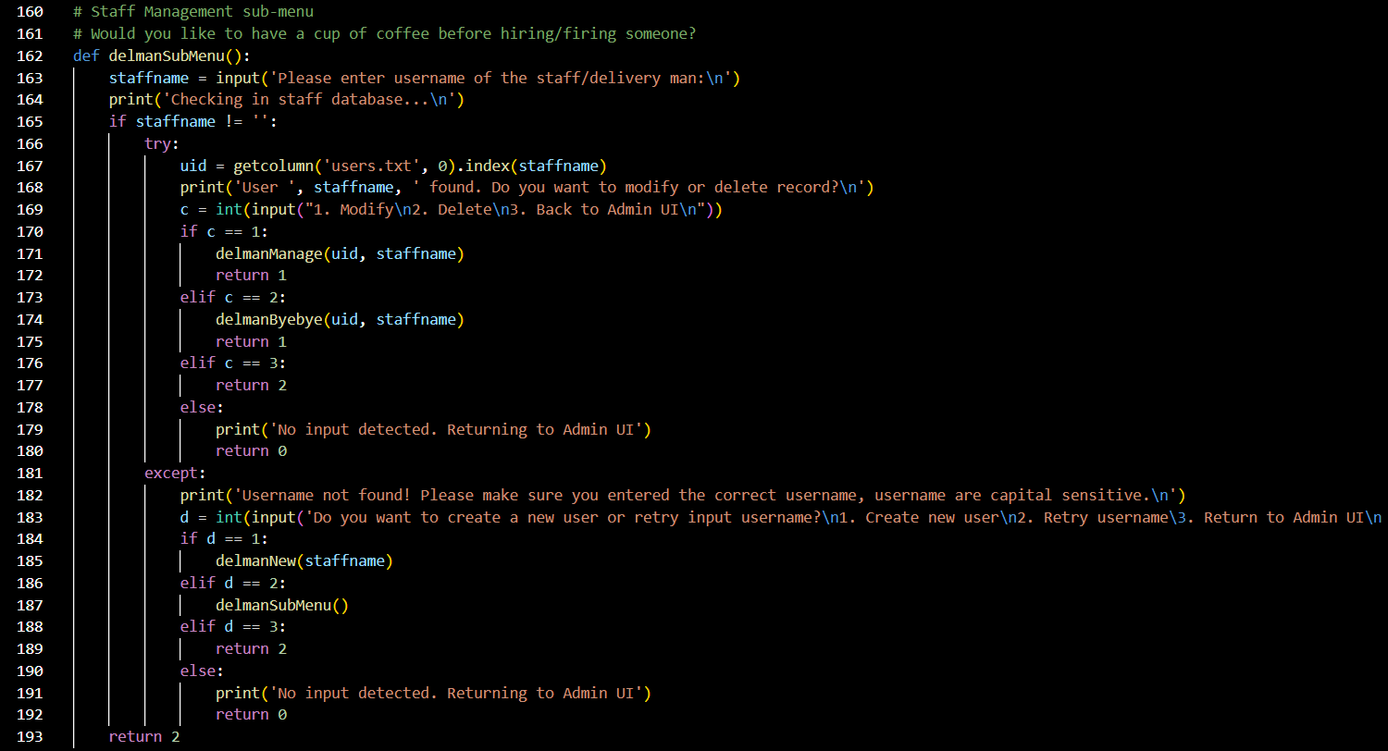  
Figure 11: Del Man Sub Menu Source Code

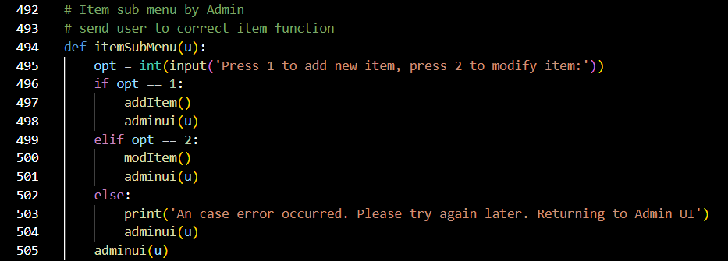  
Figure 12: Item Sub Menu(u) Source Code

|  |  |
| --- | --- |
| Variables | Explanation |
| staffname | A string variable used to store the usernames of staff members/delivery workers, derived from user input. |
| uid | A variable used to store the output from another function. |
| c | A variable used to store the option that the user has entered; it is defined as an integer. |
| d | A variable used to store the option that the user has entered; it is defined as an integer. |

|  |  |
| --- | --- |
| Line(s) | Explanation |
| 160 ~ 161 | Comments: This is the staff management sub-menu. Admin is encouraged to hydrate. |
| 162 | The function delmanSubMenu is defined. |
| 163 ~ 164 | A message requesting the user to enter the username of the staff or delivery man is printed. The input from user is stored into the staffname variable.  A message informing the user that the system is checking staff database is printed. |
| 165 ~ 193 | Data is gotten from users.txt, column 0 by calling the getcolumn function, and the index value of staffname is found in the list. The output from the functions is stored into the variable uid.  A message is printed informing the user that the staffname variable has been found and asks whether the user wishes to modify or delete the record.  A message is printed requesting the user to enter 1 to modify the user profile, 2 to delete the user profile, and 3 to return back to Admin UI. The input from user is stored into c variable.  If c = 1, the delmanManage function is called; else if c = 2, the delmanByebye function is called, with the variables uid and staffname acting as variables in either called function.  Else if c = 3, and the staffname input is empty, the function will return 2, an exit route from this function. Else a message will be printed to inform the user that no input has been detected, and the user will be returned to Admin UI.  In the event of incorrect input, a message is printed informing the user that they have entered an incorrect username and to recheck their input.  A message is printed informing the operator that they are given chances to retry with correct username or create a new user profile if intended and requests the operator to enter 1 to create a new user, 2 to retry username, and 3 to return to Admin UI. The input is stored into d variable.  If d = 1, the delmanNew function is called, with the variable staffname acting as a variable in the called function; else if d = 2, the user is returned to the page to enter the username within the function.  Else if d = 3 or there is no input, actions for c in same conditions are repeated. |

The function is managing other users' profile directly, including admin role users. Therefore, as it has a high level of importance, it requires the operator to remember and enter the full username of the managed user in order to perform the modifying and deleting tasks.

This concept is used in Item Sub Menu(u) as well. It is only called by Admin. The purpose of itemSubMenu(u) is to redirect administrator users to their respective functions and returns them back to Admin UI with their username still intact, regardless of task status.

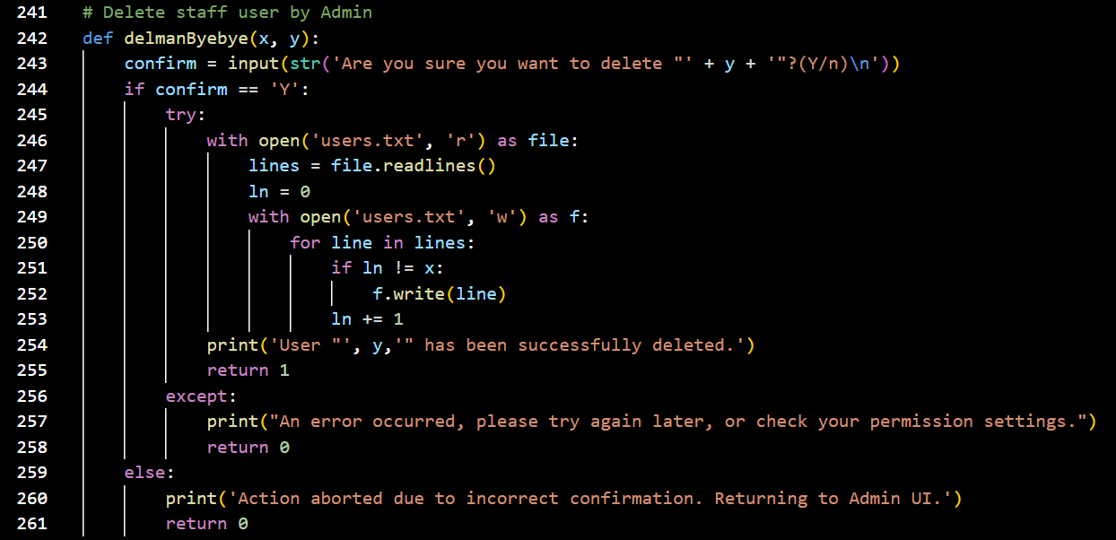  
Figure 13: Del Man Bye Bye(x, y) Source Code

|  |  |
| --- | --- |
| Variables | Explanation |
| x | A variable used to store output from another function; the user IDs of staff members/delivery man to be deleted. |
| y | A variable used to store output from another function; the usernames of staff members/delivery man to be deleted. |
| confirm | A string variable used to store ‘Y’ or ‘n’, derived from user input. |
| file | A variable that is set to ‘users.txt’, generated from the function itself. |
| lines | A variable that stores ‘users.txt’ in reading mode. |
| ln | A variable that represents the line count. |
| f | A variable that is short for ‘file’. |

|  |  |
| --- | --- |
| Line(s) | Explanation |
| 241 | Comments: This allows administrators to delete staff users. |
| 242 | The function delmanByebye(x, y) is defined. |
| 243 | A message asking the user if they are sure that they wish to delete the entry of y variable, and to enter Y/n to confirm is printed. The input is stored into confirm variable. |
| 244 ~ 261 | The function reads the user database and writes back all the existing rows except the row with the "deleted user".  It first opens the ‘users.txt’ in reading mode, forming a path to the database. The file is read by calling the function readlines and stored into variable lines.  The line count = 0.  Next, it opens ‘users.txt’ in writing mode, allowing the file to be overwritten.  For every single line in the lines variable, as long as ln not equal to x, it is written back into the file by calling f.write(line) function, meaning line is written into f. Line count increases by 1 with every new line written back in. |

This function is called only by delmanSubMenu to ensure its intended operation and is the only user-called function that can directly write changes to file.

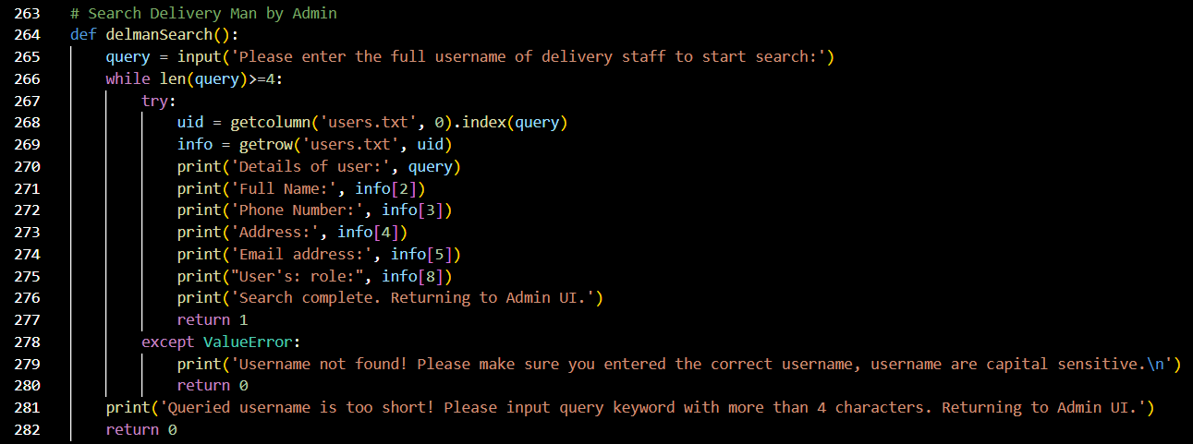  
Figure 14: Del Man Search Source Code

|  |  |
| --- | --- |
| Variables | Explanation |
| query | A string variable used to store input from user, the full usernames of delivery staff. |
| uid | A variable used to store output from another function. |
| info | A variable used to store output from another function. |

|  |  |
| --- | --- |
| Line(s) | Explanation |
| 263 | Comments: This allows administrators to search for delivery staff users. |
| 264 | The function delmanSearch is defined. |
| 265 | A message requested the user to enter the full username of the delivery staff in order to start search is printed. The input is stored into query variable. |
| 266 ~ 282 | Data is gotten from users.txt, column 0 by calling the getcolumn function, and the index value of query is found in the list. The output from the functions is stored into the variable uid.  Next, data is gotten from users.txt, row uid, with the getrow function. The output from the function is stored into the variable info.  Messages displaying the retrieved data, including the query variable and parts of the info variable are printed.  A message informing the user that the search has completed and that the user will be returned to Admin UI is printed.  In the event of a value error during the getcolumn or getrow process, or an error of invalid query input, appropriate error messages are thrown out, and the function returns 0. |

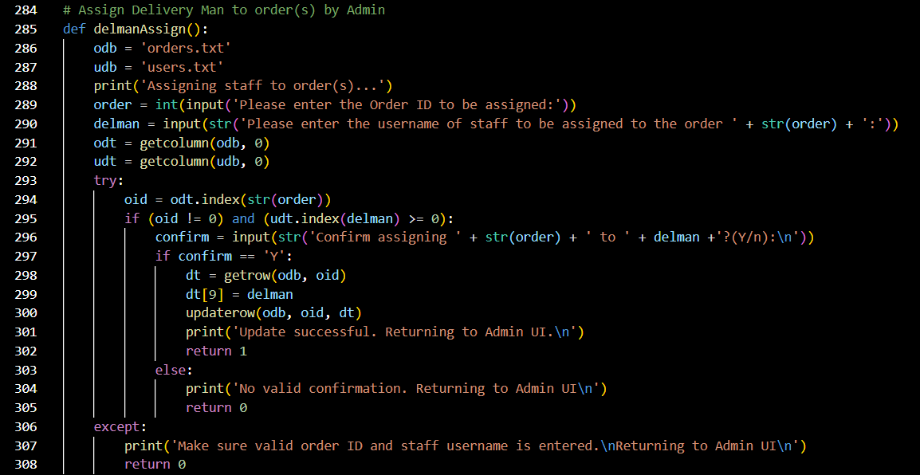  
Figure 15: Del Man Assign Source Code

|  |  |
| --- | --- |
| Variables | Explanation |
| odb | A variable set to ‘orders.txt’, generated from the function itself. |
| udb | A variable set to ‘users.txt’, generated from the function itself. |
| order | A variable used to store the order IDs of staff members, derived from user input. It is defined as an integer. |
| delman | A string variable used to store the usernames of staff, derived from user input. |
| odt | A variable used to store output from another function. |
| udt | A variable used to store output from another function. |
| oid | A variable used to store output from another function. |
| confirm | A string variable used to store ‘Y’ or ‘n’, derived from user input. |
| dt | A variable used to store output from another function. |

|  |  |
| --- | --- |
| Line(s) | Explanation |
| 284 | Comments: This allows administrators to assign delivery workers to order IDs. |
| 285 | The function delmanAssign is defined. |
| 286 ~ 287 | Refer to variables table. |
| 288 | A message informing the user that the system is assigning staff to order(s) is printed. |
| 289 ~ 290 | A message requesting the user to input the order ID to be assigned is printed. The input is stored into the order variable.  A message requesting the user to input the staff username to be assigned to the order is printed. The input is stored into the delman variable. |
| 291 ~ 292 | Data is gotten by calling the getcolumn function twice, with variable odb, column 0 and variable udb, column 0 acting as variables in the first and second called function respectively.  The system checks against database and see if both the order ID and staff username exists. |
| 293 ~ 308 | The system checks the index value of the order ID in the order list. The variable oid stores the output from the called function.  If both the order ID and staff username exist, then a message asking for confirmation is printed, before proceeding with the change.  The function getrow is called, with variable odb and variable oid acting as variables in the called function. The output is stored into variable dt.  Amendments are done by calling the function updaterow, with variable odb, variable oid, and variable dt acting as variables in the called function.  Amendments will be changed only if confirm = 'Y', else the function will cancel operations, throwing out appropriate error messages, and will return 0. |

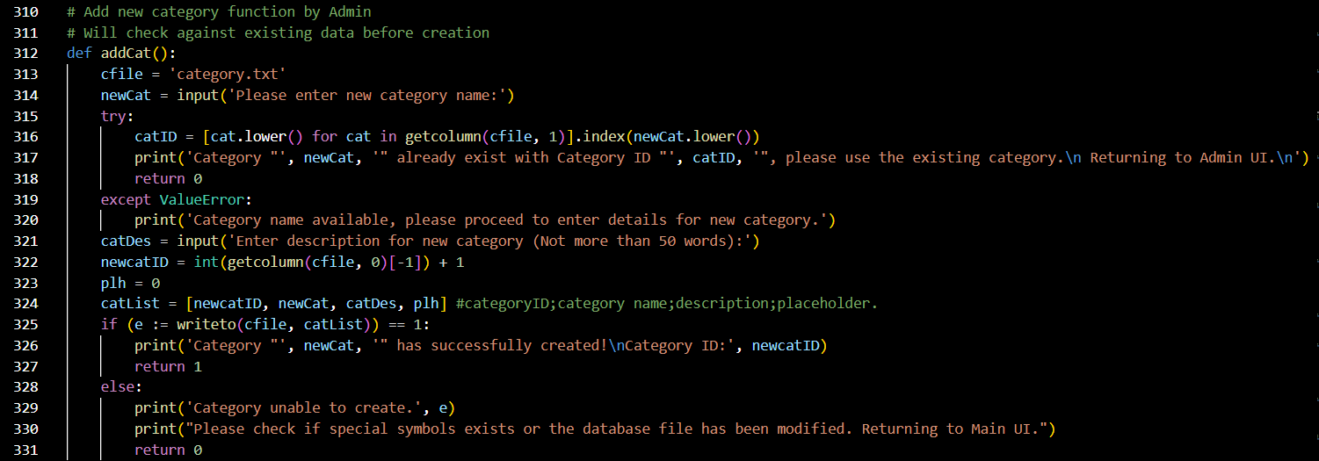  
Figure 16: Add Cat Source Code

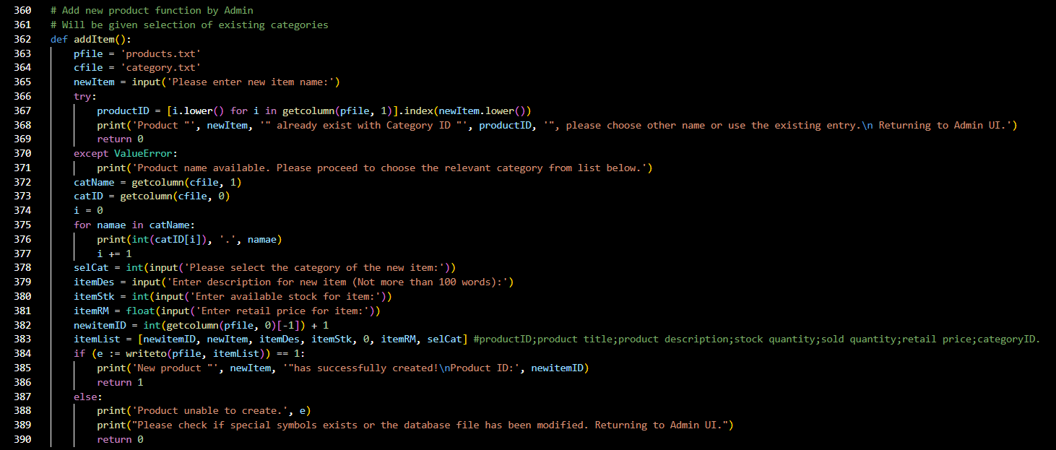  
Figure 17: Add Item Source Code

|  |  |
| --- | --- |
| Variables | Explanation |
| pfile | A variable set to ‘products.txt’, generated from the function itself. |
| cfile | A variable set to ‘category.txt’, generated from the function itself. |
| newItem | A variable used to store item names, derived from user input. |
| productID | A variable used to store output from another function. |
| catName | A variable used to store category names derived from output from another function. |
| catID | A variable used to store category IDs, derived from output from another function. |
| i | A variable used to store index value, derived from output from another function. |
| selCat | A variable used to store item categories, derived from user input. It is defined as an integer. |
| itemDes | A string variable used to store item descriptions, derived from user input. |
| itemStk | A variable used to store item stock quantities, derived from user input. It is defined as integer. |
| itemRM | A variable used to store item price, derived from user input. It is defined as float. |
| newitemID | A variable used to store output from another function. It is defined as an integer. |
| itemList | A variable is used to store [newitemID, newItem, itemDes, itemStk, 0, itemRM, selCat] |
| e | A variable standing for the word ‘error’. |

|  |  |
| --- | --- |
| Line(s) | Explanation |
| 360 ~ 361 | Comments: This allows administrators to add new product functions. The user will be given selection of existing categories. |
| 362 | The function addItem is defined. |
| 363 ~ 364 | Refer to variables table. |
| 365 | A message requesting the user to input item name is printed. The input is stored into newItem. |
| 366 ~ 377 | The system performs a check on the item name from user input, by calling the function getcolumn and searching for the index value. The output is stored into product ID.  If item name exists, a message displaying the existing item ID is printed.  If not, category data is gotten from ‘category.txt’ by calling the getcolumn function. A message displaying brief details of the available categories is printed. |
| 378 ~ 383 | After the user has selected the category ID, a message requesting the user to input more product details to be stored into various variables is printed, and the input is compiled into a list, refer to variable table. |
| 384 ~ 390 | The input from user is passed to writeTo function in order to write item data into ‘products.txt’.  A message displaying the new Item ID is printed.  The function will throw out an error message and return 0 if the task failed to complete. |

This concept is used in Add Cat as well. The addCat function will start by getting the category name from the user, then checking against the database if the new category name exists. If the category name is found to exist, a message displaying the existing category’s ID is printed out. If it is not found to exist, the function will proceed to get the category description from the user and generates a new category ID, then calls the writeTo function to update ‘category.txt’. A message displaying the new category ID is printed out. The function will return 0 if creation process failed.

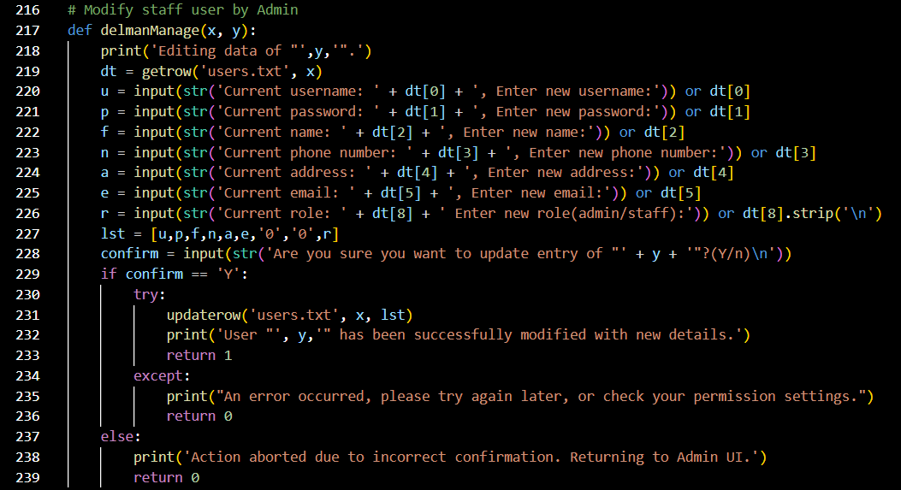  
Figure 18: Del Man Manage(x, y) Source Code

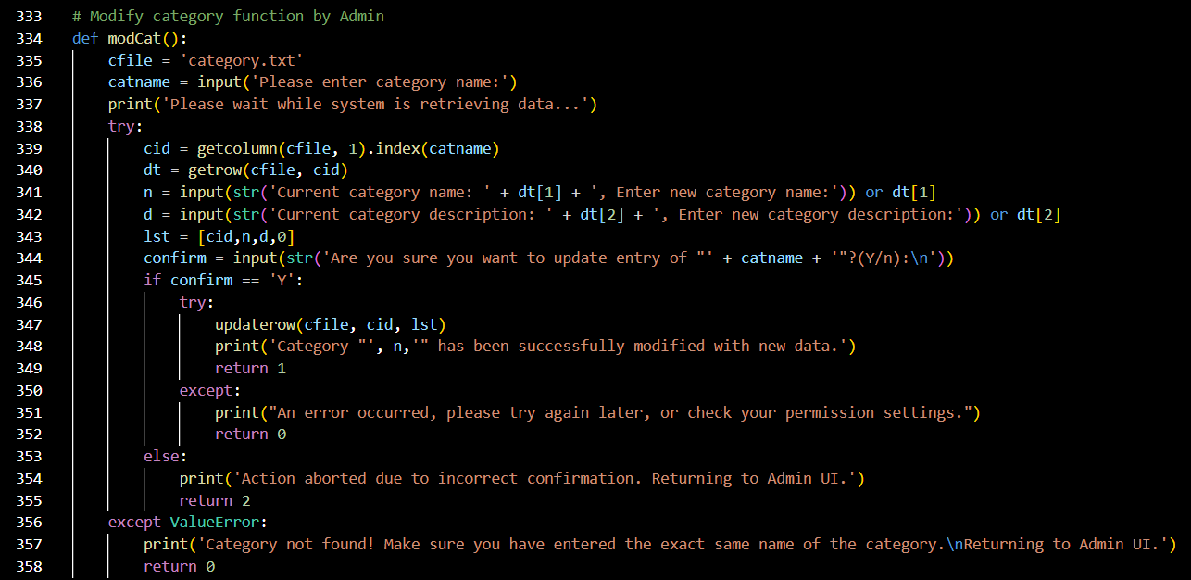  
Figure 19: Mod Cat Source Code

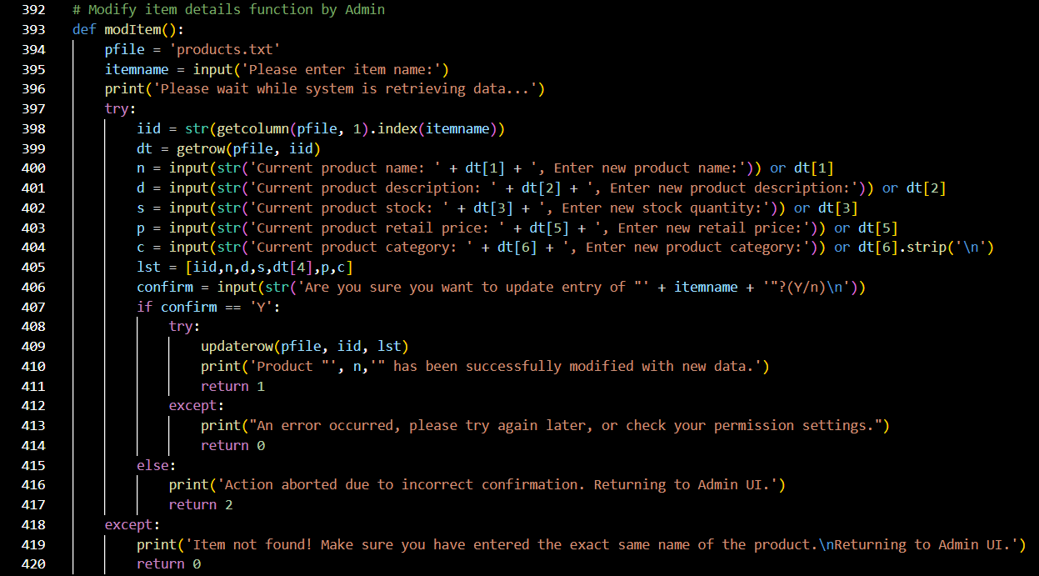  
Figure 20: Mod Item Source Code

|  |  |
| --- | --- |
| Variables | Explanation |
| pfile | A variable set to ‘products.txt’, generated from the function itself. |
| itemname | A variable used to store item names, derived from user input. |
| iid | A variable used to store output from another function. |
| dt | A variable used to store output from another function. |
| n | A string variable used to store ‘Current product name: ’ + dt[1] + ‘, Enter new product name:’, derived from user input. |
| d | A string variable used to store ‘Current product description: ’ + dt[2] + ‘, Enter new product description:’, derived from user input. |
| s | A string variable used to store ‘Current product stock: ’ + dt[3] + ‘, Enter new stock quantity:’, derived from user input. |
| p | A string variable used to store ‘Current product retail price: ’ + dt[5] + ‘, Enter new retail price:’, derived from user input. |
| c | A string variable used to store ‘Current product category: ’ + dt[6] + ‘, Enter new product category:’, derived from user input. |
| lst | A variable used to store [iid, n, d, s, dt[4], p, c] |
| confirm | A string variable used to store ‘Y’ or ‘n’, derived from user input. |

|  |  |
| --- | --- |
| Line(s) | Explanation |
| 392 | Comments: This allows the administrators to modify item details. |
| 393 | The function modItem is defined. |
| 394 | Refer to variables table. |
| 395 | A message requesting the user to input the item name is printed. The input is stored into the itemname variable. |
| 396 | A message informing the user to wait while the system retrieves data is printed. |
| 397 ~ 399 | The system tries to check against the product database.  The getcolumn function is called, with variable pfile, column 1 acting as variables in the called function, and the index value for the item is gotten. The output from the called functions is stored into variable iid.  The getrow function is called, with variable pfile and variable iid acting as variables in the called function. The output from the called function is stored into variable dt. |
| 400 ~ 405 | If the system is successful in retrieving data, it gets new data from user input. Messages are printed, and the inputs are stored into variables n, d, s, and p, and then compiled into lst variable; refer to variables table. |
| 406 | A message asking the user for confirmation 'Y' is printed. |
| 407 ~ 420 | If confirmation ‘Y’ is received, the function updaterow is called to update product data in the database, with the variables pfile, iid, and lst acting as variables in the called function.  A message informing the user that the modification process has been successful will be printed if there are no errors.  In the event of errors occurring at different processes, appropriate error messages will be printed for each error case, and the function will return code 0 or 2. |

This concept is used in Del Man Manage(x, y) and Mod Cat as well.

The function delmanManage(x, y) is called only by delmanSubMenu() to ensure its intended operation. It gets new user details directly in the function, stores and compiles the input into variables, and then calls the updaterow function to update the user's details in database.

The function modCat() gets the category name from user input. It tries to check against category database and gets the index number for the category. If the category is successfully found, it gets new data from user input and asks for confirmation 'Y'. If confirmation ‘Y’ is received, the function updaterow will be called to update category data in the database. Appropriate error messages will be printed on each error case.

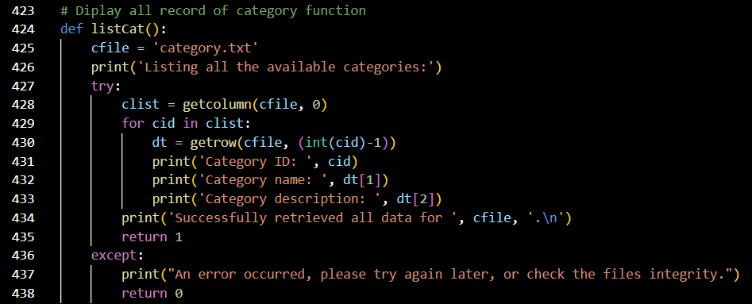  
Figure 21: List Cat Source Code

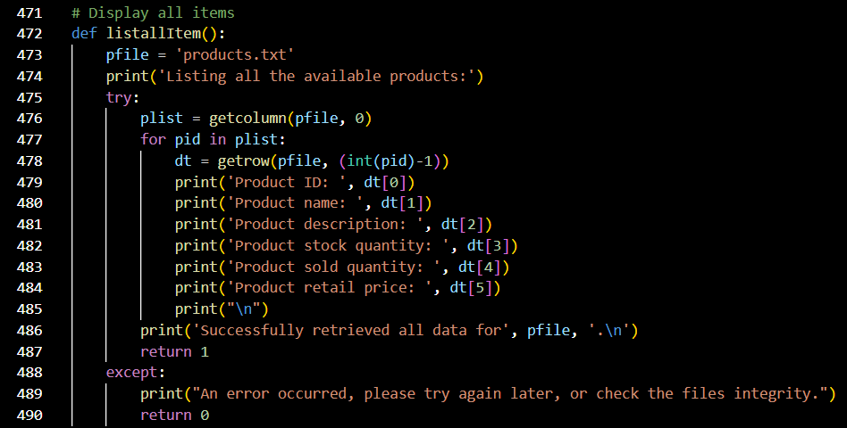  
Figure 22: List All Item Source Code

|  |  |
| --- | --- |
| Variables | Explanation |
| cfile | A variable set to ‘category.txt’, generated from the function itself. |
| clist | A variable used to store output from another function. |
| cid | A variable that stores category IDs and is defined as an integer. |
| dt | A variable used to store output from another function. |

|  |  |
| --- | --- |
| Line(s) | Explanation |
| 423 | Comments: This function displays all the records of categories. |
| 424 | The function listCat() is defined. |
| 425 | Refer to variables table. |
| 426 | A message informing the user that the system is listing all available categories is printed. |
| 427 ~ 438 | Data of all the available category IDs in category database is gotten from cfile, column 0 by calling the getcolumn function. The output from the function is stored into the variable clist.  Each category data is gotten from cfile, row (cid - 1) by calling the getrow function.  Messages displaying the category details gotten are printed, followed by a message informing the user that the retrieval process has been successful.  If an error occurred in any part of the process, an appropriate error message is thrown out and the function returns code 0. |

This concept is used by List All Item as well. The purpose of listallItem() is to get all available product IDs from product database, then get each product data and print them out by calling the getrow function with product ID.

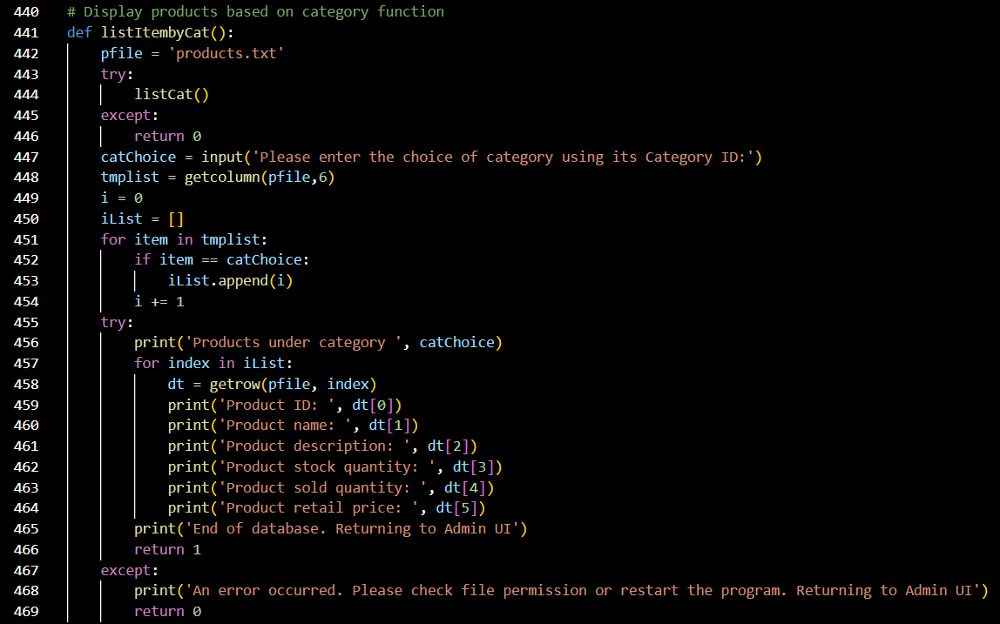  
Figure 23: List Item by Cat Source Code

|  |  |
| --- | --- |
| Variables | Explanation |
| pfile | A variable set to ‘products.txt’, generated from the function itself. |
| catChoice | A variable used to store category IDs, derived from user input. |
| tmplist | A variable used to store output from another function. |
| i | A variable used to store product IDs; and is short for index value. |
| iList | A variable used to compile product IDs; index values and acts as an index list. |
| dt | A variable used to store output from another function. |

|  |  |
| --- | --- |
| Line(s) | Explanation |
| 440 | Comments: This function displays all the products based on category. |
| 441 | The function listItembyCat() is defined. |
| 442 | Refer to variables table. |
| 443 ~ 454 | First, the function tries to call the function listCat. If unable to call, the function will return code 0.  If successful, the function will proceed to get input of category ID. A message requesting the user to enter a category ID will be printed. The input will be stored into variable catChoice.  The function will then get product's category info by calling the function getcolumn, with variable pfile, column 6 acting as variables in the called function.  The data will be iterated through.  Then, the function will append ID(i) into iList if the product category matches with variable catChoice. Refer to variables table. |
| 455 ~ 469 | Messages displaying all matched products will be printed out, by calling the getrow function, with variable pfile and variable index (product ID) acting as variables in the called function. A message informing the user that the end of the database has been shown and that the user will be returned to Admin UI is printed.  If an error occurred during the process, an appropriate error message is printed out and the function will return code 0. |

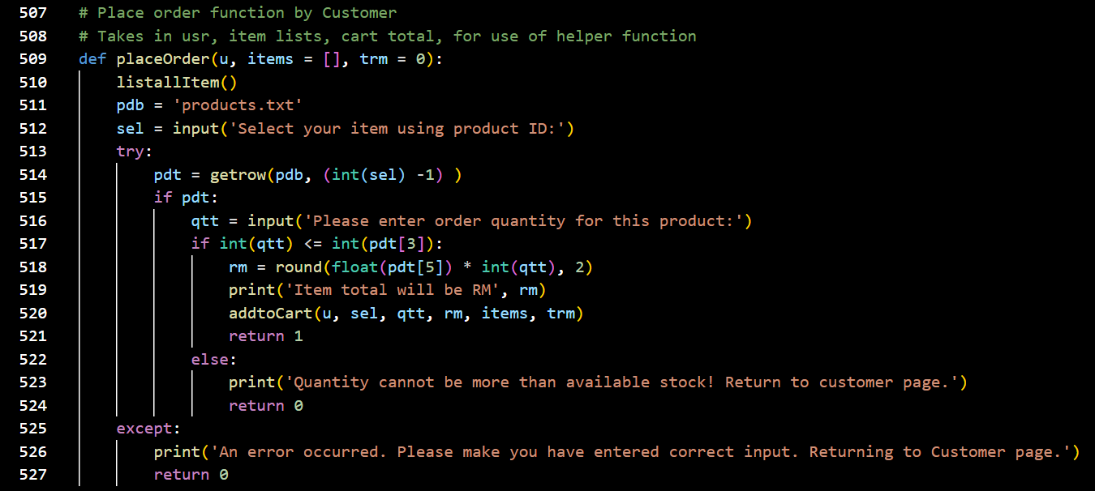  
Figure 24: Place Order(u, items = [], trm = 0) Source Code

|  |  |
| --- | --- |
| Variables | Explanation |
| u, items, trm | Refer to main explanation table below. |
| pdb | A variable set to ‘products.txt’, generated from the function itself. |
| sel | A variable used to store selected product IDs, derived from user input. |
| pdt | A variable used to store output from another function. |
| qtt | A variable used to store the order quantity for products, derived from user input. |

|  |  |
| --- | --- |
| Line(s) | Explanation |
| 507 ~ 508 | Comments: This function allows customers to place orders. It takes the username, as the usr variable, and the cart total, shown by the variable items (a list of products) and the variable trm (the total price of products in the cart). |
| 509 | The function placeOrder() is defined. |
| 510 | The function listallItem() is called. |
| 511 | Refer to variables table. |
| 512 | A message requesting the user to input a product ID to select their item of choice is printed. The input is stored into the variable sel. |
| 513 ~ 527 | The function tries to check against product database, from pdb, row (sel – 1), by calling the function getrow. The output is stored into variable pdt.  If the product exists in the database, a message requesting the user to input their order quantity is printed. The input is stored into variable qtt.  Next the function gets the product price, then carries out multiplication of the product price by the quantity ordered.  A message informing the user of the total of their cart is printed.  The function will pass the inputs of username, product ID, quantity, item subtotal and other arguments to the function addtoCart.  If any errors occurred throughout the process, appropriate error messages are printed, and the function will return code 0. |

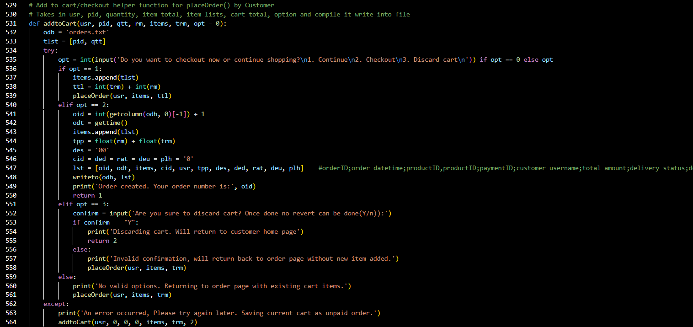  
Figure 25: Add to Cart(usr, pid, qtt, rm, items, trm, opt = 0) Source Code

|  |  |
| --- | --- |
| Variables | Explanation |
| usr, pid, qtt, rm, items, trm | Refer to main explanation table below. |
| odb | A variable set to ‘orders.txt’, generated from the function itself. |
| tlst | A variable used to store [pid, qtt] |
| opt | A variable used to store the option that the user has entered; it is defined as an integer, as users are often required to input integers to proceed to another function. |
| ttl | A variable used to store [trm + rm] |
| oid | A variable used to store the output from another function. |
| odt | A variable used to store the output from another function. |
| tpp | A variable used to store [rm + trm] |
| des | ‘00’ |
| cid | A variable that is equal to ded = rat = deu = plh |
| lst | A variable that stores [oid, odt, items, cid, usr, tpp, des, ded, rat, deu, plh] |
| confirm | A string variable used to store ‘Y’ or ‘n’, derived from user input. |

|  |  |
| --- | --- |
| Line(s) | Explanation |
| 529 ~ 530 | Comments: This is the add to cart or checkout helper function for customers. It takes the username as the variable usr, product ID as the variable pid, quantity as the variable qtt, item total as the variable rm, item list as the variable items, cart total as the variable trm, and the user option. The function compiles and writes the arguments into the file. |
| 531 | The function addtoCart(usr, pid, qtt, rm, items, trm, opt = 0) is defined. |
| 532 | Refer to variables table. |
| 533 | The function compiles product ID and quantity into variable tlst. |
| 534 ~ 539 | A message asking the user to input 1 to continue shopping, 2 to checkout or 3 to discard cart is printed. The input will be stored in variable opt.  If opt = 1, meaning continue shopping, the function will append tlst into items list and add up total cart amount.  The function will then pass back and call to placeOrder() for next selection. |
| 540 ~ 546 | If opt = 2, meaning checkout, the function will compile all necessary data into lst variable. Refer to variables table. |
| 547 | Comments: The data compiled in the lst variable are: - the order ID as the variable oid - the order date and time as the variable odt - all the product IDs as the variable items - the customer username as the variable usr - the total amount as the variable tpp - the delivery status as the variable ded - the feedback as the variable rat (short for rate) - delivery man username as the variable deu - placeholder as the variable plh |
| 548 ~ 550 | Continuing from if opt = 2, the function will call to writeTo to save the customer order into order database, with variables odb and lst acting as variables in the called function.  A message informing the user that their order has been created and providing them with their order number is printed. |
| 551 ~ 564 | Else if, opt = 3, a message asking for confirmation 'Y' to discard cart will be printed. The input will be stored into variable confirm.  If confirm = ‘Y’ is received, the user will be returned to customer home page, and the function will return code 2.  Invalid options or choices will return the customer to placeOrder to continue shopping, and any error occurred the function will save current cart into order database as default. Appropriate error messages will be printed informing the user what went wrong and what actions will be carried out throughout the process. |

The placeOrder() helper function helps to process selected items before passing to this function.

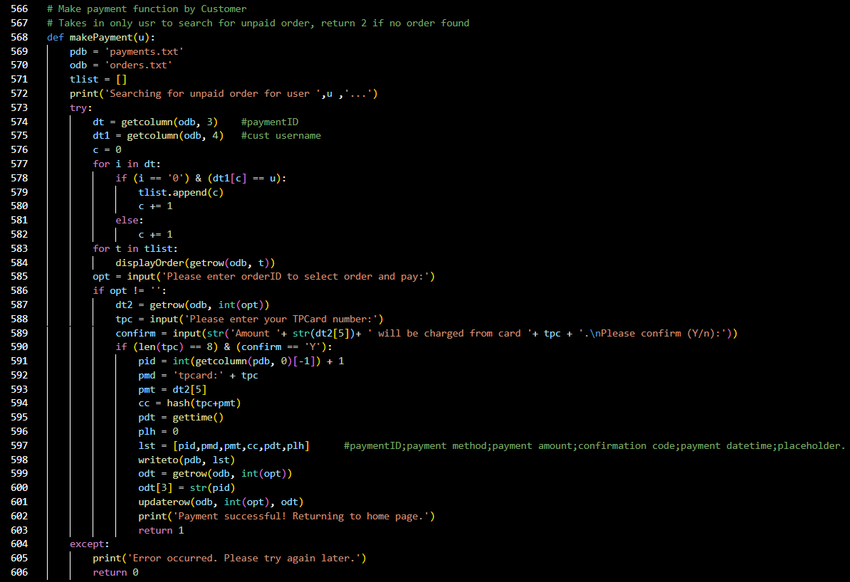  
Figure 26: Make Payment(u) Source Code

|  |  |
| --- | --- |
| Variables | Explanation |
| u | Refer to main explanation table below. |
| pdb | A variable set to ‘payments.txt’, generated from the function itself. |
| odb | A variable set to ‘orders.txt’, generated from the function itself. |
| tlist | A variable used to compile order IDs in a list, generated from the function itself. |
| dt | A variable used to store the output from another function. |
| dt1 | A variable used to store the output from another function. |
| c | A variable used to store customer username, generated from the function itself. |
| i | A variable used to store index value. |
| t | A variable used to store order ID, generated from the function itself. |
| opt | A variable used to store the option that the user has entered; it is defined as an integer, as users are often required to input integers to proceed to another function. |
| dt2 | A variable used to store the output from another function. |
| tpc | A variable used to store TP card numbers, derived from user input. |
| confirm | A string variable used to store ‘Y’ or ‘n’, derived from user input. |
| pid, pmd, pmt, cc, pdt, plh | Refer to main explanation table. |
| lst | A variable used to store [pid, pmd, pmt, cc, pdt, plh] |
| odt | A variable used to store the output from another function. |

|  |  |
| --- | --- |
| Line(s) | Explanation |
| 566 ~ 567 | Comments: This function allows customer to make payments. It takes in the customer username as the variable u, to search for the unpaid order, and it returns 2 if no order is found. |
| 568 | The function makePayment(u) is defined. |
| 569 ~ 570 | Refer to variables table. |
| 571 | Refer to variables table. |
| 572 | A message informing the user that the system is searching for their unpaid order associated with their current username is printed. |
| 573 ~ 589 | The function gets 2 columns of data from order database, which are stored in variables dt and dt1 respectively. The data is gotten from odb, column 3 (payment ID) and column 4 (Cust username), by calling the function getcolumn.  Data of the order IDs is displayed by calling the getrow function and calling the displayOrder function.  A message requesting the user to input their order ID to select their order and pay is printed. The input is stored into opt.  After receiving order ID input from user, the function getrow is called with variable odb and opt acting as variables in the called function. The output is stored into variable dt2.  A message requesting the user to input their TP card number is printed. The input is stored in variable tpc.  A message is printed, confirming with the user their card details and amount to be paid, and requesting the user for confirmation ‘Y’.  If confirmation ‘Y’ is received, compile payment data into lst, refer to variable table. |
| 591 ~ 597 | Comments: The data compiled in the lst variable are: - the payment ID as the variable pid  - the payment method as the variable pmd, ‘TPCard’ + variable tpc  - the payment amount as the variable pmt, dt2[5] - the confirmation code as the variable cc, obtained by calling the function hash, with variable tpc and pmt acting as variables in the called function - the payment date and time as the variable pdt, obtained by calling the function gettime - placeholder as the variable plh = 0 |
| 598 ~ 603 | The function will call to the function writeTo for writing data to payment database, with variables pdb and lst acting as variables in the called function.  The function getrow is called, with variables odb and opt acting as variables in the called function. The output is stored in the variable odt.  The function updaterow is called, with variables odb, opt, and odt acting as variables in the called function. |
| 604 ~ 606 | In the event of an error occurring, an appropriate error message will be printed and the function will return code 0. |

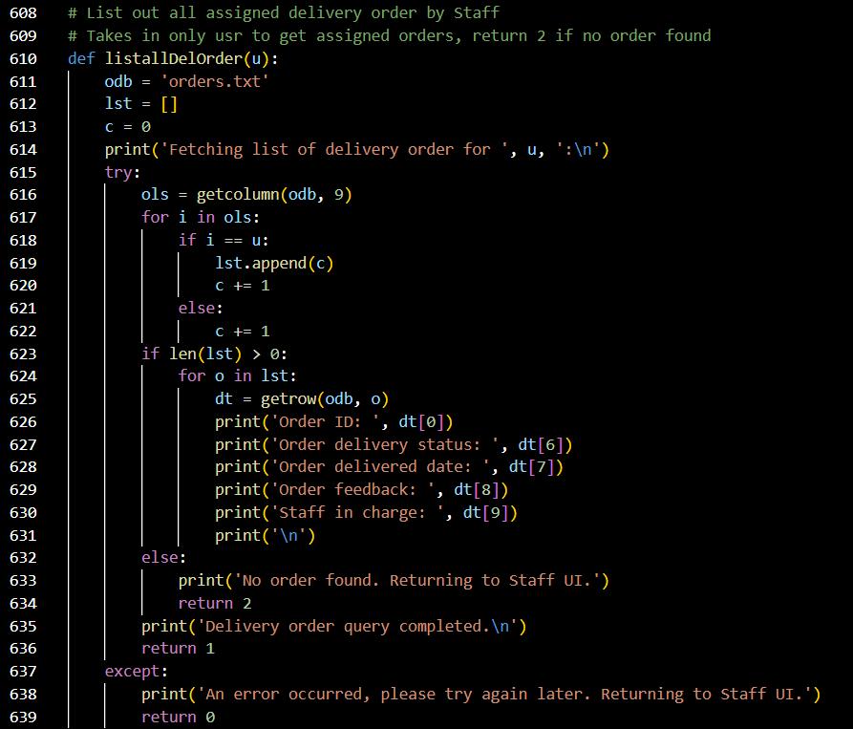  
Figure 27: List All Del Order(u) Source Code

|  |  |
| --- | --- |
| Variables | Explanation |
| u | Refer to main explanation table below. |
| odb | A variable set to ‘orders.txt’, generated from the function itself. |
| lst | [] |
| c | 0 |
| ols | A variable used to store the output from another function. |
| dt | A variable used to store the output from another function. |

|  |  |
| --- | --- |
| Line(s) | Explanation |
| 608 ~ 609 | Comments: This function lists out all delivery orders by Staff. It takes in only the username as the variable u, to get assigned orders, return 2 if no order is found. |
| 610 | The function listallDelOrder(u) is defined. |
| 611 ~ 613 | Refer to variables table. |
| 614 | A message informing the user that the system is fetching list of the delivery orders is printed. |
| 615 ~ 639 | Data is gotten from the assigned column of all orders from odb, column 9, by calling the getcolumn function, and the output is stored into variable ols.  The function matches the assigned to name against the current staff name to see if it is the same or not.  If it is the same, the function appends the order ID into lst variable, then checks if the lst has anything to do.  If lst is not empty, the function iterates all the order IDs and gets the order details to be printed out from odb, row o, by calling the getrow function.  In the event of errors throughout the process, appropriate error messages will be printed, explaining each error case, and returning the user to Staff UI. |

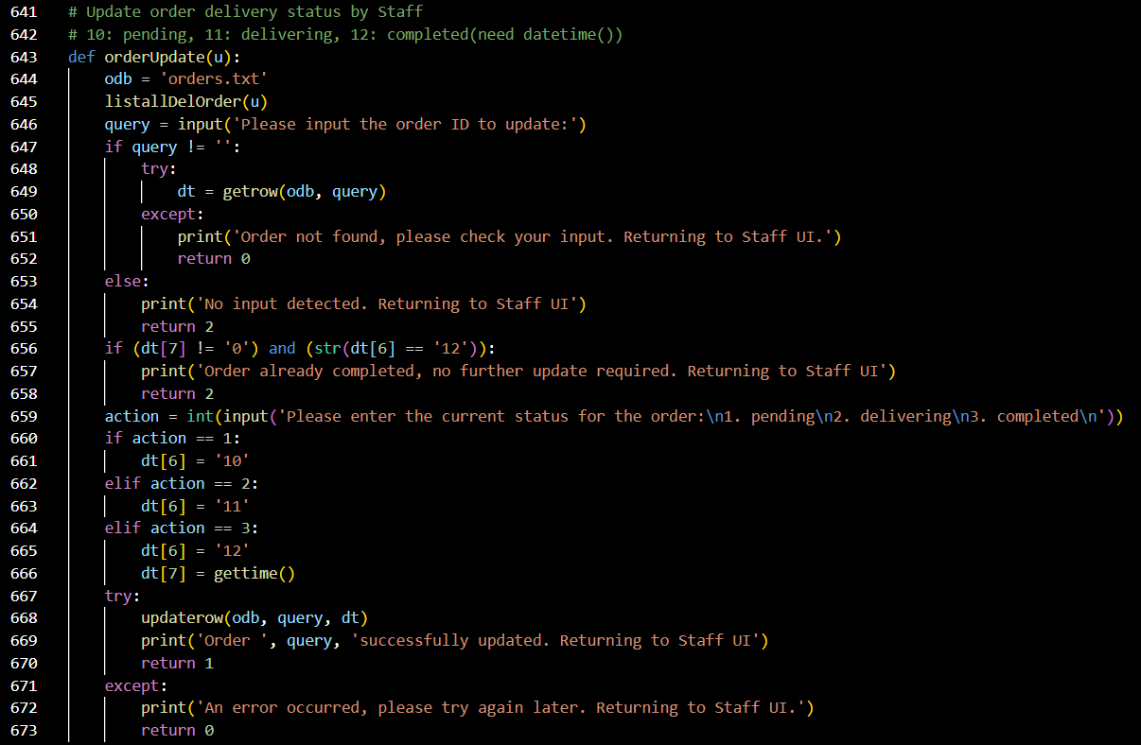  
Figure 28: Order Update(u) Source Code

|  |  |
| --- | --- |
| Variables | Explanation |
| u | A variable used to store staff member usernames. |
| odb | A variable set to ‘orders.txt’, generated from the function itself. |
| query | A variable that stores order IDs, derived from user input. |
| dt | A variable used to store the output from another function. |
| action | A variable used to store the current delivery status of orders, derived from user input. |

|  |  |
| --- | --- |
| Line(s) | Explanation |
| 641 ~ 642 | Comments: This function allows staff members to update the order delivery status. The function will return code 10 to indicate pending, 11 to indicate delivering, and 12 to need completed, need datetime. |
| 643 | The function orderUpdate(u) is defined. |
| 644 | Refer to variables table. |
| 645 | The function listallDelOrder(u) is called. |
| 646 | A message requesting the user to input the order ID is printed. The input is stored into the variable query. |
| 647 ~ 673 | The function checks the order ID entered against order database by calling the function getrow, with variables odb and query acting as variables in the called function. The output is stored into variable dt.  If the input is not empty, the function will return code 0 if order is not found.  If the order exists in the database, and data in each column matches conditions, a message requesting user to enter the current status of the order, 1 for pending, 2 for delivering, and 3 for completed, will be printed.  The function will then update order data accordingly by calling the function updaterow, with variables odb, query, and dt acting as variables in the called function. A message is printed informing the user of the successful update and the user will be returned to Staff UI.  Else, a message informing the user that the order was already completed is printed, and the function will return code 2.  In the event of exceptions or errors occurring, appropriate error messages are printed, and the function will return code 0. |

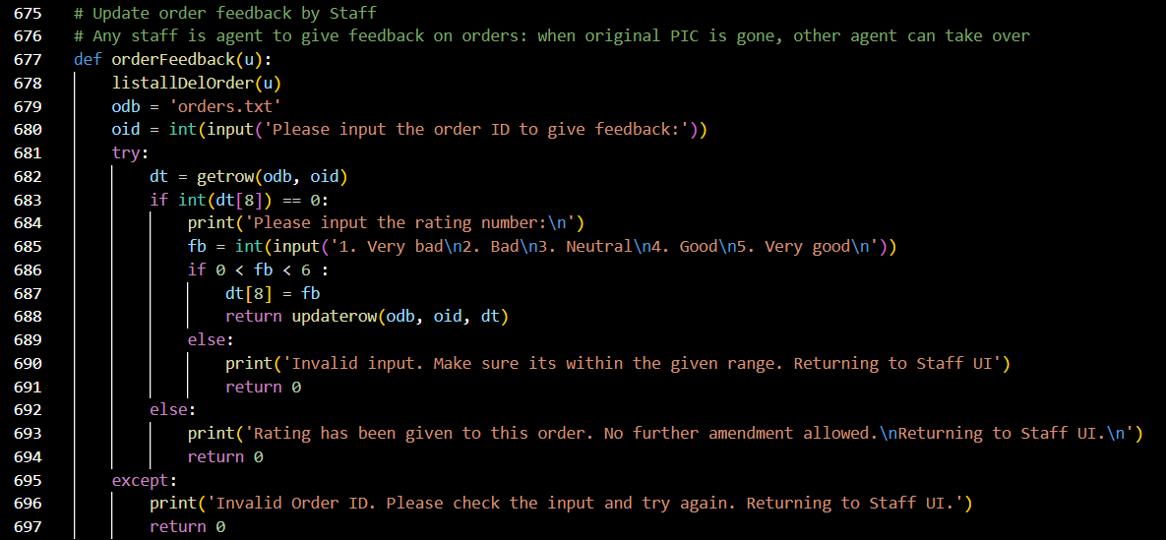  
Figure 29: Order Feedback(u) Source Code

|  |  |
| --- | --- |
| Variables | Explanation |
| u | A variable used to store staff usernames, derived from user input. |
| odb | A variable set to ‘orders.txt’, generated from the function itself. |
| oid | A variable used to store order IDs, derived from user input. It is defined as an integer. |
| dt | A variable used to store output from another function. |
| fb | A variable used to store feedback, derived from user input. |

|  |  |
| --- | --- |
| Line(s) | Explanation |
| 675 ~ 676 | Comments: This function allows order feedback to be updated by staff members. Any staff can be the agent to give feedback on orders: when the original person in charge is gone, other staff members can act as the agent and take over. |
| 677 | The function orderFeedback(u) is defined. |
| 678 | The function listallDelOrder(u) is called. |
| 679 | Refer to variables table. |
| 680 | A message requesting the user to input the order ID to give feedback is printed. The input is stored into variable oid. |
| 681 ~ 697 | The function checks the input against the database. The input is matched if it is the same as data in odb, row oid by calling the function getrow. The output is stored into variable dt.  A message requesting the user to input a rating is printed.  A message informing the user to rate 1 for Very Bad, 2 for Bad, 3 for Neutral, 4 for Good, and 5 for Very Good is printed. The input is stored into variable fb.  If a rating is not given on the order, then take input as rating and save it into order database by calling the function updaterow, with variables odb, oid, and dt acting as variables in the called functions.  In the event of errors throughout the process, appropriate error messages will be printed for each error case, the user will be returned to Staff UI and the function will return code 0. |

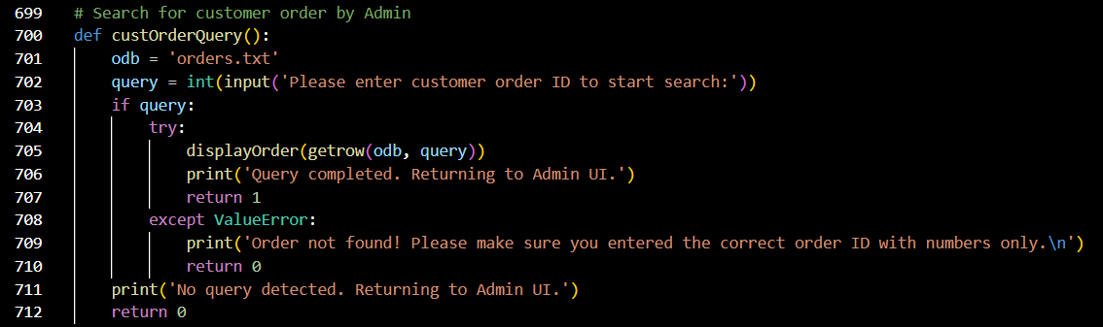  
Figure 30: Cust Order Query Source Code

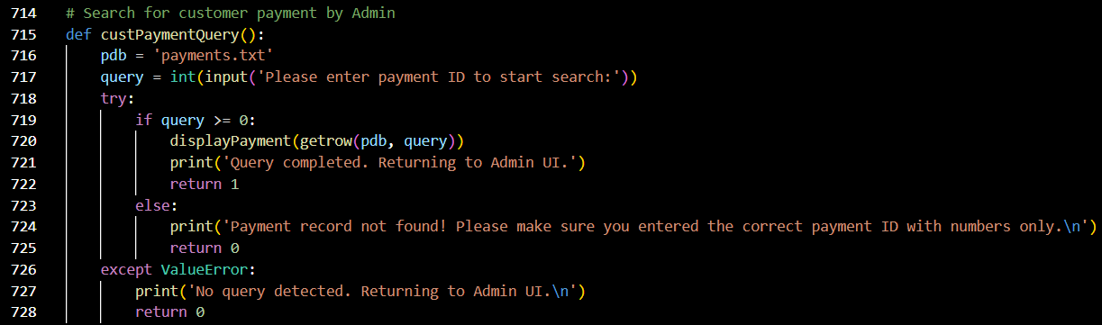  
Figure 31: Cust Payment Query Source Code

|  |  |
| --- | --- |
| Variables | Explanation |
| odb | A variable set to ‘orders.txt’, generated from the function itself. |
| query | A variable used to store order IDs, derived from user input. |

|  |  |
| --- | --- |
| Line(s) | Explanation |
| 699 | Comments: This function allows administrators to search for customer orders. |
| 700 | The function custOrderQuery() is defined. |
| 701 | Refer to variables table. |
| 702 | A message requesting the user to input their order ID to start search is printed. The input is stored into the variable query. |
| 703 ~ 712 | The function searches for the order ID in the order database, by calling the function displayOrder with the function getrow, with variables odb and query acting as variables in the called functions, to print the order details. If successfully found, a message informing the user that the query has been completed and that the user will be returned to Admin UI is printed.  In the event of the order not being found or there is no input detected, appropriate error messages will be printed, and the function will return code 0. |

This concept is used in Cust Payment Query as well. The function custPaymentQuery takes user input and searches for the payment ID in payment database. It calls to function displayPayment with function getrow to display out the payment details. The function will return 0 if the payment ID not found or no input is detected.

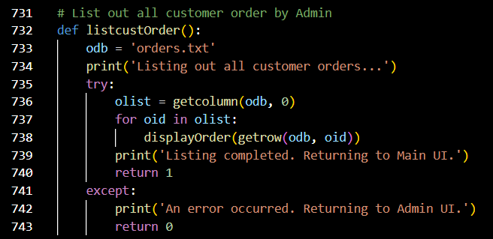  
Figure 32: List Cust Order Source Code

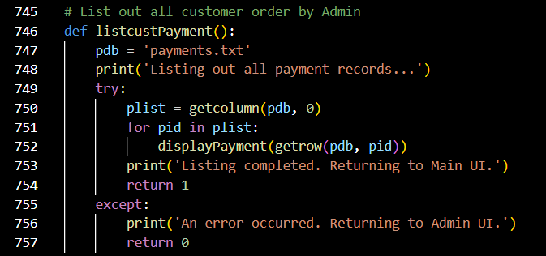  
Figure 33: List Cust Payment Source Code

|  |  |
| --- | --- |
| Variables | Explanation |
| odb | A variable set to ‘orders.txt’, generated from the function itself. |
| olist | A variable used to store output from another function. |

|  |  |
| --- | --- |
| Line(s) | Explanation |
| 731 | Comments: This allows the administrator to list out all customer orders. |
| 732 | The function listcustOrder() is defined. |
| 733 | Refer to variables table. |
| 734 | A message informing the user that the system is listing out all customer orders is printed. |
| 735 ~ 743 | The function gets all order IDs in order database, from odb, column 0, by calling the function getcolumn. The output is stored into olist.  Next, the function lists all data retrieved by calling the function displayOrder with the function getrow, with variables odb and oid acting as variables in the called functions. If successful, a message informing the user that listing is completed and that they will be returned to Main UI is printed.  In the event of an exception, an appropriate error message will be printed, the user will be returned to Admin UI, and the function returns code 0. |

This concept is used List Cust Payment as well. The function listcustPayment gets all payment IDs in the payment database and lists all data by calling the function getrow and the function displayPayment using payment ID.

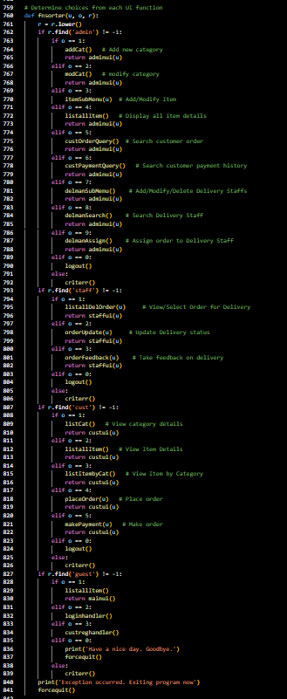  
Figure 34: Fnsorter(u, o, r) Source Code

|  |  |
| --- | --- |
| Variables | Explanation |
| u | A variable used to store usernames. |
| o | A variable used to store |
| r | A variable used to store user roles. |

|  |  |
| --- | --- |
| Line(s) | Explanation |
| 759 | Comments: This function determines choices from each UI function. |
| 760 | The function fnsorter is defined. |
| 761 |  |
| 762 ~ 792 |  |
| 793 ~ 806 |  |
| 807 ~ 826 |  |
| 827 ~ 839 |  |
| 840 ~ 841 |  |

Fnsorter: to redirect all user to correct menu and functions, act as a central hub

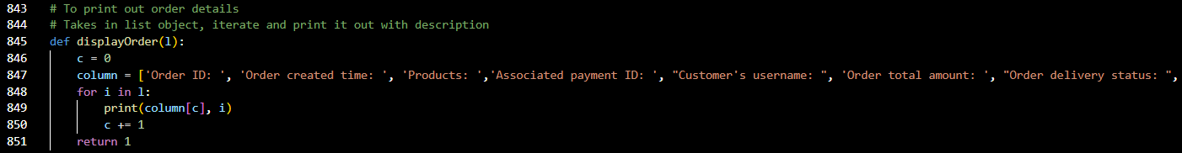  
Figure 35: Display Order(l) Source Code

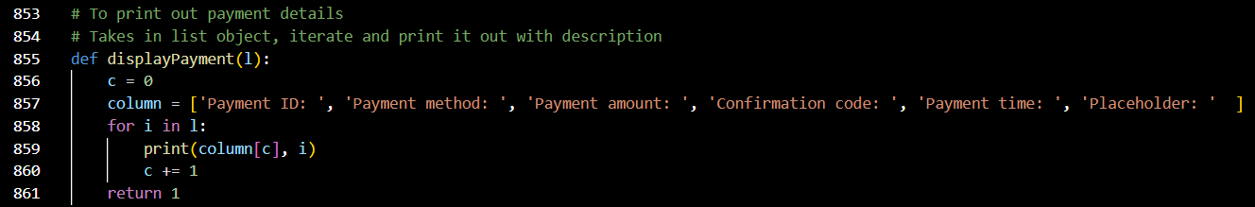  
Figure 36: Display Payment(l) Source Code

|  |  |
| --- | --- |
| Variables | Explanation |
| l | A variable which acts as a list. |
| c | 0 |
| column | A string variable used to store ['Order ID: ', 'Order created time: ', 'Products: ', 'Associated payment ID: ', "Customer's username: ", 'Order total amount: ', "Order delivery status: ", "Order delivered date: ", "Order feedback: ", "Delivery info: ", "Placeholder: "] |

|  |  |
| --- | --- |
| Line(s) | Explanation |
| 843 ~ 844 | Comments: This function exists to print out order details. It takes in a list object, iterates it, and prints it out with additional description. |
| 845 | The function displayOrder(l) is defined. |
| 846 ~ 847 | Refer to variables table. |
| 848 ~ 851 | A message displaying order details along with their attributes is printed, by printing column 0 of variable l. The function returns code 1. |

This concept is used in Display Payment(l) as well. The purpose of displayPayment(l) is to act as a helper function to print payment details along with its attributes.

# Additional Features

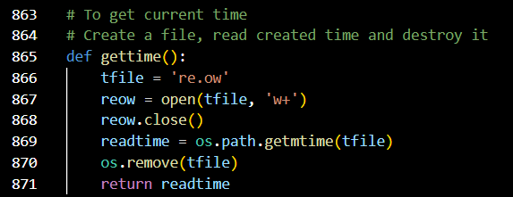  
Figure 37: Get Time Source Code

|  |  |
| --- | --- |
| Variable | Explanation |
| tfile | A variable used to store the permanent filename ‘re.ow’. |
| reow | A variable used to store the output stream from the function open(). |
| readtime | A variable used to store the output from the function os.path.getmtime(). |

|  |  |
| --- | --- |
| Line(s) | Explanation |
| 863 ~ 864 | Comments: This function allow other functions to get the exact Unix time by creating a temporary file, read the file created time and then delete the temporary file. |
| 866 ~ 867 | Refer to variables table. |
| 868 | Close the file stream as no data will be written into the temporary file. |
| 869 | Refer to variables table. |
| 870 | Call os.remove() function to remove the temporary file |
| 871 | Return the value in readtime variable |

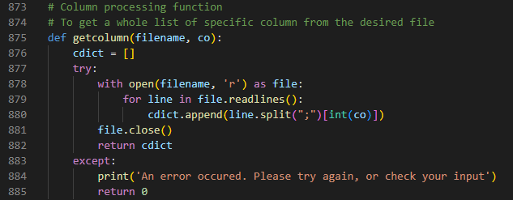  
Figure 38: Get Column(filename, co) Source Code

|  |  |
| --- | --- |
| Variable | Explanation |
| filename | Refer to main explanation table below. |
| ro | Refer to main explanation table below. |
| cdict | A variable defining empty list at beginning. |

|  |  |
| --- | --- |
| Line(s) | Explanation |
| 873 ~ 874 | Comments: This function is for getting specified column from the specified text file (database), returned value will be in list data type. |
| 876 | Refer to variables table. |
| 877 ~ 882 | Try to open argument “filename” as file with mode read-only, read every line in the specified file as line. Then split the data in the line into list with custom delimiter “;”, get the specified data with index “co”, and append into cdict. Once all lines are read, close the file, and return value of cdict. |
| 883 ~ 885 | If any exception occurred during the tasks, print out error message and return 0. |

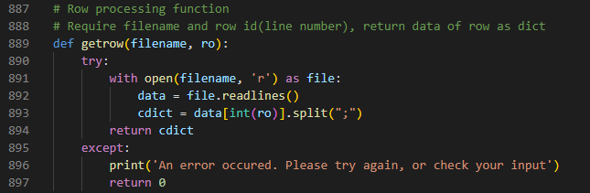  
Figure 39: Get Row(filename, ro) Source Code

|  |  |
| --- | --- |
| Variable | Explanation |
| filename | Refer to main explanation table below. |
| co | Refer to main explanation table below. |
| data | A variable to store read lines from the specified file. |
| cdict | A variable to store the specified row data as list, split by custom delimiter “;” . |

|  |  |
| --- | --- |
| Line(s) | Explanation |
| 887 ~ 888 | Comments: This function is for getting specified row from the specified text file (database), returned value will be in list data type. |
| 890 ~ 894 | Try to open argument “filename” as file with mode read-only, read every line in the specified file and save it to “line” variable. Then get the specified row by argument “ro”, split the retrieved data with custom delimiter “;”, and store into cdict. Return value in cdict at the end. |
| 895 ~ 897 | If any exception occurred during the tasks, print out error message and return 0. |

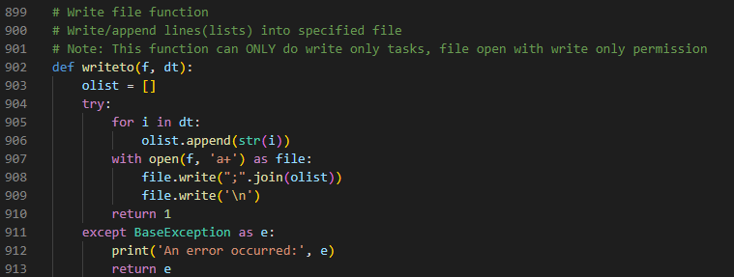  
Figure 40: Write To(f, dt) Source Code

|  |  |
| --- | --- |
| Variable | Explanation |
| f | Refer to main explanation table below. |
| dt | Refer to main explanation table below. |
| olist | A variable defining empty list at beginning. |
| e | Refer to main explanation table below. |

|  |  |
| --- | --- |
| Line(s) | Explanation |
| 899 ~ 901 | Comments: This function is only to write data received into end of line in specified file. |
| 903 | Refer to variables table. |
| 904 | Try to perform following tasks |
| 905 ~ 906 | Get every data in argument “dt”, iterate through it and convert it into string, then append into olist. |
| 907 ~ 910 | Open specified file “f” with mode a+ as file, join and write all the indexes in olist at the end of the specified file “f” with custom delimiter “;”, then write newline character after written data to prepare the file for next write. Return 1 if all tasks succeed. |
| 911 ~ 913 | If BaseException occurred during the tasks, take error message as e, print it out and return value of e |

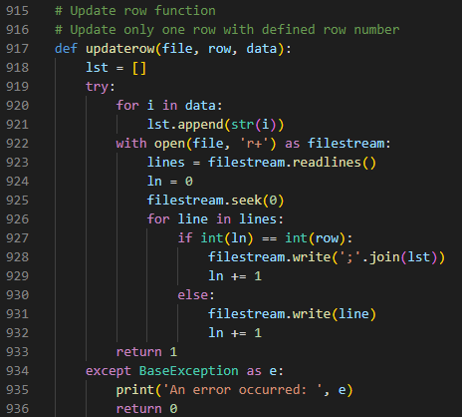  
Figure 41: Update Row(file, row, data) Source Code

|  |  |
| --- | --- |
| Variable | Explanation |
| file | Refer to main explanation table below. |
| row | Refer to main explanation table below. |
| data | Refer to main explanation table below. |
| lst | A variable defining empty list at beginning. |
| lines | Refer to main explanation table below. |
| ln | A variable defined as 0 to count for current operating line. |

|  |  |
| --- | --- |
| Line(s) | Explanation |
| 915 ~ 916 | Comments: This function is for getting specified row from the specified text file (database), returned value will be in list data type. |
| 919 | Try to perform following tasks |
| 920 ~ 921 | Get every data in argument “data”, iterate through it and convert it into string, then append into lst. |
| 922 ~ 933 | Open specified file “file” with mode r+ as filestream, read all the data in the file and store into “lines”, then set the file pointer to the beginning of file. Go through data in lines and write back into the specified file if the data is not the row specified “row”, if the current line count matches “row”, write in new data “data with custom delimiter “;” instead. Return 1 on success. |
| 934 ~ 936 | If BaseException occurred during the tasks, take error message as e, print it out and return 0 |

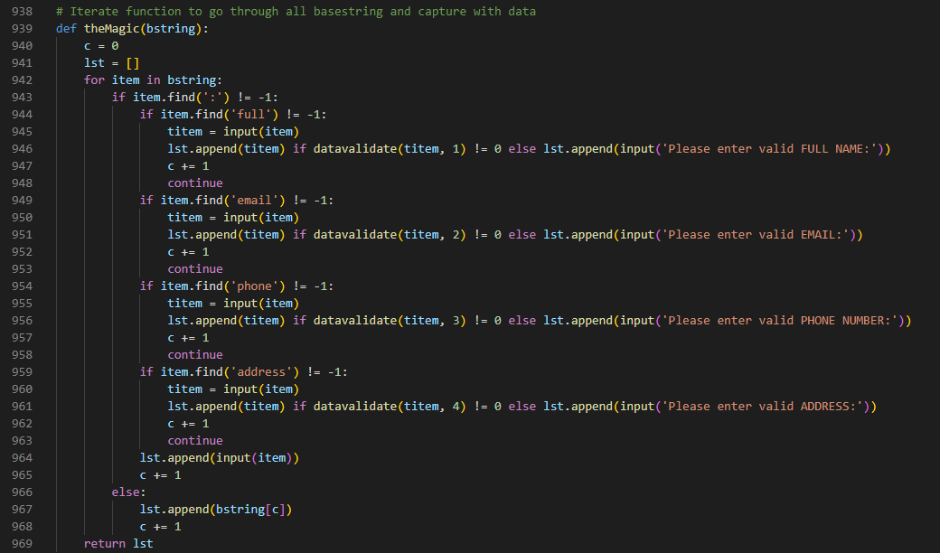  
Figure 42: The Magic(bstring) Source Code

|  |  |
| --- | --- |
| Variable | Explanation |
| bString | Refer to main explanation table below. |
| c | A variable defined as 0 to count for current index number |
| lst | A variable defining empty list at beginning. |
| titem | A variable to store input from user. |

|  |  |
| --- | --- |
| Line(s) | Explanation |
| 938 | Comments: A custom function to iterate through given list and return a list of user’s input. |
| 940 ~ 941 | Refer to variables table. |
| 942 ~ 969 | For item in argument “bString”, find if colon exist in the item, then find for the keyword and display the original value of item. After received input from user as variable titem, invoke datavalidate function to perform data validation with the input type. Append value of variable titem into variable lst if the data was validated successfully.  Else, request for the correct user input and append into variable lst. If colon doesn’t exist in item, append item into lst. If colon exist but no keyword found, display the value for the item and append into variable lst. Return list lst at the end. |

  
Figure 43: Dettol(x) Source Code

|  |  |
| --- | --- |
| Variable | Explanation |
| x | Refer to main explanation table below. |

|  |  |
| --- | --- |
| Line(s) | Explanation |
| 971 ~ 972 | Comments: A function to sanitize user’s input to prevent bug happens. |
| 973 | Return argument “x” with special characters and spaces at the start and end striped. |

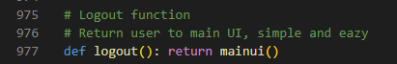  
Figure 44: Log Out Source Code

|  |  |
| --- | --- |
| Line(s) | Explanation |
| 975 ~ 976 | Comments: Logout function for logged in user to reset their state and able to log in as other users. |
| 977 | Clear every data and return user to mainui() |

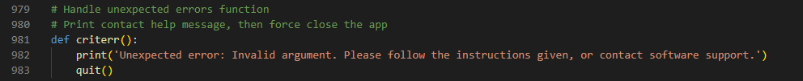  
Figure 45: Criterr Source Code

|  |  |
| --- | --- |
| Line(s) | Explanation |
| 979 ~ 980 | Comments: this function is to handle critical errors in fnsorter(), try to exit the function or program on call. |
| 982 | Print error and help message. |
| 983 | Call built-in quit() function |

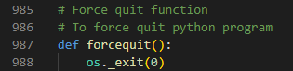  
Figure 46: Force Quit Source Code

|  |  |
| --- | --- |
| Line(s) | Explanation |
| 985 ~ 986 | Comments: Force quit from the python program upon function call |
| 988 | Invoke _exit() function of os module with parameter 0 |

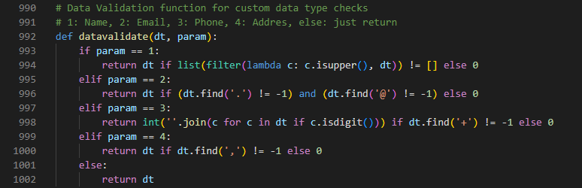  
Figure 47: Data Validate(dt, param) Source Code

|  |  |
| --- | --- |
| Variable | Explanation |
| dt | Refer to main explanation table below. |
| param | Refer to main explanation table below. |

|  |  |
| --- | --- |
| Line(s) | Explanation |
| 990 ~ 991 | Comments: Data validation function for checking multiple different input types. Case 1 for name, case 2 for email, case 3 for phone number, case 4 for address, anything unspecified will be returned original value. |
| 993 ~ 994 | If argument “param” is 1, invoke filter, list and custom lambda functions to check if the argument “dt” has capital letters. Return “dt” if condition met, else return 0. |
| 995 ~ 996 | If argument “param” is 2, find for “.” and “@” characters in argument “dt”. Return “dt” if condition met, else return 0. |
| 997 ~ 998 | If argument “param” is 3, find for “+” character in argument “dt”. Return “dt” with only digits if condition met, else return 0. |
| 999 ~ 1000 | If argument “param” is 4, find for “,” character in argument “dt”. Return “dt” if condition met, else return 0. |
| 1001 ~ 1002 | Return “dt” by default, if “param” out of range or incorrect. |

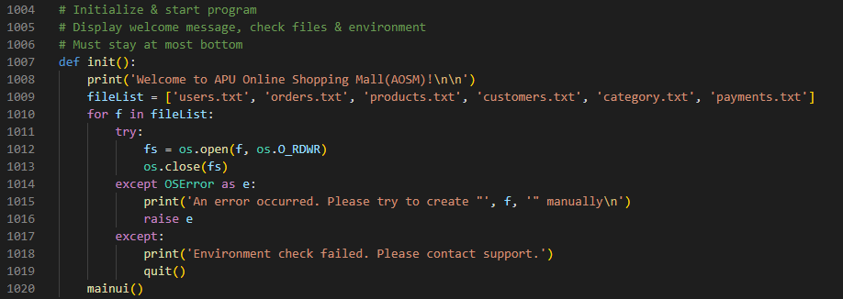  
Figure 48: Init Source Code

|  |  |
| --- | --- |
| Variable | Explanation |
| fileList | A predefined variable consists list of required text files as database |

|  |  |
| --- | --- |
| Line(s) | Explanation |
| 1004 ~ 1006 | Comments: Initialize program and check if the environment, text files (database) is valid and display welcome message. |
| 1008 | Print welcome message. |
| 1009 | Refer to variables table. |
| 1010 ~ 1013 | For files “f” in “fileList”, try to open it with mode os.O_RDWR (Read Write), then close the file and proceed to next file in list. |
| 1014 ~ 1016 | If file operation error, print out error message with the file that is causing error, then raise e(error). |
| 1017 ~ 1019 | If any other exception occurred, print out error message and quit the program. |
| 1020 | Call function mainui() if everything is ok. |

# Demonstration and Explanation

The default values used in these demonstrations are shown below:

Customer: guest@0000  
Admin: tp067553@1234   
Staff: tp060486@0000

Welcome Page – Guest Access

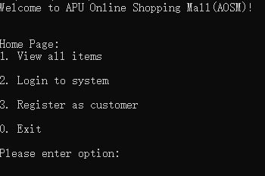  
Result 1: Welcome Page - Guest Access

This is the first page shown to users when the program begins to run and offers them the option to view all items as an unregistered guest user, to log in to the system, to register as customer, or to exit.

List All Item

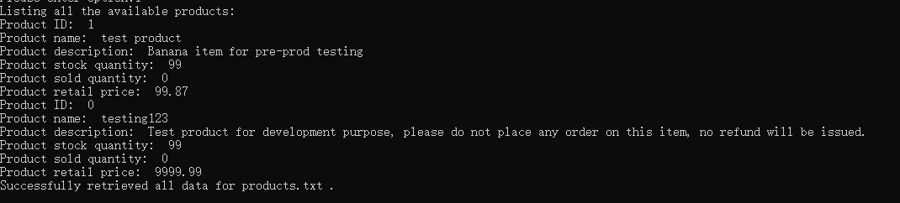  
Result 2: List All Item

When users enter input 1 at the home page, they will be shown this page, a list of all items in the system, as per their request. This helps the unregistered guess user decide if they wish to register as customer to make orders after viewing the items.

Login Page

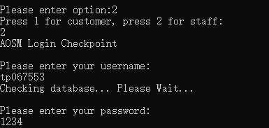  
Result 3: Login Page

When users enter input 2 at the home page, they will be shown to this page when they attempt to log in. A prompt will appear asking which role the current users belong to, then asks for the user’s login details.

Admin UI

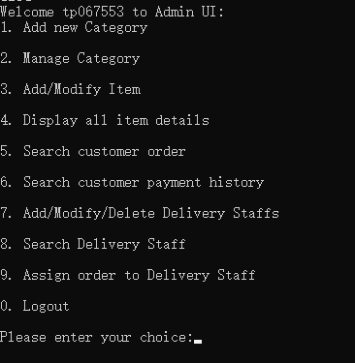  
Result 4: Admin UI

After an administrator has successfully logged in, they will be shown to this page. They are welcomed, and the page displays the various actions that they are able to carry out as an admin user.

Search Staff

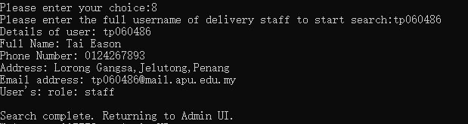  
Result 5: Search Staff

This page is shown to admin users searching for staff member profiles. It can be accessed by entering option 9 on admin’s UI. The user then needs to input the full username of the target staff in order to initiate the search and get the detailed information of the user. The user’s password is hidden on this page.

Assign Order

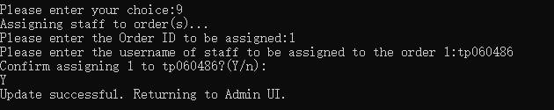  
Result 6: Assign Order

This page is shown to admin users assigning orders to staff members. It can be accessed by entering option 9 on admin’s UI. The user then needs to enter the target order ID, then the username of the target staff. The administrator is required to confirm operation by entering “Y”.

Search Order

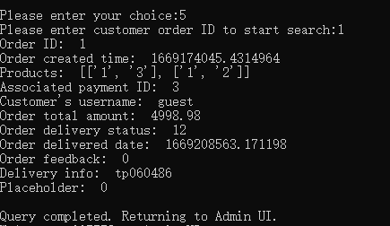  
Result 7: Search Order

This page is shown to admin users searching for customer orders. It can be accessed by entering option 5 on admin’s UI. After input the target order’s number, the details of the queried order will be displayed out.

Critical Error

  
Result 8: Critical Error

This is an example of what an error message would look like. These are printed according to the error, which could be due to exceptions, invalid inputs, and so on.

Staff UI

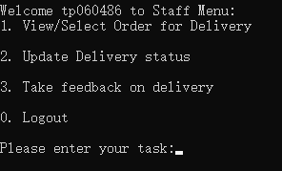  
Result 9: Staff UI

After a delivery staff member has successfully logged in, they will be shown to this page. They are welcomed, and the page displays the actions that they are able to carry out as a delivery staff member.

Search Payment

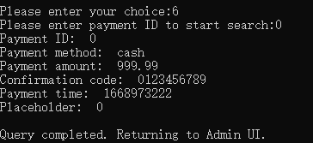  
Result 10: Search Payment

This page is shown to admin users searching for customer’s payment history. It can be accessed by entering option 6 on admin’s UI. After the user inputs the target payment ID, the details of the queried payment details will be displayed out.

Modify Staff

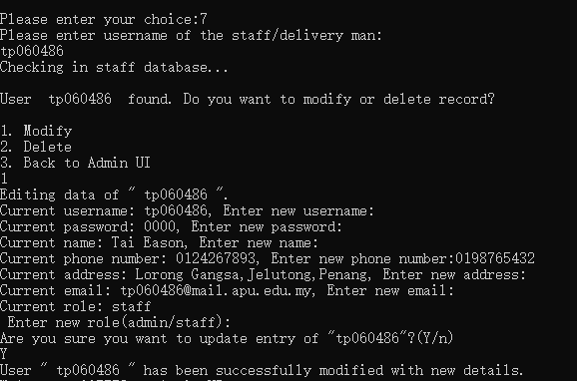  
Result 11: Modify Staff

This page is shown to admin users for modifying staff details. It can be accessed only after keying in existing staff’s complete username and selecting 1 on the sub menu. It will display out selected staff’s details and request for new inputs. If no input received old details will be used. Confirm the changes by entering “Y”, and a confirmation message will be displayed.

Delete Staff

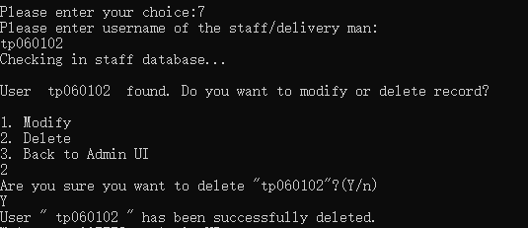  
Result 12: Delete Staff

This page is shown to admin users for deleting staff members. It can be accessed by entering option 7 on admin’s UI. It can be accessed only after keying in existing staff’s complete username and selecting 2 on the sub menu. Confirm the changes by entering “Y”, and a confirmation message will be displayed.

Create New Staff

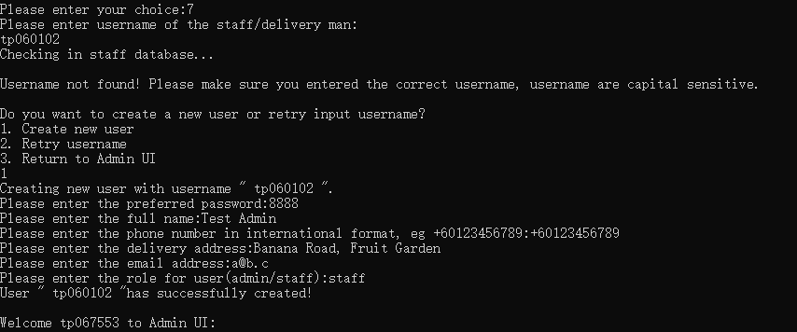  
Result 13: Create New Staff

This page is shown to admin users trying to create new staff account. It can be accessed by inputting the username of the new staff and then selecting option 1 on the sub menu. Once in, admin need to fill in all the fields with valid data and confirm with “Y”. A confirmation message will be displayed.

Create New Item

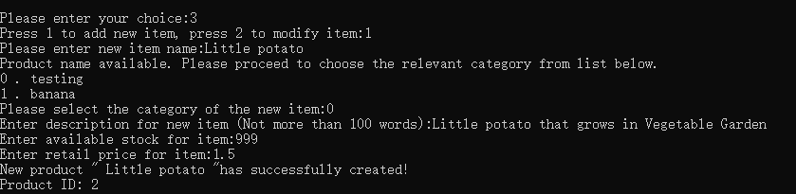  
Result 14: Create New Item

This page is shown to admin users to create new item. After option 3 was selected on Admin UI, press 1 to start adding new item by keying in the new item’s name. A category dialog will show up, and admin need to choose which category the new item belongs. After this, just fill in all the correct details to create the new item. A new item ID will be displayed.

Modify Item

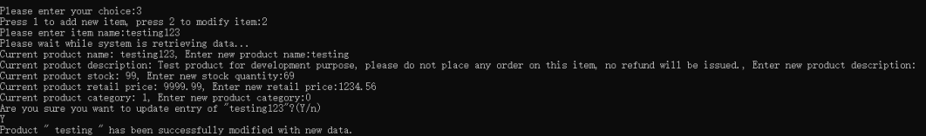  
Result 15: Modify Item

This page is shown to admin users to modify items. It can be accessed by entering option 3 on Admin’s UI, then by pressing 2 on the sub menu to start modifying the item by keying in the existing item name. The current product details are displayed, and the user is required to input the new details for the product. Confirm the changes by entering “Y”. A confirmation message will be displayed.

Modify Category

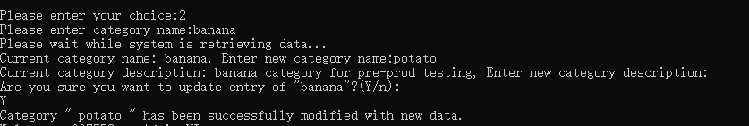  
Result 16: Modify Category

This page is shown to admin users to modify categories. It can be accessed by entering option 2 on admin’s UI. Admins need to input the full existing category name along with an additional description. Confirm the changes by entering “Y”. A confirmation message will be displayed.

Add New Category

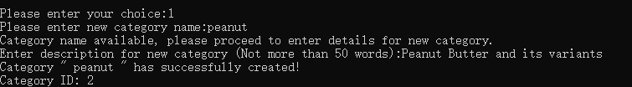  
Result 17: Add New Category

This page is shown to admin users to create new category. It can be accessed by entering option 1 on admin’s UI. Admins need to input the new category name for availability check, then enter the description for the new category. A new category ID will be displayed after the confirmation message.

View Order for Delivery

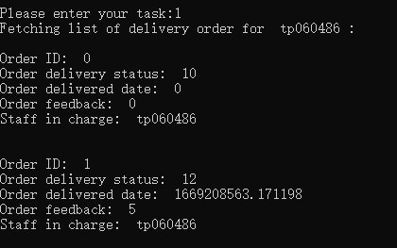  
Result 18: View Order for Delivery

This page is shown to staff users to viewing customer orders. It can be accessed by entering option 1 on staff’s UI. The necessary information of the orders assigned to the current staff will be displayed out.

Update Delivery Status

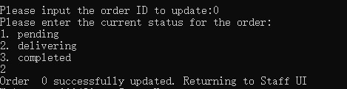  
Result 19: Update Delivery Status

This page is shown to staff users to update delivery status on customer orders. It can be accessed by entering option 2 on staff’s UI. After the user has inputted the target order number, 3 options of order status will be displayed for the user to choose. A confirmation message will be displayed after selecting any of the 3 statuses.

Feedback on Delivery

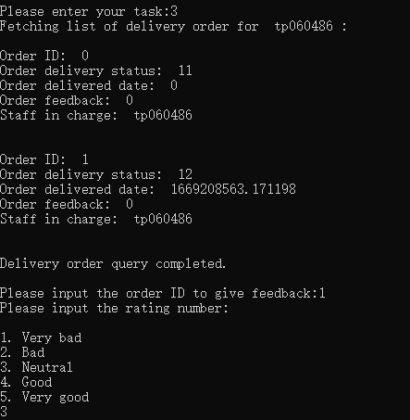  
Result 20: Feedback on Delivery

This page is shown to staff users for updating review on customer’s order. It can be accessed by entering option 3 on staff’s UI. All orders assigned to the current staff user will be displayed and staff user need to pick and input the order ID. Options for rating will then be displayed for guidance.

Customer UI

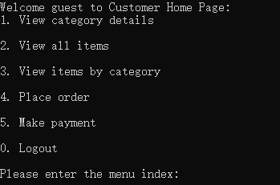  
Result 21: Customer UI

After a customer has successfully logged in, they will be shown to this page. They are welcomed, and the page displays the actions that they are able to carry out as a customer.

List Categories

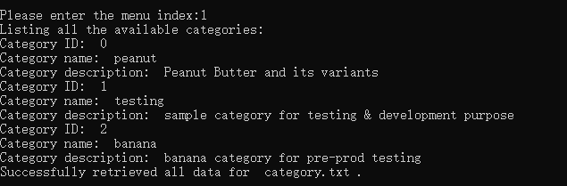  
Result 22: List Categories

This page is shown to customers for listing out all categories. It can be accessed by entering option 1 on customer’s UI. The details of all available categories will be displayed out.

List All Items

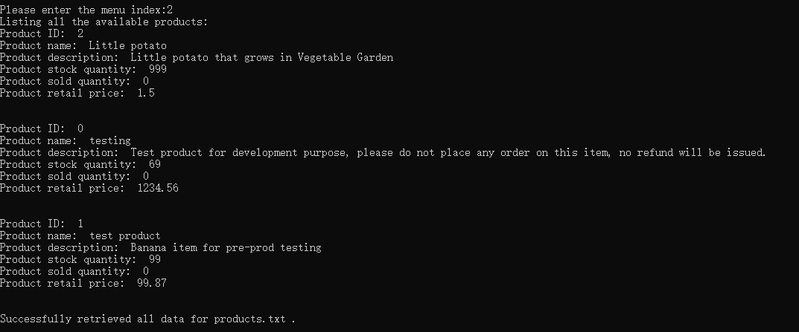  
Result 23: List All Items

This page is shown to customers to list all available products. It can be accessed by entering option 2 on customer’s UI. All product details will be displayed on this page.

List Item by Category

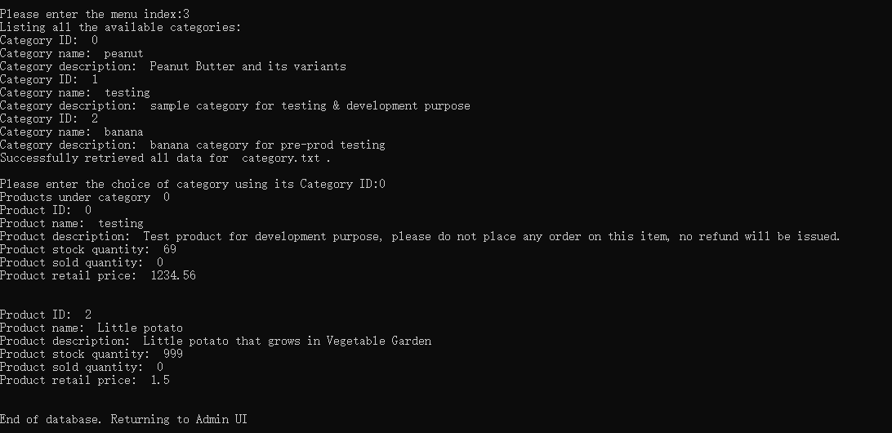  
Result 24: List Item by Category

This page is shown to customers to list items based on each category. It can be accessed by entering option 3 on customer’s UI. Available categories will be displayed first for customer to select category ID, then the products under the selected category will be displayed with its details.

Place Order

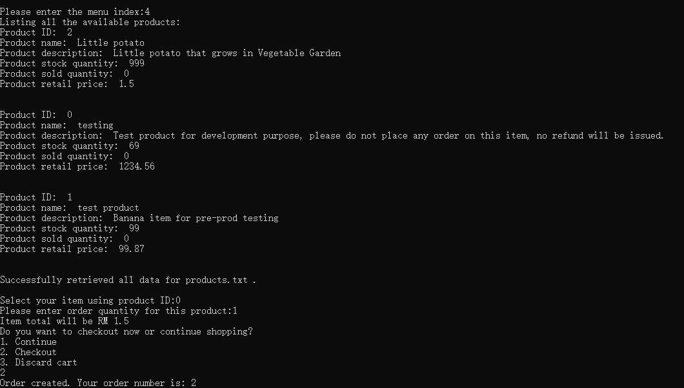  
Result 25: Place Order

This page is shown to customers for placing order. It can be accessed by entering option 4 on customer’s UI. A full list of available products will be displayed for customer, and customer will be given choices of continue shopping or checkout. If checkout option is selected, customer’s cart will be saved as new order and the order number will be displayed.

Make Payment

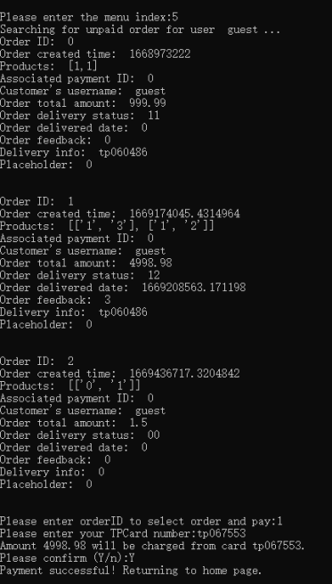  
Result 26: Make Payment

This page is shown to customers for making payment for unpaid order. It can be accessed by entering option 5 on customer’s UI. A full list of unpaid orders will be displayed for customer to select, then customer will need to key in their TP card number to proceed payment. Confirm the changes by entering “Y”, and a confirmation message will be displayed.

Register as Customer

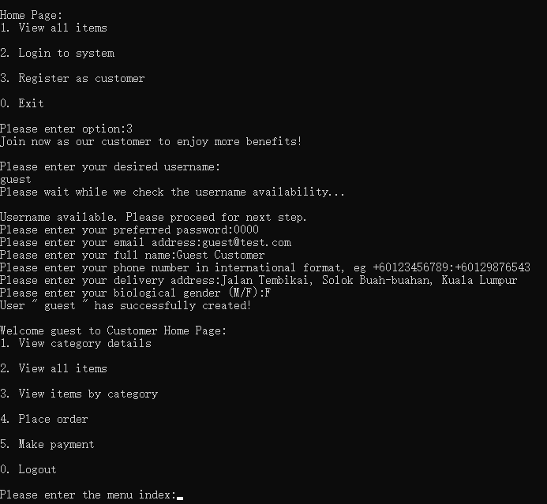  
Result 27: Register as Customer

This page is shown to guest for registering as AOSM’s customer. It can be accessed by entering option 3 on welcome UI. Guest first need to enter their preferred username for availability check, then enter the other details to complete registration. Guest will then be brought to customer UI as new customer.

# Conclusion

In conclusion, our group has successfully created a program for the AOSM, which runs without any errors and is able to fulfil the intended services which it was created to provide. It is written with pure Python code without the usage of global variables.

During the process, we researched built in and module functions to make our program run smoothly. Examples of built-in functions that we learnt are the functions index, find, .quit, strip, and append. Examples of module functions that we learnt while doing our code are the functions os.open, os._exit(0), and os.O_RDWR. For the function os.exit(0), it will exit the program without cleaning up anything, which will not trigger any exceptions, terminating the program directly. The “0” inside is the return code when exiting program, which means no error. We also discovered the modes in which can be opened to be read and written, and the differences between them. The struggles we went through were learning to apply the functions that we were unfamiliar with.

We also learnt about the different shapes used in flowchart which have different purposes, such as an oval to indicate the start and end of functions, a double-lined rectangle to indicate a function being called to, a parallelogram to indicate input or output of information, a hexagon to indicate a loop, and so on.

When creating flowcharts, it was difficult to keep track of all the code logic and to maintain consistency throughout. A major struggle was constantly updating the pseudo code and flowcharts as the original source code was tested and debugged. It was hard to progress without going back to work that was previously thought as being completed and it was very inefficient and felt very unrealistic as a planning process should not have to be updated constantly.

It was also challenging to explain the code in an organized way that is comprehensible by outsiders, beginners and so on.

All in all, it was a great learning experience to plan and create a functioning code line by line, as well as document it. It provided us with an insight into the industrial process of creating the code for a program and challenged us to think of ways to creatively code the necessary functions without using global variables, and without using much other module functions.

# References

Attention Required! | Cloudflare. (n.d.). Retrieved October 16, 2022, from https://pynative.com/python-search-for-a-string-in-text-files/

GeeksforGeeks. (2021a, July 1). Default arguments in Python. Retrieved from https://www.geeksforgeeks.org/default-arguments-in-python/

GeeksforGeeks. (2021b, September 26). Python Program to Delete Specific Line from File. Retrieved from https://www.geeksforgeeks.org/python-program-to-delete-specific-line-from-file/

GeeksforGeeks. (2021c, October 10). Python | os.path.getmtime() method. Retrieved October 15, 2022, from https://www.geeksforgeeks.org/python-os-path-getmtime-method/

GeeksforGeeks. (2022, October 31). Python - Extract Upper Case Characters. Retrieved from https://www.geeksforgeeks.org/python-extract-upper-case-characters/

How can I read a particular column in a text file (.txt) using Python? (n.d.). Retrieved October 16, 2022, from https://www.quora.com/How-can-I-read-a-particular-column-in-a-text-file-txt-using-Python

How do I run pip on python for windows? (2015, October 18). Retrieved October 15, 2022, from https://stackoverflow.com/questions/33193374/how-do-i-run-pip-on-python-for-windows

How to Create and Delete a file in Python? -. (n.d.). Retrieved October 15, 2022, from https://www.projectpro.io/recipes/create-and-delete-file-in-python

Lemonaki, D. (2022, February 24). Python Find in List – How to Find the Index of an Item or Element in a List. Retrieved November 3, 2022, from https://www.freecodecamp.org/news/python-find-in-list-how-to-find-the-index-of-an-item-or-element-in-a-list/

Python os.open() Method. (n.d.). Retrieved November 6, 2022, from https://www.tutorialspoint.com/python/os_open.htm

Python String rstrip() Method. (n.d.). Retrieved October 28, 2022, from https://www.w3schools.com/python/ref_string_rstrip.asp

Python String split() Method. (n.d.). Retrieved October 28, 2022, from https://www.w3schools.com/python/ref_string_split.asp

Real Python. (2021, May 8). Splitting, Concatenating, and Joining Strings in Python. Retrieved from https://realpython.com/python-string-split-concatenate-join/

What is the difference between os.open and os.fdopen in python? (n.d.). Retrieved October 16, 2022, from https://www.tutorialspoint.com/What-is-the-difference-between-os-open-and-os-fdopen-in-python

What’s New In Python 3.8 — Python 3.11.0 documentation. (n.d.). Retrieved November 6, 2022, from https://docs.python.org/3/whatsnew/3.8.html

write output with delimiter in python. (2016, January 30). Retrieved from https://stackoverflow.com/questions/35100222/write-output-with-delimiter-in-python

# Appendix